Table of Contents

UNITED STATES

SECURITIES AND EXCHANGE COMMISSION

WASHINGTON, D.C. 20549

_______________________________________

FORM 10-Q

_______________________________________
(Mark One)

- Quarterly Report Pursuant to Section 13 or 15(d) of the Securities Exchange Act of 1934

For the quarterly period ended September 30, 2025

or

- Transition Report Pursuant to Section 13 or 15 (d) of the Securities Exchange Act of 1934

For the transition period from to

Commission File No. 1-15461

__________________________________________

MATRIX SERVICE COMPANY

(Exact name of registrant as specified in its charter)

__________________________________________

 |  | Delaware |  |  |  | 73-1352174
 | (State of incorporation) |  |  |  | (I.R.S. Employer Identification No.)
 |  |  | 15 East 5th Street, Suite 1100, Tulsa, Oklahoma 74103
 |  |  | (Address of principal executive offices and zip code)
 |  |  | Registrant’s telephone number, including area code: (918) 838-8822
 |  |  |  | Not Applicable
 |  |  | (Former name, former address and former fiscal year, if changed since last report)
 |  |  | ___________________________
 |  |  | Securities registered pursuant to Section 12(b) of the Act:
 | Title of each class |  |  | Trading Symbol(s) |  | Name of each exchange on which registered
Common Stock, par value $0.01 per share |  |  |  | MTRX |  | NASDAQ Global Select Market

Indicate by check mark whether the registrant (1) has filed all reports required to be filed by Section 13 or 15(d) of the Securities Exchange Act of 1934 during the preceding 12 months (or for such shorter period that the registrant was required to file such reports), and (2) has been subject to such filing requirements for the past 90 days. Yes ☒ No ☐

Indicate by check mark whether the registrant has submitted electronically every Interactive Data File required to be submitted pursuant to Rule 405 of Regulation S-T during the preceding 12 months (or for such shorter period that the registrant was required to submit such files). Yes ☒ No ☐

Indicate by check mark whether the registrant is a large accelerated filer, an accelerated filer, a non-accelerated filer, a smaller reporting company, or an emerging growth company. See definitions of “large accelerated filer”, “accelerated filer”, “smaller reporting company”, and "emerging growth company" in Rule 12b-2 of the Exchange Act.

Large Accelerated Filer | ☐ | Accelerated Filer | ☒
Non-accelerated Filer | ☐ | Smaller Reporting Company | ☐
Emerging Growth Company | ☐

If an emerging growth company, indicate by check mark if the registrant has elected not to use the extended transition period for complying with any new or revised financial accounting standards provided pursuant to Section 13(a) of the Exchange Act. ☐
Indicate by check mark whether the registrant is a shell company (as defined in Rule 12b-2 of the Exchange Act). Yes ☐ No ☒ As of November 5, 2025 there were 28,124,527 shares of the Company's common stock, $0.01 par value per share, outstanding.

Table of Contents

TABLE OF CONTENTS

 |  |  |  |  |  |  |  |  |  |  |  |  |  |  |  |  |  |  |  |  | PAGE
 | PART I |  |  |  |  |  |  |  |  |  |  |  |  | FINANCIAL INFORMATION
 | Item 1. |  |  |  | Financial Statements (Unaudited)
 |  |  |  |  | Condensed Consolidated Statements of Income for the Three Months Ended September 30, 2025 and 2024 |  |  |  |  |  |  |  |  |  |  |  |  |  |  |  | 1
 |  |  |  |  | Condensed Consolidated Statements of Comprehensive Income for the Three Months Ended September 30, 2025 and 2024 |  |  |  |  |  |  |  |  |  |  |  |  |  |  |  | 2
 |  |  |  |  | Condensed Consolidated Balance Sheets as of September 30, 2025 and June 30, 2025 |  |  |  |  |  |  |  |  |  |  |  |  |  |  |  | 3
 |  |  |  |  | Condensed Consolidated Statements of Cash Flows for the Three Months Ended September 30, 2025 and 2024 |  |  |  |  |  |  |  |  |  |  |  |  |  |  |  | 5
 |  |  |  |  | Condensed Consolidated Statements of Changes in Stockholders’ Equity for the Three Months Ended September 30, 2025 and 2024 |  |  |  |  |  |  |  |  |  |  |  |  |  |  |  | 6
 |  |  |  |  | Notes to Condensed Consolidated Financial Statements |  |  |  |  |  |  |  |  |  |  |  |  |  |  |  | 7
 | Item 2. |  |  |  | Management’s Discussion and Analysis of Financial Condition and Results of Operations |  |  |  |  |  |  |  |  |  |  |  |  |  |  |  |  | 15
 | Item 3. |  |  |  | Quantitative and Qualitative Disclosures About Market Risk |  |  |  |  |  |  |  |  |  |  |  |  |  |  |  |  | 28
 | Item 4. |  |  |  | Controls and Procedures |  |  |  |  |  |  |  |  |  |  |  |  |  |  |  | 28
 | PART II |  |  |  |  |  |  |  |  |  |  |  |  | OTHER INFORMATION
 | Item 1. |  |  |  | Legal Proceedings |  |  |  |  |  |  |  |  |  |  |  |  |  |  |  |  | 29
 | Item 1A. |  |  |  | Risk Factors |  |  |  |  |  |  |  |  |  |  |  |  |  |  |  |  | 29
 | Item 2. |  |  |  | Unregistered Sales of Equity Securities and Use of Proceeds |  |  |  |  |  |  |  |  |  |  |  |  |  |  |  | 29
 | Item 3. |  |  |  | Defaults Upon Senior Securities |  |  |  |  |  |  |  |  |  |  |  |  |  |  |  |  | 29
 | Item 4. |  |  |  | Mine Safety Disclosures |  |  |  |  |  |  |  |  |  |  |  |  |  |  |  |  | 29
 | Item 5. |  |  |  | Other Information |  |  |  |  |  |  |  |  |  |  |  |  |  |  |  |  | 29
 | Item 6. |  |  |  | Exhibits |  |  |  |  |  |  |  |  |  |  |  |  |  |  |  |  | 29
 | Signature |  |  |  |  |  |  |  |  |  |  |  |  |  |  |  |  |  |  |  | 31

Table of Contents

PART I. FINANCIAL INFORMATION

Item 1. Financial Statements

Matrix Service Company

Condensed Consolidated Statements of Income

(In thousands, except per share data)

(unaudited)

 |  | Three Months Ended
 |  | September 30, 2025 |  |  | September 30, 2024
Revenue | $ | 211,884 |  | $ | 165,579
Cost of revenue |  | 197,702 |  |  | 157,766
Gross profit |  | 14,182 |  |  | 7,813
Selling, general and administrative expenses |  | 16,334 |  |  | 18,580
Restructuring costs |  | 3,348 |  |  | —
Operating loss |  | (5,500) |  |  | (10,767)
Other income (expense):
Interest expense |  | (127) |  |  | (89)
Interest income |  | 1,802 |  |  | 1,572
Other |  | 231 |  |  | 61
Loss before income tax expense |  | (3,594) |  |  | (9,223)
Provision for federal, state and foreign income taxes |  | 69 |  |  | —
Net loss | $ | (3,663) |  | $ | (9,223)
Basic loss per common share | $ | (0.13) |  | $ | (0.33)
Diluted loss per common share | $ | (0.13) |  | $ | (0.33)
Weighted average common shares outstanding:
Basic |  | 28,008 |  |  | 27,559
Diluted |  | 28,008 |  |  | 27,559

See accompanying notes.

-1-

Table of Contents

Net loss

Other comprehensive income (loss), net of tax:

Foreign currency translation gain (loss)

Comprehensive loss

Matrix Service Company

Condensed Consolidated Statements of Comprehensive Income

(In thousands)

(unaudited)

Three Months Ended

 | September 30, |  |  | September 30,
 | 2025 |  |  | 2024
$ | (3,663) |  | $ | (9,223)
 | (528) |  |  | 436
$ | (4,191) |  | $ | (8,787)

See accompanying notes.

-2-

Table of Contents

Matrix Service Company

Condensed Consolidated Balance Sheets

(In thousands)

(unaudited)

 |  | September 30, |  |  | June 30,
 |  | 2025 |  |  | 2025
Assets
Current assets:
Cash and cash equivalents | $ | 192,307 |  | $ | 224,641
Accounts receivable, net of allowance for credit losses |  | 160,344 |  |  | 154,994
Costs and estimated earnings in excess of billings on uncompleted contracts |  | 37,912 |  |  | 29,764
Inventories |  | 5,579 |  |  | 5,917
Income taxes receivable |  | 75 |  |  | 110
Prepaid expenses and other current assets |  | 14,195 |  |  | 4,347
Total current assets |  | 410,412 |  |  | 419,773
Restricted cash |  | 25,000 |  |  | 25,000
Property, plant and equipment, net |  | 41,347 |  |  | 42,097
Operating lease right-of-use assets |  | 15,827 |  |  | 17,827
Goodwill |  | 28,978 |  |  | 29,047
Other intangible assets, net of accumulated amortization |  | 281 |  |  | 555
Other assets, non-current (Note 2) |  | 76,341 |  |  | 65,957
Total assets | $ | 598,186 |  | $ | 600,256

See accompanying notes.

-3-

Table of Contents

Matrix Service Company

Condensed Consolidated Balance Sheets

(In thousands, except share data)

(unaudited)

 |  | September 30, |  |  | June 30,
 |  | 2025 |  |  | 2025
Liabilities and stockholders’ equity
Current liabilities:
Accounts payable | $ | 98,199 |  | $ | 80,453
Billings on uncompleted contracts in excess of costs and estimated earnings |  | 317,556 |  |  | 323,593
Accrued wages and benefits |  | 15,409 |  |  | 18,961
Accrued insurance |  | 4,711 |  |  | 5,310
Operating lease liabilities |  | 4,458 |  |  | 4,441
Other accrued expenses |  | 3,122 |  |  | 3,617
Total current liabilities |  | 443,455 |  |  | 436,375
Deferred income taxes |  | 24 |  |  | 25
Operating lease liabilities |  | 15,902 |  |  | 16,986
Other liabilities, non-current |  | 2,539 |  |  | 4,154
Total liabilities |  | 461,920 |  |  | 457,540
Commitments and contingencies (Note 5)
Stockholders’ equity:
Common stock — $0.01 par value; 60,000,000 shares authorized; 28,070,427 shares issued and outstanding at September 30, 2025; 27,888,217
shares issued at June 30, 2025 and 27,610,486 shares outstanding as of June 30, 2025; |  | 281 |  |  | 279
Additional paid-in capital |  | 145,100 |  |  | 149,969
Retained earnings |  | 816 |  |  | 4,479
Accumulated other comprehensive loss |  | (9,931) |  |  | (9,403)
Treasury stock, at cost — 0 shares as of September 30, 2025 and 277,731 shares as of June 30, 2025; |  | — |  |  | (2,608)
Total stockholders' equity |  | 136,266 |  |  | 142,716
Total liabilities and stockholders’ equity | $ | 598,186 |  | $ | 600,256

See accompanying notes.

-4-

Table of Contents

Matrix Service Company

Condensed Consolidated Statements of Cash Flows

(In thousands)

(unaudited)

 |  | Three Months Ended
 |  | September 30, |  |  | September 30,
 |  | 2025 |  |  | 2024
Operating activities:
Net loss | $ | (3,663) |  | $ | (9,223)
Adjustments to reconcile net loss to net cash provided (used) by operating activities:
Depreciation and amortization |  | 2,461 |  |  | 2,515
Stock-based compensation expense |  | 1,921 |  |  | 2,311
Operating lease impairment due to restructuring |  | 1,529 |  |  | —
Loss (gain) on disposal of property, plant and equipment |  | (217) |  |  | 68
Other |  | 94 |  |  | 38
Changes in operating assets and liabilities increasing (decreasing) cash:
Accounts receivable, net of allowance for credit losses |  | (15,083) |  |  | (5,110)
Costs and estimated earnings in excess of billings on uncompleted contracts |  | (8,148) |  |  | 2,075
Inventories |  | 338 |  |  | 1,331
Other assets and liabilities |  | (10,553) |  |  | (8,580)
Accounts payable |  | 17,720 |  |  | (3,903)
Billings on uncompleted contracts in excess of costs and estimated earnings |  | (6,037) |  |  | 33,304
Accrued expenses |  | (6,261) |  |  | (2,908)
Net cash provided (used) by operating activities |  | (25,899) |  |  | 11,918
Investing activities:
Capital expenditures |  | (2,011) |  |  | (1,944)
Proceeds from sale of property, plant and equipment |  | 222 |  |  | —
Net cash used by investing activities |  | (1,789) |  |  | (1,944)
Financing activities:
Payment of debt amendment fees |  | (149) |  |  | —
Proceeds from issuance of common stock under employee stock purchase plan |  | 43 |  |  | 46
Payments related to tax withholding for stock-based compensation |  | (4,223) |  |  | (1,235)
Net cash used by financing activities |  | (4,329) |  |  | (1,189)
Effect of exchange rate changes on cash |  | (317) |  |  | 210
Net increase (decrease) in cash and cash equivalents |  | (32,334) |  |  | 8,995
Cash, cash equivalents and restricted cash, beginning of period |  | 249,641 |  |  | 140,615
Cash, cash equivalents and restricted cash, end of period | $ | 217,307 |  | $ | 149,610
Supplemental disclosure of cash flow information:
Cash paid during the period for:
Income taxes | $ | 34 |  | $ | —
Interest | $ | 131 |  | $ | 145
Non-cash investing and financing activities:
Purchases of property, plant and equipment on account | $ | 156 |  | $ | 197

See accompanying notes.

-5-

Table of Contents

Matrix Service Company

Condensed Consolidated Statements of Changes in Stockholders’ Equity

(In thousands, except share data)

(unaudited)

 |  |  |  |  |  | Additional |  |  |  |  |  | Accumulated
 | Common Stock |  |  |  |  |  |  |  |  |  |  | Other |  | Treasury Stock
 |  |  |  |  |  | Paid-In |  |  | Retained |  |  | Comprehensive
 | Shares |  | Amount |  |  |  |  |  |  |  |  |  |  | Shares |  | Amount |  |  | Total
 | Shares |  |  |  |  | Capital |  |  | Earnings |  |  | Loss |  | Shares |  |  |  |  | Total
June 30, 2025 | 27,888,217 | $ | 279 |  | $ | 149,969 |  | $ | 4,479 |  | $ | (9,403) |  | 277,731 | $ | (2,608) |  | $ | 142,716
Net loss | — |  | — |  |  | — |  |  | (3,663) |  |  | — |  | — |  | — |  |  | (3,663)
Other comprehensive loss | — |  | — |  |  | — |  |  | — |  |  | (528) |  | — |  | — |  |  | (528)
Issuance of restricted stock | 182,210 |  | 2 |  |  | (6,805) |  |  | — |  |  | — |  | (274,578) |  | 2,580 |  |  | (4,223)
Treasury shares sold to Employee Stock Purchase Plan | — |  | — |  |  | 15 |  |  | — |  |  | — |  | (3,153) |  | 28 |  |  | 43
Stock-based compensation expense | — |  | — |  |  | 1,921 |  |  | — |  |  | — |  | — |  | — |  |  | 1,921
September 30, 2025 | 28,070,427 | $ | 281 |  | $ | 145,100 |  | $ | 816 |  | $ | (9,931) |  | — | $ | — |  | $ | 136,266
June 30, 2024 | 27,888,217 | $ | 279 |  | $ | 145,580 |  | $ | 33,941 |  | $ | (9,535) |  | 579,422 | $ | (6,083) |  | $ | 164,182
Net loss | — |  | — |  |  | — |  |  | (9,223) |  |  | — |  | — |  | — |  |  | (9,223)
Other comprehensive income | — |  | — |  |  | — |  |  | — |  |  | 436 |  | — |  | — |  |  | 436
Issuance of restricted stock | — |  | — |  |  | (4,109) |  |  | — |  |  | — |  | (360,460) |  | 4,109 |  |  | —
Treasury shares sold to Employee Stock Purchase Plan | — |  | — |  |  | (17) |  |  | — |  |  | — |  | (4,797) |  | 63 |  |  | 46
Treasury shares purchased to satisfy tax withholding | — |  | — |  |  | — |  |  | — |  |  | — |  | 123,850 |  | (1,235) |  |  | (1,235)
obligations | — |  |  |  |  |  |  |  |  |  |  |  |  | 123,850 |  | (1,235) |  |  | (1,235)
Stock-based compensation expense | — |  | — |  |  | 2,311 |  |  | — |  |  | — |  | — |  | — |  |  | 2,311
September 30, 2024 | 27,888,217 | $ | 279 |  | $ | 143,765 |  | $ | 24,718 |  | $ | (9,099) |  | 338,015 | $ | (3,146) |  | $ | 156,517

-6-

Table of Contents

Matrix Service Company

Notes to Condensed Consolidated Financial Statements

(unaudited)

Note 1 – Basis of Presentation and Significant Accounting Policies

Basis of Presentation

The condensed consolidated financial statements include the accounts of Matrix Service Company and its subsidiaries (“Matrix”, “we”, “our”, “us”, “its” or the “Company”), unless otherwise indicated. Intercompany balances and transactions have been eliminated in consolidation.

The accompanying unaudited condensed consolidated financial statements have been prepared in accordance with Rule 10-01 of Regulation S-X for interim financial statements required to be filed with the Securities and Exchange Commission and do not include all information and footnotes required by U.S. generally accepted accounting principles ("GAAP") for complete financial statements. The information furnished reflects all adjustments, consisting of normal recurring adjustments, that are, in the opinion of management, necessary for a fair statement of the results of operations, cash flows and financial position for the interim periods presented. The accompanying condensed consolidated financial statements should be read in conjunction with the audited financial statements for the year ended June 30, 2025, included in our Annual Report on Form 10-K. The results of operations for the three month period ended September 30, 2025 may not necessarily be indicative of the results of operations for the full year ending June 30, 2026.

Significant Accounting Policies

Our significant accounting policies are detailed in “Note 1 - Basis of Presentation and Significant Accounting Policies” of our Annual Report on Form 10-K for the year ended June 30, 2025.

Accounting Standards Not Yet Adopted

In December 2023, the FASB issued ASU 2023-09, Income Taxes (Topic 740): Improvements to Income Tax Disclosures, which expands disclosures in an entity’s income tax rate reconciliation table and regarding cash taxes paid both in the U.S. and foreign jurisdictions. The update will be effective for annual periods beginning after December 15, 2024 (fiscal 2026). Adoption of this ASU will result in additional disclosure, but will not impact the Company's consolidated financial position, results of operations or cash flows.

In November 2024, the FASB issued ASU 2024-03, Income Statement Reporting Comprehensive Income Expense Disaggregation Disclosures (Subtopic 220-40): Disaggregation of Income Statement Expenses, requiring companies to provide more detailed and organized disclosures of their expenses. Disclosures will include disaggregation of expense captions presented on the face of the income statement into specific categories, such as purchases of inventory, employee compensation, and costs related to depreciation and amortization. The new requirements will take effect for annual reporting periods beginning after December 15, 2026 (fiscal 2028) and for interim periods within fiscal years beginning after December 15, 2027 (fiscal 2029), with early adoption permitted. Adoption of this ASU will result in additional disclosure, but will not impact the Company's consolidated financial position, results of operations or cash flows.

Other accounting pronouncements issued but not effective until after September 30, 2025 are not expected to have a material impact on the Company's consolidated financial position, results of operations, or cash flows.

Note 2 – Revenue

Remaining Performance Obligations

We had $958.3 million of remaining performance obligations yet to be satisfied as of September 30, 2025. We expect to recognize $621.3 million of our remaining performance obligations as revenue within the next twelve months.

-7-

Table of Contents

Contract Balances

Contract terms with customers include the timing of billing and payments, which usually differs from the timing of revenue recognition. As a result, we carry contract assets and liabilities in our balance sheet. These contract assets and liabilities are calculated on a contract-by-contract basis and are classified as current. We present our contract assets in the balance sheet as Costs and Estimated Earnings in Excess of Billings on Uncompleted Contracts ("CIE"). CIE consists of revenue recognized in excess of billings. We present our contract liabilities in the balance sheet as Billings on Uncompleted Contracts in Excess of Costs and Estimated Earnings ("BIE"). BIE consists of billings in excess of revenue recognized. The following table provides information about CIE and BIE:

Costs and estimated earnings in excess of billings on uncompleted contracts Billings on uncompleted contracts in excess of costs and estimated earnings
Net contract liabilities

 | September 30, |  |  | June 30, |  |  | Change
 | 2025 |  |  | 2025 |  |  | Change
 |  |  |  | (In thousands)
$ | 37,912 |  | $ | 29,764 |  | $ | 8,148
 | (317,556) |  |  | (323,593) |  |  | 6,037
$ | (279,644) |  | $ | (293,829) |  | $ | 14,185

The difference between the beginning and ending balances of our CIE and BIE primarily results from the timing of revenue recognized relative to our billings. The amount of revenue recognized during the three months ended September 30, 2025 that was included in the June 30, 2025 BIE balance was $126.6 million.

Progress billings in accounts receivable at September 30, 2025 and June 30, 2025 included retentions to be collected within one year of $29.4 million and $29.0 million, respectively. Contract retentions collectible beyond one year are included in Other assets, non-current in the Condensed Consolidated Balance Sheets and totaled $71.3 million as of September 30, 2025 and $61.5 million as of June 30, 2025, respectively.

Unpriced Change Orders and Claims

Costs and estimated earnings in excess of billings on uncompleted contracts included revenues for unpriced change orders and claims of $12.9 million at September 30, 2025 and $11.4 million at June 30, 2025. The amounts ultimately realized may be different than the recorded amounts resulting in adjustments to future earnings. Generally, we expect collection of amounts related to unpriced change orders and claims within twelve months. However, customers may not pay these amounts until final resolution of related claims, which may extend beyond one year.

Disaggregated Revenue

Revenue disaggregated by reportable segment is presented in Note 7 - Segment Information. The following series of tables presents revenue disaggregated by geographic area where the work was performed and by contract type:

Geographic Disaggregation:

 |  |  | Three Months Ended
 |  |  | September 30, |  |  |  | September 30,
 |  |  | 2025 |  |  |  | 2024
 |  |  | (In thousands)
United States | $ |  | 198,991 |  | $ |  | 153,222
Canada |  |  | 11,428 |  |  |  | 10,768
Other international |  |  | 1,465 |  |  |  | 1,589
Total Revenue |  | $ | 211,884 |  | $ |  | 165,579
Contract Type Disaggregation:
 |  |  | Three Months Ended
 |  |  | September 30, |  |  |  | September 30,
 |  |  | 2025 |  |  |  | 2024
 |  |  | (In thousands)
Fixed-price contracts | $ |  | 164,530 |  | $ |  | 123,769
Time and materials and other cost reimbursable contracts |  |  | 47,354 |  |  |  | 41,810
Total Revenue |  | $ | 211,884 |  |  | $ | 165,579
 | -8-

Table of Contents

Note 3 – Debt

On September 9, 2021, the Company and our primary U.S. and Canada operating subsidiaries entered into an asset-based credit agreement, which was most recently amended on August 22, 2025 (as amended, the "ABL Facility"), with Bank of Montreal, as Administrative Agent, Swing Line Lender and a Letter of Credit Issuer. The maximum amount of loans under the ABL Facility is limited to $90.0 million. The ABL Facility's available borrowings may be increased by an amount not to exceed $15.0 million, subject to certain conditions, including obtaining additional commitments. The ABL Facility is intended to be used for working capital, capital expenditures, issuances of letters of credit and other lawful purposes. Our obligations under the ABL Facility are guaranteed by substantially all of our U.S. and Canadian subsidiaries and are secured by a first lien on all our assets under the ABL Facility. The ABL Facility matures, and any outstanding amounts become due and payable, on September 9, 2029.

The maximum amount that we may borrow under the ABL Facility is subject to a borrowing base, which is based on restricted cash plus a percentage of the value of certain accounts receivable, inventory and equipment, reduced for certain reserves. We are required to maintain a minimum of $25.0 million of restricted cash at all times, but such amounts are also included in the borrowing base. The borrowing base is recalculated on a monthly basis and at September 30, 2025, our borrowing base was $61.4 million. The Company had $4.8 million in letters of credit outstanding as of September 30, 2025, which resulted in availability of $56.6 million under the ABL Facility.

Borrowings under the ABL Facility bear interest through maturity at a variable rate based upon, at our option, an annual rate of either a base rate (“Base Rate”), a Term Secured Overnight Financing Rate ("Term SOFR"), or at the Canadian Prime Rate, plus an applicable margin. The Term SOFR rate, whether for one-month or three-month tenor, is provided by a third party defined in the ABL Facility ("Term SOFR Administrator"). The Term SOFR Administrator publishes a daily set of forward-looking interest rates for various tenors, provided that the Term SOFR cannot be below zero. The Base Rate is defined as a fluctuating interest rate equal to the greater of: (i) rate of interest announced by Bank of Montreal from time to time as its prime rate; (ii) the U.S. federal funds rate plus 0.50%; (iii) Term SOFR for one month period plus 1.00%; or (iv) 1.00%. Depending on the amount of average availability, the applicable margin is between 1.00% to 1.50% for Base Rate and Canadian Prime Rate borrowings, which includes either U.S. or Canadian prime rate, and between 2.00% and 2.50% for Term SOFR borrowings. Interest is payable either (i) monthly for Base Rate or Canadian Prime Rate borrowings or (ii) the last day of the interest period for Term SOFR borrowings, as set forth in the ABL Facility. The fee for undrawn amounts is 0.25% per annum and is due quarterly.

The ABL Facility contains customary conditions to borrowings, events of default and covenants, including, but not limited to, covenants that limit our ability to sell assets; engage in mergers and acquisitions; make investments, including investments in certain international subsidiaries; incur, assume or permit to exist additional indebtedness and guarantees; create or permit to exist liens; pay cash dividends or make distributions; issue equity instruments; or redeem or repurchase capital stock. In the event that our availability is less than the greater of (i) $13.5 million and (ii) 15.00% of the commitments under the ABL Facility then in effect, a consolidated Fixed Charge Coverage Ratio of at least 1.00 to 1.00 must be maintained. We were in compliance with all covenants of the ABL Facility as of September 30, 2025.

Note 4 – Income Taxes

Effective Tax Rate

During the three months ended September 30, 2025 and 2024, our effective tax rates were (1.9)% and zero. The effective tax rates during both periods were impacted by valuation allowances of $1.4 million and $1.3 million, respectively, placed on deferred tax assets generated during the quarters.

Valuation Allowance

We recorded a valuation allowance on our deferred tax assets due to the existence of a cumulative loss over a three-year period. We will continue to place valuation allowances on newly generated deferred tax assets. We will realize the benefit associated with the deferred tax assets for which the valuation allowance has been provided as we generate taxable income.

-9-

Table of Contents

Note 5 – Commitments and Contingencies

We are party to various legal actions, claims and other contingencies that arise in the ordinary course of business. These actions typically seek, among other things, compensation for alleged workers’ compensation claims, personal injury claims, and contract disputes, some of which may be subject to certain insurance coverage. With respect to all such matters, we record a loss when it is probable that a liability has been incurred and the amount of loss can be reasonably estimated. In addition, we disclose matters for which management believes a material loss is at least reasonably possible.

Insurance Reserves

We maintain insurance coverage for various aspects of our operations. However, we retain exposure to potential losses through the use of deductibles, self-insured retentions and coverage limits.

Typically our contracts require us to indemnify our customers for injury, damage or loss arising from the performance of our services and provide warranties for materials and workmanship. We may also be required to name the customer as an additional insured up to the limits of insurance available, or we may be required to purchase special insurance policies or surety bonds for specific customers or provide letters of credit in lieu of bonds to satisfy performance and financial guarantees on some projects. We maintain a performance and payment bonding line sufficient to support the business. We generally require our subcontractors to indemnify us and our customer and name us as an additional insured for activities arising out of the subcontractors’ work. We also require certain subcontractors to provide additional insurance policies, including surety bonds in favor of us, to secure the subcontractors’ work or as required by the subcontract.

There can be no assurance that our insurance and the additional insurance coverage provided by our subcontractors will fully protect us against a valid claim or loss under the contracts with our customers.

Litigation

In January 2021, we achieved mechanical completion on a crude oil storage project. On April 1, 2022, we filed an arbitration demand against Keyera Energy, Inc. in an effort to collect outstanding balances of $32.7 million related to the project. In response, on June 2, 2022, the customer filed counterclaims seeking $20.0 million, which included liquidated damages and damages with respect to miscellaneous warranty items. On October 31, 2022, the customer amended its counterclaim claiming damages in a range of $18.8 million to $36.0 million, which included estimated amounts for “potential future costs.” In July 2024, the customer filed a second amended counterclaim which significantly increased the amount of alleged damages up to $97.9 million. As part of the arbitration process, our claim amount was specified at $24.5 million and Keyera's counterclaim was reduced to $72.9 million. We believe we have substantial legal and contractual defenses to the claims presented, many of which are expressly disallowed per the contract. Additionally, in the event we are found liable for a portion of the alleged damages, they may be subject to certain insurance coverages. Arbitration proceedings were held in August 2025. Following submission of post-hearing briefs, the arbitration hearing will be closed and awaiting a decision by the arbitrator, which is expected in fiscal 2026.

During fiscal 2023, we completed construction services on a time and materials basis at a mining and minerals facility. In late fiscal 2023, after numerous attempts to collect outstanding receivables, we filed a notice of default for lack of payment of outstanding balances, and in early fiscal 2024, we filed a lien on the facility. The customer, 5E Boron Americas, LLC, responded by commencing litigation against us on July 17, 2023 in the United States District Court for the Central District of California, Eastern Division (5E Boron Americas, LLC v. Matrix Service Inc., Case No. 5:23-cv-01396-AB(DTBx)), alleging breach of contract and breach of express warranty. We denied all claims and filed a countersuit against the customer for failure to pay amounts due of $5.6 million. Based on the current trial schedule, we anticipate this matter will be resolved in calendar year 2026.

We believe we have set appropriate accruals based on our evaluation of the possible outcomes for the matters described above. However, the results of litigation are inherently unpredictable, and the possibility exists that the ultimate resolution of one or more of these matters could result in a material effect on our financial position, results of operations or liquidity. We and our subsidiaries are participants in various other legal actions; however, assessing the eventual outcome of litigation involves forward-looking speculation as to judgment being made by arbitrators, judges, juries and appellate courts in the future. Based upon information presently available, and in light of legal and other factual defenses available to the Company, management does not believe that such other known legal actions will have a material adverse effect on our financial position, results of operations or liquidity.

-10-

Table of Contents

Note 6 – Earnings per Common Share

Basic earnings per share (“EPS”) is calculated based on the weighted average shares outstanding during the period. Diluted earnings per share includes the dilutive effect of employee and director nonvested restricted stock units. Nonvested restricted stock units are considered dilutive (antidilutive) to our EPS whenever the average market value of the shares during the period exceeds (is less than) the sum of the related average unamortized compensation expense during the period plus the related hypothetical estimated excess tax benefit that will be realized when the shares vest. Nonvested restricted stock units are considered antidilutive to our EPS in the event we report a net loss.

The computation of basic and diluted earnings per share is as follows:

 |  |  | Three Months Ended
 |  | September 30, |  |  | September 30,
 |  | 2025 |  |  | 2024
 |  | (In thousands, except per share data)
 | Basic EPS:
 | Net loss | $ | (3,663) |  | $ | (9,223)
 | Weighted average shares outstanding |  | 28,008 |  |  | 27,559
 | Basic loss per share | $ | (0.13) |  | $ | (0.33)
 | Diluted EPS:
 | Net loss | $ | (3,663) |  | $ | (9,223)
 | Diluted weighted average shares outstanding |  | 28,008 |  |  | 27,559
 | Diluted loss per share | $ | (0.13) |  | $ | (0.33)
The following securities are considered antidilutive and have been excluded from the calculation of Diluted EPS:
 |  |  | Three Months Ended
 |  | September 30, |  |  | September 30,
 |  | 2025 |  |  | 2024
 |  |  | (In thousands)
 | Nonvested restricted stock units | $ | 901 |  | $ | 631

-11-

Table of Contents

Note 7 – Segment Information

We operate our business through a number of different operating subsidiaries, which are organized into three reportable segments based on the type of work performed and the markets serviced:

- Storage and Terminal Solutions: primarily consists of engineering, procurement, fabrication, and construction services related to cryogenic and other specialty tanks and terminals for LNG, NGLs such as butane, propane, ethane, ethylene, and other liquid petroleum products, as well as hydrogen and ammonia. We also perform work related to traditional aboveground crude oil and refined product storage tanks and terminals. This segment also includes terminal balance of plant work, truck and rail loading/offloading facilities, and marine structures as well as storage tank and terminal maintenance and repair. Finally, we manufacture and sell precision engineered specialty tank products, including geodesic domes, aluminum internal floating roofs, floating suction and skimmer systems, roof drain systems and floating roof seals.

- Utility and Power Infrastructure: primarily consists of engineering, procurement, fabrication, and construction services to support growing demand for LNG utility peak shaving facilities. We also perform power delivery work for public and private utilities, including construction of new substations, upgrades of existing substations, and maintenance. We also provide construction services to a variety of power generation facilities, including natural gas fired facilities in simple or combined cycle configurations for base load, peaking, and backup power supply.

- Process and Industrial Facilities: primarily consists of plant maintenance, repair, and turnarounds in the downstream and midstream markets for energy clients including refining and processing of crude oil, fractionating, and marketing of natural gas and natural gas liquids. We also perform engineering, procurement, fabrication, and construction for refinery upgrades and retrofits for renewable fuels, including hydrogen processing, production, loading and distribution facilities. We also engineer and construct thermal vacuum test chambers for aerospace and defense industries and other infrastructure for industries including chemicals, petrochemical, sulfur, mining and minerals, cement, agriculture, wastewater treatment facilities and other industrial customers.

Our Chief Operating Decision Maker ("CODM") is our President and Chief Executive Officer, who regularly reviews operating and financial performance based on our segments. The Company's CODM uses segment operating income as the key metric in evaluating segment performance. The CODM uses this metric in the budget and forecasting processes. The CODM considers budget-to-actual and forecast-to-actual variances when making decisions about allocating resources, including capital and personnel, to the segments.

We incur certain expenses at the corporate level that relate to our business as a whole. A portion of these expenses are allocated to our business segments. The balance of the corporate level expenses are reported in the Corporate "Selling, general and administrative expenses" line, which is primarily comprised of corporate facility expense, the cost of the executive management team, and other expenses pertaining to certain centralized functions that benefit the entire Company but are not directly attributable to any specific business segment, such as corporate human resources, legal, governance, compliance and finance functions. The accounting policies of the segments are the same as those described in the Summary of Significant Accounting Policies (see Note 1). We eliminate intersegment sales; therefore, no intercompany profit or loss is recognized. Segment assets consist primarily of accounts receivable, costs and estimated earnings in excess of billings on uncompleted contracts, property, plant and equipment, right-of-use lease assets, goodwill and other intangible assets. Corporate assets consist primarily of cash, restricted cash, prepaid expenses, corporate fixed assets, and corporate operating lease right-of-use assets.

-12-

Table of Contents

Segment Information - The following tables set forth certain selected financial information for our segments for the periods indicated:

(In thousands)

 |  | Storage and Terminal |  |  | Utility and Power |  |  | Process and Industrial |  |  | Corporate |  |  | Total
 |  | Solutions |  |  | Infrastructure |  |  | Facilities |  |  |  |  |  | Total
 |  |  |  |  | Three Months Ended September 30, 2025
Total revenue ⁽¹⁾ | $ | 109,459 |  | $ | 74,501 |  | $ | 27,924 |  | $ | — |  | $ | 211,884
Cost of revenue |  | (102,962) |  |  | (67,717) |  |  | (26,495) |  |  | (528) |  |  | (197,702)
Gross profit (loss) |  | 6,497 |  |  | 6,784 |  |  | 1,429 |  |  | (528) |  |  | 14,182
Selling, general and administrative expenses |  | 5,548 |  |  | 2,977 |  |  | 1,307 |  |  | 6,502 |  |  | 16,334
Restructuring costs |  | 1,759 |  |  | 640 |  |  | 729 |  |  | 220 |  |  | 3,348
Operating income (loss) | $ | (810) |  | $ | 3,167 |  | $ | (607) |  | $ | (7,250) |  | $ | (5,500)

(1) Total revenues are net of inter-segment revenues which are primarily Storage and Terminal Solutions and Process and Industrial Facilities and were $0.6 million for the three months ended September 30, 2025.

Capital expenditures | $ | 871 | $ | 851 | $ | 81 | $ | 208 | $ | 2,011
Depreciation and amortization | $ | 533 | $ | 92 | $ | 217 | $ | 1,619 | $ | 2,461
 |  | Storage and Terminal |  | Utility and Power |  | Process and Industrial |  | Corporate |  | Total
 |  | Solutions |  | Infrastructure |  | Facilities |  | Corporate |  | Total
Three Months Ended September 30, 2024

Total revenue ⁽¹⁾

Cost of revenue

Gross profit (loss)

Selling, general and administrative expenses Operating income (loss)

$ | 78,239 |  | $ | 55,912 |  | $ | 31,428 |  | $ | — |  | $ | 165,579
 | (73,542) |  |  | (54,605) |  |  | (29,431) |  |  | (188) |  |  | (157,766)
 | 4,697 |  |  | 1,307 |  |  | 1,997 |  |  | (188) |  |  | 7,813
 | 5,569 |  |  | 3,976 |  |  | 1,766 |  |  | 7,269 |  |  | 18,580
$ | (872) |  | $ | (2,669) |  | $ | 231 |  | $ | (7,457) |  | $ | (10,767)

(1) Total revenues are net of inter-segment revenues which are primarily Storage and Terminal Solutions and Process and Industrial Solutions and were $0.9 million for the three months ended September 30, 2024.

Capital expenditures |  | $ | 1,047 | $ | 280 | $ |  | 139 |  | $ | 478 | $ | 1,944
Depreciation and amortization |  | $ | 522 | $ | 92 | $ |  | 168 |  | $ | 1,733 | $ | 2,515
 | Total assets by segment
 |  |  |  |  | September 30, 2025 |  |  |  |  |  | June 30, 2025
 | Storage and Terminal Solutions |  |  |  | $ |  | 209,625 |  | $ |  |  | 194,354
 | Utility and Power Infrastructure |  |  |  |  |  | 114,261 |  |  |  |  | 98,582
 | Process and Industrial Facilities |  |  |  |  |  | 32,156 |  |  |  |  | 39,490
 | Corporate |  |  |  |  |  | 242,144 |  |  |  |  | 267,830
 | Total Segment Assets |  |  |  | $ |  | 598,186 |  | $ |  |  | 600,256

-13-

Table of Contents

Note 8 – Restructuring Costs

In the fourth quarter of fiscal 2025, we commenced an organizational restructuring plan to create a flatter, leaner organization by eliminating certain senior-level positions, streamlining our engineering and construction services, and decentralizing elements of our business development organization. As a result of this restructuring we incurred certain costs, consisting primarily of severance and other personnel-related costs, which totaled $3.6 million for fiscal year 2025.

In the first quarter of fiscal 2026, we continued the organizational restructuring plan to further integrate our engineering and construction services, consolidate service lines, and close an under-performing office, among other changes. We incurred $3.3 million of restructuring costs during the first quarter of fiscal 2026 associated with these actions. These costs included $1.5 million of operating lease and fixed asset impairments associated with certain real estate leases that we exited as part of our restructuring plan. The fair values of the assets associated with these leases were determined based on Level 3 fair value measurements, utilizing a discounted cash flow method based in part on projected sublease income. Remaining costs incurred during the first quarter of fiscal 2026 consisted primarily of severance and other personnel-related costs. Our restructuring plan was substantially complete as of September 30, 2025.

-14-

Table of Contents

Item 2. Management’s Discussion and Analysis of Financial Condition and Results of Operations FORWARD-LOOKING STATEMENTS

This Form 10-Q includes “forward-looking statements” within the meaning of Section 27A of the Securities Act of 1933, as amended, and Section 21E of the Securities Exchange Act of 1934, as amended. All statements, other than statements of historical facts, included in this Form 10-Q which address activities, events or developments which we expect, believe or anticipate will or may occur in the future are forward-looking statements. The words “believes,” “intends,” “expects,” “anticipates,” “projects,” “estimates,” “predicts” and similar expressions are also intended to identify forward-looking statements. Although we believe that our expectations regarding future events are based on reasonable assumptions, we can give no assurance that such expectations or assumptions will be achieved. Important factors that could cause actual results to differ materially from those in the forward-looking statements are described under Item 1A of Part I of our Annual Report on Form 10-K for the fiscal year ended June 30, 2025.

These forward-looking statements include, among others, such things as:

- amounts and nature of future project awards, revenue and margins from each of our segments;

- our ability to generate sufficient cash from operations, access our credit facility, or raise cash in order to meet our short and long-term capital requirements;

- our ability to comply with the covenants in our credit agreement;

- the impact to our business from economic, market or business conditions in general and in the natural gas, oil, petrochemical, industrial and power industries in particular;

- the impact of interest rates and inflation on our operating expenses and our business operations;

- the likely impact of new or existing regulations or market forces on the demand for our services;

- the impact to our business from disruptions to supply chains, inflation and availability of materials and labor;

- our expectations with respect to the likelihood of a future impairment;

- our expectations regarding pending litigation; and

- expansion and other trends of the industries we serve.

These statements are based on certain assumptions and analyses we made in light of our experience and our historical trends, current conditions and expected future developments as well as other factors we believe are appropriate. However, whether actual results and developments will conform to our expectations and predictions is subject to a number of risks and uncertainties which could cause actual results to differ materially from our expectations, including:

- any risk factors discussed in this Form 10-Q, Form 10-K for the fiscal year ended June 30, 2025, and in our other filings with the Securities and Exchange Commission;

- economic, market or business conditions in general and in the natural gas, power, oil, petrochemical, industrial and power industries in particular;

- the transition to renewable energy sources and its impact on our current customer base;

- the under- or over-utilization of our work force;

- unexpected adjustments to our remaining performance obligations or backlog;

- delays in the commencement or progression of major projects, whether due to permitting issues or other factors;

- reduced creditworthiness of our customer base and the higher risk of non-payment of receivables;

- the inherently uncertain outcome of current and future litigation;

- the adequacy of our reserves for claims and contingencies; and

- changes in laws or regulations, including the imposition, cancellation or delay of tariffs on imported goods.

-15-

Table of Contents

Consequently, all of the forward-looking statements made in this Form 10-Q are qualified by these cautionary statements and there can be no assurance that the actual results or developments anticipated by us will be realized or, even if substantially realized, that they will have the expected consequences or effects on our business operations. We assume no obligation to update, except as required by law, any such forward-looking statements, whether as a result of new information, future events or otherwise.

-16-

Table of Contents

RESULTS OF OPERATIONS

Overview

We operate our business through a number of different operating subsidiaries, which are organized into three reportable segments based on the type of work performed and the markets serviced:

- Storage and Terminal Solutions: primarily consists of engineering, procurement, fabrication, and construction services related to cryogenic and other specialty tanks and terminals for LNG, NGLs such as butane, propane, ethane, ethylene, and other liquid petroleum products, as well as hydrogen and ammonia. We also perform work related to traditional aboveground crude oil and refined product storage tanks and terminals. This segment also includes terminal balance of plant work, truck and rail loading/offloading facilities, and marine structures as well as storage tank and terminal maintenance and repair. Finally, we manufacture and sell precision engineered specialty tank products, including geodesic domes, aluminum internal floating roofs, floating suction and skimmer systems, roof drain systems and floating roof seals.

- Utility and Power Infrastructure: primarily consists of engineering, procurement, fabrication, and construction services to support growing demand for LNG utility peak shaving facilities. We also perform power delivery work for public and private utilities, including construction of new substations, upgrades of existing substations, and maintenance. We also provide construction services to a variety of power generation facilities, including natural gas fired facilities in simple or combined cycle configurations for base load, peaking, and backup power supply.

- Process and Industrial Facilities: primarily consists of plant maintenance, repair, and turnarounds in the downstream and midstream markets for energy clients including refining and processing of crude oil, fractionating, and marketing of natural gas and natural gas liquids. We also perform engineering, procurement, fabrication, and construction for refinery upgrades and retrofits for renewable fuels, including hydrogen processing, production, loading and distribution facilities. We also engineer and construct thermal vacuum test chambers for aerospace and defense industries and other infrastructure for industries including chemicals, petrochemical, sulfur, mining and minerals, cement, agriculture, wastewater treatment facilities and other industrial customers.

Operational Update

Operating activity increased during the first quarter of fiscal 2026 as revenues showed a 28% increase compared to the first quarter of 2025. The increase was driven primarily by an increase in activity for LNG storage, LNG peak-shaver, and specialty vessel projects. Strong project execution on our projects, along with improved overhead cost absorption, generated higher gross margins compared to the same period in prior year. As we move forward through the coming quarters of fiscal 2026, we believe activity levels will rise for projects currently in backlog.

Project awards during the quarter were $187.8 million, resulting in a current quarter book-to-bill of 0.9x. Award activity was driven by our Storage and Terminal Solutions segment, and included the award for the construction for the balance of plant supporting a dual service full containment storage tank. The market drivers for each of our segments are strong and include increased oil and gas demand, the clean energy transition, low-cost feed stock, data center energy demand, industrial reshoring/onshoring, grid reliability and electrical supply assurance.

While we always strive to maximize efficiency, we commenced an initiative in the fourth quarter of fiscal 2025 to sharpen and better align our business for the current and coming marketplace. Accordingly, we have consolidated certain aspects of the business to further improve our performance and create a flatter, leaner management structure. In addition, we continue to evaluate our business lines and, where appropriate, reallocate resources to those businesses that present the best opportunities. We remain focused on delivering sustainable, long-term shareholder value by building a resilient, growth-oriented platform aligned with the evolving needs of our customers. We believe actions taken in the fourth quarter of fiscal 2025 and the first quarter of fiscal 2026 will reduce our overall cost structure, improving our overhead recovery and operating leverage.

-17-

Table of Contents

Backlog

We define backlog as the total dollar amount of revenue that we expect to recognize as a result of performing work that has been awarded to us through a signed contract, limited notice to proceed ("LNTP") or other type of assurance that we consider firm. The following arrangements are considered firm:

- fixed-price awards;

- minimum customer commitments on cost plus arrangements; and

- certain time and material arrangements in which the estimated value is firm or can be estimated with a reasonable amount of certainty in both timing and amounts.

For long-term maintenance contracts with no minimum commitments and other established customer agreements, we include only the amounts that we expect to recognize as revenue over the next 12 months. For arrangements in which we have received a LNTP, we include the entire scope of work in our backlog if we conclude that the likelihood of the full project proceeding is probable. For all other arrangements, we calculate backlog as the estimated contract amount less revenue recognized as of the reporting date. Backlog differs from the amount of our remaining performance obligations, which are described in Note 2 - Revenue in the notes to the unaudited consolidated financial statements. Differences are due primarily to the inclusion within our backlog of estimates of future revenue under long-term maintenance contracts; future revenue for the full scope of work for certain arrangements where we have received an LNTP; and future revenue for arrangements where we have received assurance that we consider firm, but the associated contract has not been fully executed.

The following table provides a summary of changes in our backlog for the three months ended September 30, 2025:

 |  | Storage and Terminal |  | Utility and Power |  | Process and Industrial |  | Total
 |  | Solutions |  | Infrastructure |  | Facilities |  | Total
 |  |  |  | (In thousands)
Backlog as of June 30, 2025 | $ | 770,095 | $ | 346,384 | $ | 265,629 | $ | 1,382,108
Project awards |  | 136,077 |  | 34,744 |  | 16,934 |  | 187,755
Other adjustments ⁽²⁾ |  | — |  | (44,239) |  | (152,720) |  | (196,959)
Revenue recognized |  | (109,459) |  | (74,501) |  | (27,924) |  | (211,884)
Backlog as of September 30, 2025 | $ | 796,713 | $ | 262,388 | $ | 101,919 | $ | 1,161,020
Book-to-bill ratio⁽¹⁾
Book-to-bill ratio⁽¹⁾ |  | 1.2x |  | 0.5x |  | 0.6x |  | 0.9x

- Calculated by dividing project awards by revenue recognized.

- Previous project awards removed from backlog.

In the Storage and Terminal Solutions segment, we booked $136.1 million of project awards during the first quarter of fiscal 2026. Project awards included a large award for the construction for the balance of plant supporting a dual service full containment storage tank. This segment includes significant opportunities for storage infrastructure projects related to natural gas, LNG, ammonia, NGLs and other forms of low carbon energy. We believe LNG, NGLS and ammonia projects in particular will be key growth drivers for this segment. Bidding activity in these markets has been strong and we expect that to continue.

In the Utility and Power Infrastructure segment, we booked $34.7 million of project awards during the first quarter of fiscal 2026. Our backlog in this segment was impacted by the removal of an award, originally added to backlog in the fourth quarter of fiscal 2025. The removal is the result of a change in certain contractual terms and conditions that significantly increased our risk profile on the project. Considering the strength of the opportunities available in our markets, particularly in this segment, as well as the high quality financial and commercial risk profile of our current backlog, we deemed that it was unnecessary for us to accept an award that deteriorates that position. Our unwillingness to accept this modified risk profile caused the client to change their award decision. Our opportunity pipeline for LNG peak shaving projects continues to be promising, with both greenfield facility projects as well as the projects for the upgrade, maintenance, and repair to existing infrastructure. The timing between the major greenfield awards can be extended due to the client activity and bidding diligence, but their addition to backlog is significant and will drive long-term sustainable growth in the segment. The smaller upgrade projects are key measures of our brand power and strength in the market, keeping key resources active while creating opportunities to strengthen execution and engineering teams. Power generation and delivery infrastructure opportunities are expected to be driven over the long-term by

-18-

Table of Contents

increasing electrical demand and the related electrical grid requirements. Project opportunities and bidding activity are strong across the segment.

In the Process and Industrial Facilities segment, we booked $16.9 million of project awards during the first quarter of fiscal 2026. Our backlog in this segment was impacted by the removal of an award, originally added to backlog in the third quarter of fiscal 2023. Field work on this construction-only project has continued to be delayed as our client and the ultimate customer work to finalize the scope and engineering for the project. The project was removed from backlog as the ultimate customer is now planning to change the project execution and sourcing strategy for the project. While we ultimately may perform some of this work, we determined inclusion of the award in backlog was no longer appropriate. We continue to see increasing opportunities in mining and minerals, chemicals, renewable fuels, refinery maintenance and turnarounds, and thermal vacuum chambers in this segment.

Project awards in all segments are cyclical and are typically the result of a sales process that can take several months or years to complete. It is common for awards to shift from one period to another as the timing of awards is dependent upon a number of factors including changes in market conditions, permitting, off take agreements, project financing and other factors. Backlog volatility may increase for some segments from time to time when individual project awards are less frequent, but more significant. There is an inherent lag between the time a project is awarded and when it begins to have a material impact on revenue. This lag can vary and can extend up to six months or longer in unique circumstances, depending on finalization of scopes, contracts, permits, and facility process requirements. Additionally, awards for larger construction projects may be recognized as revenue over a multi-year period as the projects may take a few years to complete.

-19-

Table of Contents

Three months ended September 30, 2025 Compared to the Three months ended September 30, 2024

The information below is an analysis of our consolidated results for the three months ended September 30, 2025, compared to the three months ended September 30, 2024. See Results of Operations by Business Segment below for additional information describing the performance of each of our reportable segments.

Consolidated Results of Operations

 |  |  |  |  |  |  | Three Months Ended
 | Dollars in thousands |  |  | September 30, |  |  |  |  |  | 2025 v 2024
 |  |  |  | 2025 |  |  | 2024 |  |  | Change |  |  | %
 | Revenue |  | $ | 211,884 |  | $ | 165,579 |  | $ | 46,305 |  |  | 28 %
 | Cost of revenue |  |  | 197,702 |  |  | 157,766 |  |  | 39,936 |  |  | 25 %
 | Gross profit |  |  | 14,182 |  |  | 7,813 |  |  | 6,369 |  |  | 82 %
 | Selling, general and administrative expenses |  |  | 16,334 |  |  | 18,580 |  |  | (2,246) |  |  | (12)%
 | Restructuring costs |  |  | 3,348 |  |  | — |  |  | 3,348 |  |  | — %
 | Operating loss |  |  | (5,500) |  |  | (10,767) |  |  | 5,267 |  |  | 49 %
 | Other income (expense):
 | Interest expense |  |  | (127) |  |  | (89) |  |  | (38) |  |  | (43)%
 | Interest income |  |  | 1,802 |  |  | 1,572 |  |  | 230 |  |  | 15 %
 | Other |  |  | 231 |  |  | 61 |  |  | 170 |  |  | 279 %
 | Loss before income tax expense |  |  | (3,594) |  |  | (9,223) |  |  | 5,629 |  |  | 61 %
 | Provision for federal, state and foreign income taxes |  |  | 69 |  |  | — |  |  | 69 |  |  | — %
 | Net loss |  | $ | (3,663) |  | $ | (9,223) |  | $ | 5,560 |  |  | 60 %

Revenue - The increase in consolidated revenue of $46.3 million, or 28%, was primarily attributable to higher revenue volumes in our Storage and Terminal Solutions and Utility and Power Infrastructure segments.

Gross profit - Gross profit in the first quarter of fiscal 2026 increased $6.4 million, or 82%, compared to the first quarter of fiscal 2025. The increase was primarily attributable to the Utility and Power Infrastructure and Storage and Terminal Solutions segments. Gross margin of 6.7% for the first quarter of fiscal 2026 increased compared with gross margin of 4.7% for the first quarter of fiscal 2025. The increase in gross margin for the quarter is attributable to higher gross margins in our Utility and Power Infrastructure segment.

Selling, general and administrative expenses - The decrease in SG&A expenses of $2.2 million, or 12%, is primarily due to cost reductions resulting from our organizational realignment.

Restructuring costs - The Company incurred $3.3 million of restructuring costs during the first quarter of fiscal 2026 related to organizational restructuring. See Part I, Item 1. Financial Statements (Unaudited), Note 8 - Restructuring Costs, for more information about our organizational restructuring plan.

Interest income - The increase in interest income of $0.2 million is primarily due to an increase in our cash balance.

Provision for income taxes - Income tax expense for both periods was insignificant. The effective tax rates during both periods were impacted by valuation allowances of $1.4 million and $1.3 million respectively, placed on deferred tax assets generated during the quarters. We placed a valuation allowance on our deferred tax assets due to the existence of a cumulative loss over a three-year period. Currently, we place valuation allowances on newly generated deferred tax assets. We will realize the benefit associated with the deferred tax assets for which the valuation allowance has been provided as we generate taxable income.

-20-

Table of Contents

Results of Operations by Business Segment

 |  |  |  |  |  |  | Three Months Ended
 | Dollars in thousands |  |  | September 30, |  |  |  |  |  | 2025 v 2024
 | Dollars in thousands |  |  | 2025 |  |  | 2024 |  |  | Change |  | % Favorable (Unfavorable)
 | Revenue
 | Storage and Terminal Solutions |  | $ | 109,459 |  | $ | 78,239 |  | $ | 31,220 |  | 40 %
 | Utility and Power Infrastructure |  |  | 74,501 |  |  | 55,912 |  |  | 18,589 |  | 33 %
 | Process and Industrial Facilities |  |  | 27,924 |  |  | 31,428 |  |  | (3,504) |  | (11)%
 | Total revenue |  | $ | 211,884 |  | $ | 165,579 |  | $ | 46,305 |  | 28 %
 | Gross profit (loss)
 | Storage and Terminal Solutions |  | $ | 6,497 |  | $ | 4,697 |  | $ | 1,800 |  | 38 %
 | Utility and Power Infrastructure |  |  | 6,784 |  |  | 1,307 |  |  | 5,477 |  | 419 %
 | Process and Industrial Facilities |  |  | 1,429 |  |  | 1,997 |  |  | (568) |  | (28)%
 | Corporate |  |  | (528) |  |  | (188) |  |  | (340) |  | 181 %
 | Total gross profit |  | $ | 14,182 |  | $ | 7,813 |  | $ | 6,369 |  | 82 %
 | Gross margin %
 | Storage and Terminal Solutions |  |  | 5.9 % |  |  | 6.0 % |  |  | (0.1)% |  | (2)%
 | Utility and Power Infrastructure |  |  | 9.1 % |  |  | 2.3 % |  |  | 6.8% |  | 296 %
 | Process and Industrial Facilities |  |  | 5.1 % |  |  | 6.4 % |  |  | (1.3)% |  | (20)%
 | Corporate |  |  | — % |  |  | — % |  |  | —% |  | — %
 | Total gross margin % |  |  | 6.7 % |  |  | 4.7 % |  |  | 2.0% |  | 43 %
 | Operating income (loss)
 | Storage and Terminal Solutions |  | $ | (810) |  | $ | (872) |  | $ | 62 |  | 7 %
 | Utility and Power Infrastructure |  |  | 3,167 |  |  | (2,669) |  |  | 5,836 |  | 219 %
 | Process and Industrial Facilities |  |  | (607) |  |  | 231 |  |  | (838) |  | (363)%
 | Corporate |  |  | (7,250) |  |  | (7,457) |  |  | 207 |  | 3 %
 | Total Operating Loss |  | $ | (5,500) |  | $ | (10,767) |  | $ | 5,267 |  | 49 %

Storage and Terminal Solutions

Storage and Terminal Solutions revenues increased by $31.2 million, or 40%, in the three months ended September 30, 2025 compared to the same period last year, driven by an increased volume of work for LNG storage and specialty vessel projects.

Storage and Terminal Solutions gross profit increased by $1.8 million, or 38%, in the three months ended September 30, 2025 compared to the same period last year. The segment gross margin of 5.9% for the three months ended September 30, 2025 was consistent with segment gross margin of 6.0% in the same period last year. Gross margins for this segment continue to be primarily impacted by under-recovery of overhead costs. We believe overhead cost absorption will improve as activity on awards currently in backlog increases through the remainder of fiscal 2026.

Utility and Power Infrastructure

Utility and Power Infrastructure revenues increased by $18.6 million, or 33%, in the three months ended September 30, 2025 compared to the same period last year. The increase is primarily attributable to a higher volume of work for power delivery and natural gas peak shaving projects.

Utility and Power Infrastructure gross profit increased by $5.5 million, or 419%, in the three months ended September 30, 2025 compared to the same period last year. The segment gross margin was 9.1% for the three months ended September 30, 2025 compared to 2.3% in the same period last year, an increase of 6.8% due to strong project execution and improved construction overhead cost absorption as a result of higher revenues.

-21-

Table of Contents

Process and Industrial Facilities

Process and Industrial Facilities revenues decreased by $3.5 million, or 11%, in the three months ended September 30, 2025 compared to the same period last year. The decrease is primarily attributable to lower revenue volumes for the engineering and construction of thermal vacuum chambers.

Process and Industrial Facilities gross profit decreased by $0.6 million, or 28%, in the three months ended September 30, 2025 compared to the same period last year. The segment gross margin was 5.1% for the three months ended September 30, 2025 compared to 6.4% in the same period last year. The decrease is primarily attributable to mix of work. Segment gross margins in both periods were impacted by under-recovery of construction overhead costs due to lower revenue volumes.

LIQUIDITY AND CAPITAL RESOURCES

Overview

We assess liquidity based on the ongoing ability to pay our liabilities as they become due, fund business operations and meet all monetary contractual obligations. Our primary sources of liquidity at September 30, 2025 were unrestricted cash and cash equivalents on hand, capacity under our ABL Facility, and cash generated from operations. Our primary operational uses of capital are expenditures required to execute our projects, fund business operations and fulfill our contractual obligations. We believe that for at least the next 12 months, our cash position, anticipated cash generated by operating activities, along with our availability under the ABL Facility, is sufficient to support our operating requirements.

Unrestricted cash and cash equivalents at September 30, 2025 totaled $192.3 million and availability under the ABL Facility totaled $56.6 million, resulting in total liquidity of $248.9 million. During the first quarter of fiscal 2026, liquidity decreased $35.5 million primarily as a result of cash used by operating activities.

The following table provides a reconciliation of restricted cash and unrestricted cash in the Consolidated Balance Sheets to the total cash, cash equivalents and restricted cash shown in the

Consolidated Statements of Cash Flows, as well as availability and total liquidity (in thousands):

 |  |  |  | September 30, |  |  |  | June 30,
 |  |  |  | 2025 |  |  |  | 2025
 |  | Total cash, cash equivalents and restricted cash | $ | 217,307 |  |  | $ | 249,641
 |  | Less: Restricted cash |  | 25,000 |  |  |  | 25,000
 |  | Unrestricted cash |  | 192,307 |  |  |  | 224,641
 |  | Availability under ABL Facility |  | 56,617 |  |  |  | 59,815
 |  | Total Liquidity | $ | 248,924 |  |  | $ | 284,456
The following table provides a summary of changes in our liquidity for the three months ended September 30, 2025 (in thousands):
 | Liquidity at June 30, 2025 |  |  | $ |  |  |  | 284,456
 | Cash used by operating activities |  |  |  |  |  |  | (25,899)
 | Capital expenditures |  |  |  |  |  |  | (2,011)
 | Proceeds from asset sales |  |  |  |  |  |  | 222
 | Decrease in availability under ABL Facility |  |  |  |  |  |  | (3,198)
 | Cash used by financing activities |  |  |  |  |  |  | (4,329)
 | Effect of exchange rate changes on cash |  |  |  |  |  |  | (317)
 | Liquidity at September 30, 2025 |  |  |  | $ |  |  | 248,924

-22-

Table of Contents
The following table provides a summary of changes in our liquidity for the three months ended September 30, 2024 (in thousands):
 | Liquidity at June 30, 2024 |  | $ | 169,603
 | Cash provided by operating activities |  |  | 11,918
 | Capital expenditures |  |  | (1,944)
 | Increase in availability under ABL Facility |  |  | 2,654
 | Cash used by financing activities |  |  | (1,189)
 | Effect of exchange rate changes on cash |  |  | 210
 | Liquidity at September 30, 2024 |  | $ | 181,252

Factors that routinely impact our short-term liquidity and may impact our long-term liquidity include, but are not limited to:

- changes in costs and estimated earnings in excess of billings on uncompleted contracts and billings on uncompleted contracts in excess of costs due to contract terms that determine the timing of billings to customers and the collection of those billings:

  - some fixed-price customer contracts allow for significant upfront billings at the beginning of a project, which increases liquidity near term;

  - some cost-plus and fixed-price customer contracts are billed based on milestones which may increase or decrease liquidity in the near term depending on the timing of when we incur significant expenditures and when we collect from our customers;

  - time and material contracts are normally billed in arrears. Therefore, we are routinely required to carry these costs until they can be billed and collected; and

  - some of our large construction projects may require security in the form of significant retentions. Retentions are normally held until certain contractual milestones are achieved; therefore, collection may extend beyond one year;

- the mix of work can impact liquidity. In periods where fixed-price contracts comprise a larger portion of revenue, liquidity may increase depending on the timing of the billing schedule in relation to project cash outflows. In periods where time and material contracts comprise a larger portion of revenue, liquidity may decrease;

- other changes in working capital, including the timing of tax payments and refunds;

- release of contract retentions, and

- capital expenditures.

Other factors that may impact both short and long-term liquidity include:

- contract disputes;

- collection issues, including those caused by weak commodity prices, economic slowdowns or other factors which can lead to credit deterioration of our customers;

- borrowing constraints under our ABL Facility and maintaining compliance with all covenants contained in the ABL Facility;

- letters of credit. We have certain contracts with customers, and may have future contracts, that permit the customer to obtain, at the customer's expense, letters of credit as a form of security under the contract. Letters of credit reduce our borrowing availability under the Company's ABL Facility;

- acquisitions and disposals of businesses or assets; and

-23-

Table of Contents

- purchases of shares under our stock buyback program.

ABL Credit Facility

We have an asset-based credit agreement, which was most recently amended on August 22, 2025 (as amended, the "ABL Facility"), with Bank of Montreal, as Administrative Agent, Swing Line Lender and a Letter of Credit Issuer. The maximum amount of loans under the ABL Facility is limited to $90.0 million. The ABL Facility's available borrowings may be increased by an amount not to exceed $15.0 million, subject to certain conditions, including obtaining additional commitments. The ABL Facility is intended to be used for working capital, capital expenditures, issuances of letters of credit and other lawful purposes. Our obligations under the ABL Facility are guaranteed by substantially all of our U.S. and Canadian subsidiaries and are secured by a first lien on all our assets under the ABL Facility. The ABL Facility matures, and any outstanding amounts become due and payable, on September 9, 2029.

The borrowing base is recalculated on a monthly basis and at September 30, 2025, our borrowing base was $61.4 million. We had no borrowings outstanding and $4.8 million in letters of credit outstanding, which resulted in availability of $56.6 million under the ABL Facility. For additional information regarding our ABL Facility, see Item I of Part I, "Financial Statements - Note 3 - Debt."

CASH FLOW ANALYSIS

The following table summarizes our changes in cash flow activities for the periods indicated (in thousands):

 |  | Three Months Ended
 |  | September 30,
 | 2025 |  |  |  | 2024
Cash flows provided (used) by operating activities | $ | (25,899) |  | $ | 11,918
Cash flows used in investing activities |  | (1,789) |  |  | (1,944)
Cash flows used in financing activities |  | (4,329) |  |  | (1,189)
Effect of exchange rate changes on cash |  | (317) |  |  | 210
Change in cash and cash equivalents |  | (32,334) |  |  | 8,995
Cash and cash equivalents at beginning of period |  | 249,641 |  |  | 140,615
Cash and cash equivalents at end of period | $ | 217,307 |  | $ | 149,610

Cash Flows Provided by Operating Activities

The following table summarizes the components of cash flows provided by operating activities for the periods indicated (in thousands):

 |  | Three Months Ended
 |  | September 30,
 | 2025 |  |  |  | 2024
Net loss | $ | (3,663) |  | $ | (9,223)
Loss (gain) on disposal of property, plant and equipment |  | (217) |  |  | 68
Depreciation and amortization |  | 2,461 |  |  | 2,515
Stock-based compensation expense |  | 1,921 |  |  | 2,311
Operating lease impairment due to restructuring |  | 1,529 |  |  | —
Other non-cash expenses |  | 94 |  |  | 38
Cash effect of changes in operating assets and liabilities |  | (28,024) |  |  | 16,209
Net cash provided (used) by operating activities | $ | (25,899) |  | $ | 11,918

The significant components of the $28.0 million change in operating assets and liabilities for the three months ended September 30, 2025 are summarized as follows:

- Accounts receivable, excluding credit losses recognized during the period and including retention amounts -24-

Table of Contents

classified as non-current, increased by $15.1 million which decreased cash flows from operating activities. The increases are primarily attributable to the timing of billing and collections.

- Costs and estimated earnings in excess of billings on uncompleted contracts ("CIE") increased $8.1 million which decreased cash flows from operating activities. Billings on uncompleted contracts in excess of costs and estimated earnings ("BIE") decreased $6.0 million which decreased cash flows from operating activities. CIE and BIE balances can experience significant fluctuations based on business volumes and the timing of when job costs are incurred and the timing of customer billings and payments. Some fixed-price customer contracts allow for significant upfront billings at the beginning of a project, which increases liquidity near-term.

- Accounts payable increased by $17.7 million which increased cash flows from operating activities. These operating liabilities can fluctuate based on business volumes; the timing of vendor payments; accruals; lease commencement, lease payments, expiration, or termination of operating leases; and other timing differences.

- Inventories, income taxes receivable, prepaid expenses, other current assets, operating right-of-use lease assets and other assets, non-current, increased $9.1 million which decreased cash flows from operating activities. These operating assets can fluctuate based on business volumes; the timing of inventory builds and draw-downs, accrual and receipt of income taxes receivable; prepayments of certain expenses; lease commencement, passage of time, expiration, or termination of operating leases; and other timing differences. We generally prepay our annual insurance premiums in the first quarter of the fiscal year.

- Accrued wages and benefits, accrued insurance, operating lease liabilities, other accrued expenses, and other liabilities, non-current decreased by $7.3 million which decreased cash flows from operating activities. These operating liabilities can fluctuate based on the timing of payroll, distributions, business volumes; vendor payments; accruals; lease commencement, lease payments, expiration, or termination of operating leases; and other timing differences.

The significant components of the $16.2 million change in operating assets and liabilities for the three months ended September 30, 2024 are summarized as follows:

- Accounts receivable, excluding credit losses recognized during the period and including retention amounts classified as non-current, increased by $5.1 million which decreased cash flows from operating activities. The increases are primarily attributable to the timing of billing and collections.

- Costs and estimated earnings in excess of billings on uncompleted contracts ("CIE") decreased $2.1 million which increased cash flows from operating activities. Billings on uncompleted contracts in excess of costs and estimated earnings ("BIE") increased $33.3 million which increased cash flows from operating activities. CIE and BIE balances can experience significant fluctuations based on business volumes and the timing of when job costs are incurred and the timing of customer billings and payments. Some fixed-price customer contracts allow for significant upfront billings at the beginning of a project, which increases liquidity near-term.

- Accounts payable decreased by $3.9 million which decreased cash flows from operating activities. These operating liabilities can fluctuate based on business volumes; the timing of vendor payments; accruals; lease commencement, lease payments, expiration, or termination of operating leases; and other timing differences.

- Inventories, income taxes receivable, prepaid expenses, other current assets, operating right-of-use lease assets and other assets, non-current, increased $7.3 million which decreased cash flows from operating activities. These operating assets can fluctuate based on business volumes; the timing of inventory builds and draw-downs, accrual and receipt of income taxes receivable; prepayments of certain expenses; lease commencement, passage of time, expiration, or termination of operating leases; and other timing differences. We generally prepay our annual insurance premiums in the first quarter of the fiscal year.

- Accrued wages and benefits, accrued insurance, operating lease liabilities, other accrued expenses, and other liabilities, non-current decreased by $2.9 million which decreased cash flows from operating activities. These operating liabilities can fluctuate based on the timing of payroll, distributions, business volumes; vendor payments; accruals; lease commencement, lease payments, expiration, or termination of operating leases; and other timing differences.

-25-

Table of Contents

Cash Flows Used by Investing Activities

Investing activities used $1.8 million and $1.9 million of cash primarily due to capital expenditures in the three months ended September 30, 2025 and 2024, respectively.

Cash Flows Used by Financing Activities

Financing activities used $4.3 million and $1.2 million of cash in the three months ended September 30, 2025 and 2024, respectively, primarily due to payments of $4.2 million and $1.2 million, respectively, to satisfy tax withholding obligations associated with stock-based compensation.

-26-

Table of Contents

Dividend Policy

We have never paid cash dividends on our common stock and the terms of our ABL Facility limit dividends to stock dividends only. Any future dividend payments will depend on the terms of our ABL Facility, our financial condition, capital requirements and earnings as well as other relevant factors.

Stock Repurchase Program

We may repurchase common stock pursuant to the Stock Buyback Program, which was approved by the board of directors in November 2018. Under the program, the aggregate number of shares repurchased may not exceed 2,707,175 shares. We may repurchase our stock from time to time in the open market at prevailing market prices or in privately negotiated transactions and are not obligated to purchase any shares. The program will continue unless and until it is modified or revoked by the Board of Directors. We made no repurchases under the program in the three months ended September 30, 2025 and have no current plans to repurchase stock. As of September 30, 2025, there were 1,349,037 shares available for repurchase under the Stock Buyback Program. The terms of our ABL Facility limit share repurchases to $2.5 million per fiscal year provided that we meet certain availability thresholds and do not violate our Fixed Charge Coverage Ratio financial covenant.

Off-Balance Sheet Arrangements and Other Commitments

We enter into certain off-balance sheet arrangements in the ordinary course of business that result in risks not directly reflected on our balance sheet. The following represents transactions, obligations or relationships that could be considered material off-balance sheet arrangements.

- Surety Bonds: The terms of our construction contracts frequently require that we obtain from surety companies, and provide to our customers, surety bonds as a condition to the award of such contracts. These surety bonds are issued in return for premiums, which vary depending on the size and type of the bond, and secure our payment and performance obligations under such contracts. We have agreed to indemnify the surety companies for amounts, if any, paid by them in respect of surety bonds issued on our behalf. Surety bonds expire at various times ranging from final completion of a project to a period extending beyond contract completion in certain circumstances. Such amounts can also fluctuate from period to period based upon the mix and level of our bonded operating activity. As of September 30, 2025, there were $186.2 million of surety bonds in force, of which we expect $126.9 million to expire within the next 12 months. Of the bonds in force, $113.3 million related to performance bonds for ongoing projects and the remainder related to contractor licensing, liens, and other bonds. In October 2025, we obtained an additional surety bond to support a recent award, bringing our total surety bonds in force to $277.1 million. We are not aware of any losses in connection with surety bonds that have been posted on our behalf, and we do not expect to incur significant losses in the foreseeable future.

- Multiemployer pension plans: We contribute to a number of multiemployer defined benefit pension plans in the U.S. and Canada under the terms of collective-bargaining agreements that cover our union-represented employees, who are represented by more than 100 local unions. Benefits under these plans are generally based on compensation levels and years of service. Under federal legislation regarding multiemployer pension plans, in the event of a withdrawal from a plan or plan termination, companies are required to continue funding their proportionate share of such plan’s unfunded vested benefits. Withdrawal liabilities or requirements for increased future contributions could negatively impact our results of operations and liquidity. For more information on our Multiemployer pension plans, see Part II, Item 8 “Note 12 - Employee Benefit Plans” of our Annual Report on Form 10-K for the year ended June 30, 2025.

- Letters of credit: We issue letters of credit under our ABL Facility in the normal course of business to support workers' compensation insurance programs or certain construction contracts. As of September 30, 2025, we had $4.8 million of letters of credit outstanding. The letters of credit that support our workers’ compensation programs are expected to renew annually through the term of our credit facility.

-27-

Table of Contents

CRITICAL ACCOUNTING POLICIES AND ESTIMATES

There have been no material changes in our critical accounting policies and estimates from those reported in our fiscal 2025 Annual Report on Form 10-K filed with the SEC. For more information on our critical accounting policies and estimates, see Part II, Item 7 of our fiscal 2025 Annual Report on Form 10-K.

Item 3. Quantitative and Qualitative Disclosures about Market Risk

There have been no material changes in market risk faced by us from those reported in our Annual Report on Form 10-K for the fiscal year ended June 30, 2025, filed with the Securities and Exchange Commission. For more information on market risk, see Part II, Item 7A in our fiscal 2025 Annual Report on Form 10-K.

Item 4. Controls and Procedures

We maintain disclosure controls and procedures that are designed to ensure that information required to be disclosed in our Securities Exchange Act reports is recorded, processed, summarized and reported within the time periods specified in the SEC’s rules and forms, and that such information is accumulated and communicated to our management, including our Chief Executive Officer and Chief Financial Officer, as appropriate, to allow timely decisions regarding required disclosure based on the definition of “disclosure controls and procedures” in Rule 13a-15(e).

We carried out an evaluation, under the supervision and with the participation of our management, including our Chief Executive Officer and our Chief Financial Officer, of the effectiveness of the design and operation of our disclosure controls and procedures as of September 30, 2025. Based on the foregoing, our Chief Executive Officer and Chief Financial Officer concluded that our disclosure controls and procedures were effective at the reasonable assurance level at September 30, 2025.

There have been no changes in our internal controls over financial reporting that have materially affected, or are reasonably likely to materially affect our internal controls over financial reporting during the quarter ended September 30, 2025.

-28-

Table of Contents

PART II

OTHER INFORMATION

Item 1. Legal Proceedings

We are a party to a number of legal proceedings. See Part I., Item 1. Financial Statements, Note 5 - Commitments and Contingencies, Litigation, for a description of our material ongoing litigation.

Item 1A. Risk Factors

There were no material changes in our Risk Factors from those reported in Item 1A of Part I of our Annual Report on Form 10-K for the fiscal year ended June 30, 2025.

Item 2. Unregistered Sales of Equity Securities and Use of Proceeds

Issuer Purchases of Equity Securities

We may repurchase common stock pursuant to the Stock Buyback Program, which was approved by the board of directors in November 2018. Under the program, the aggregate number of shares repurchased may not exceed 2,707,175 shares. As of September 30, 2025, 1,349,037 shares were available for repurchase under the stock buyback program. We may repurchase our stock from time to time in the open market at prevailing market prices or in privately negotiated transactions and are not obligated to purchase any shares. The program will continue unless and until it is modified or revoked by the Board of Directors. The terms of our ABL Facility also limit share repurchases to $2.5 million per fiscal year provided that we meet certain availability thresholds and we do not violate our Fixed Charge Coverage Ratio financial covenant. We made no repurchases under the stock buyback program in the first quarter of fiscal 2026 and have no current plans to repurchase stock.

Dividend Policy

We have never paid cash dividends on our common stock and the terms of our ABL Facility limit dividends to stock dividends only. Any future dividend payments will depend on the terms of our ABL Facility, our financial condition, capital requirements and earnings as well as other relevant factors.

Item 3. Defaults Upon Senior Securities

None

Item 4. Mine Safety Disclosures

Section 1503(a) of the Dodd-Frank Wall Street Reform and Consumer Protection Act (the "Dodd-Frank Act") requires domestic mine operators to disclose violations and orders issued under the Federal Mine Safety and Health Act of 1977 (the "Mine Act") by the Federal Mine Safety and Health Administration. We do not act as the owner of any mines, but as a result of our performing services or construction at mine sites as an independent contractor, we are considered an "operator" within the meaning of the Mine Act.

Information concerning mine safety violations or other regulatory matters required to be disclosed in this quarterly report under Section 1503(a) of the Dodd-Frank Act and Item 104 of Regulation S-K is included in Exhibit 95.

Item 5. Other Information

During the three months ended September 30, 2025, none of our directors or officers adopted or terminated a Rule 10b5-1 trading arrangement or Non-Rule 10b5-1, as each term is defined under Item 408(a) of Regulation S-K.

Item 6. Exhibits:

The following documents are included as exhibits to this Quarterly Report on Form 10-Q. Any exhibits below incorporated by reference herein are indicated as such by the information supplied in the parenthetical hereafter.

-29-

Table of Contents
 | Exhibit No. |  |  |  |  |  | Description
Exhibit 10.1: |  |  |  | Deferred Compensation Plan for Non-Employee Directors
Exhibit 31.1: |  |  |  | Certification Pursuant to Section 302 of Sarbanes-Oxley Act of 2002 – CEO.
Exhibit 31.2: |  |  |  | Certification Pursuant to Section 302 of Sarbanes-Oxley Act of 2002 – CFO.
Exhibit 32.1: |  |  |  | Certification Pursuant to 18 U.S.C. 1350 (section 906 of Sarbanes-Oxley Act of 2002) – CEO.
Exhibit 32.2: |  |  |  | Certification Pursuant to 18 U.S.C. 1350 (section 906 of Sarbanes-Oxley Act of 2002) – CFO.
Exhibit 95: |  |  |  | Mine Safety Disclosure.
Exhibit 101.INS: |  |  |  | XBRL Instance Document - the instance document does not appear in the Interactive Data File because its XBRL tags are embedded within the Inline XBRL
 |  |  |  | document.
Exhibit 101.SCH: |  |  |  | XBRL Taxonomy Schema Document.
Exhibit 101.CAL: |  |  |  | XBRL Taxonomy Extension Calculation Linkbase Document.
Exhibit 101.DEF: |  |  |  | XBRL Taxonomy Extension Definition Linkbase Document.
Exhibit 101.LAB: |  |  |  | XBRL Taxonomy Extension Labels Linkbase Document.
Exhibit 101.PRE: |  |  |  | XBRL Taxonomy Extension Presentation Linkbase Document.
Exhibit 104 |  |  |  | Cover Page Interactive Data File (formatted as Inline XBRL and contained in Exhibit 101).

-30-

Table of Contents

SIGNATURE

Pursuant to the requirements of the Securities Exchange Act of 1934, the registrant has duly caused this report to be signed on its behalf by the undersigned thereunto duly authorized.

MATRIX SERVICE COMPANY

Date: November 6, 2025 By: /s/ Kevin S. Cavanah

Kevin S. Cavanah

Vice President and Chief Financial Officer

-31-

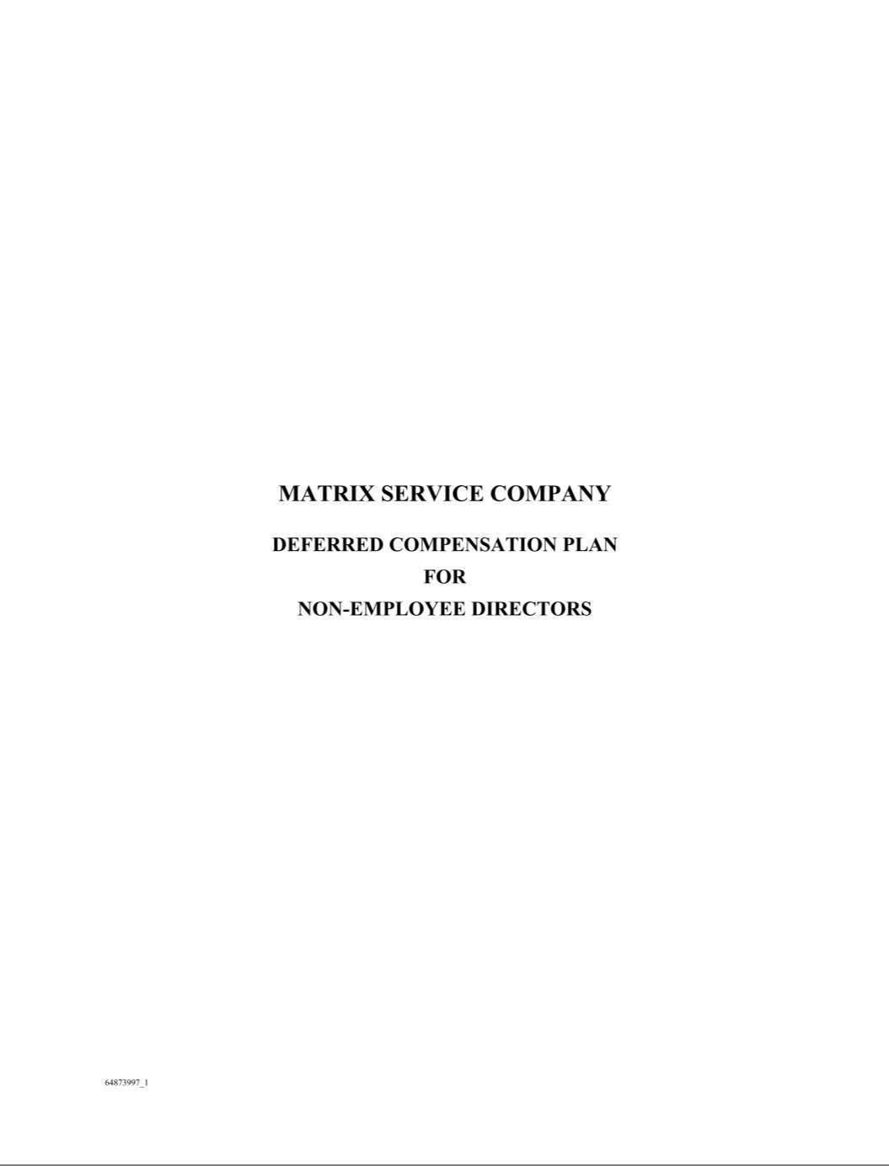

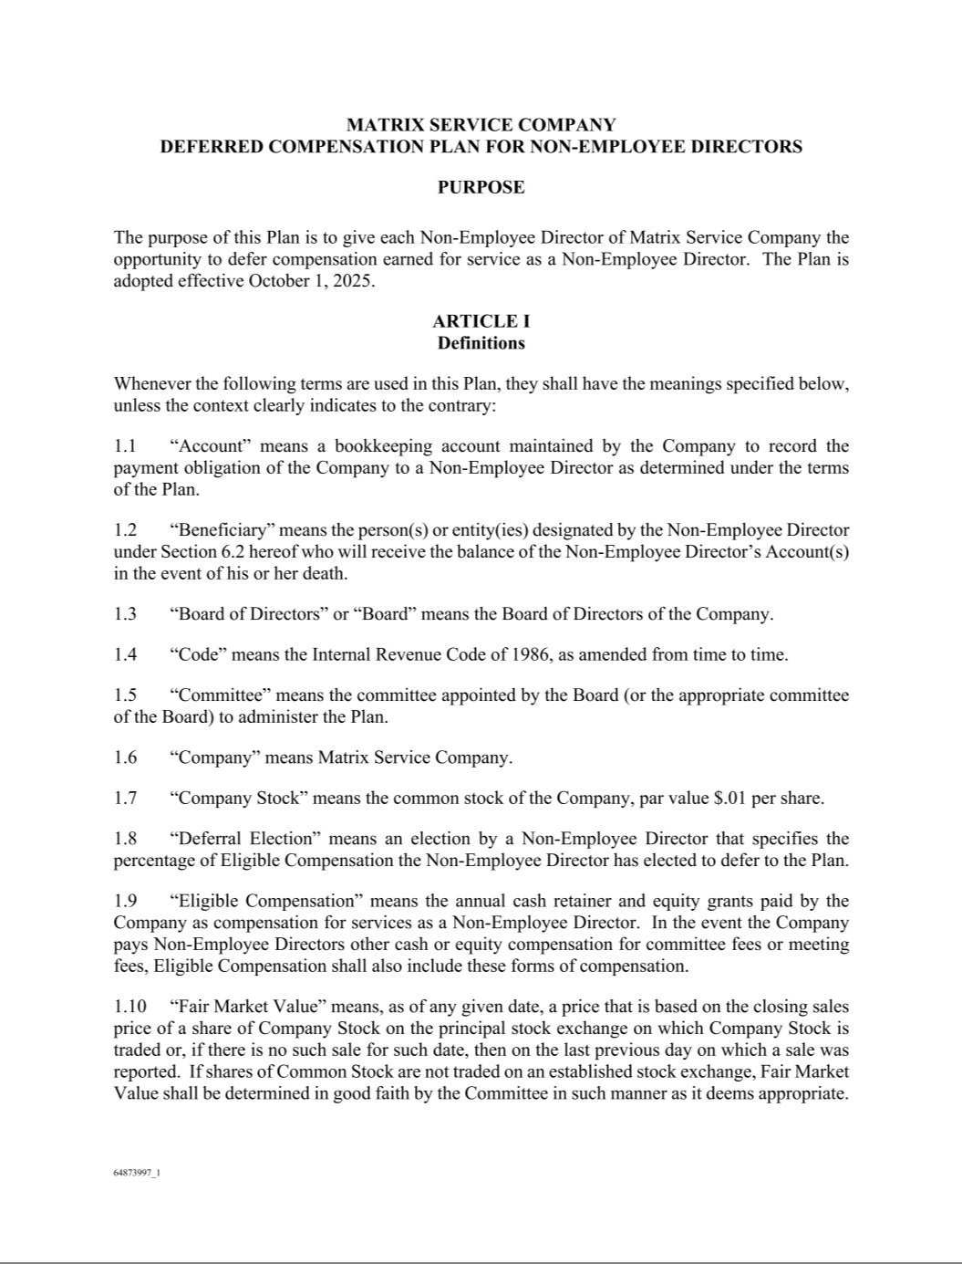

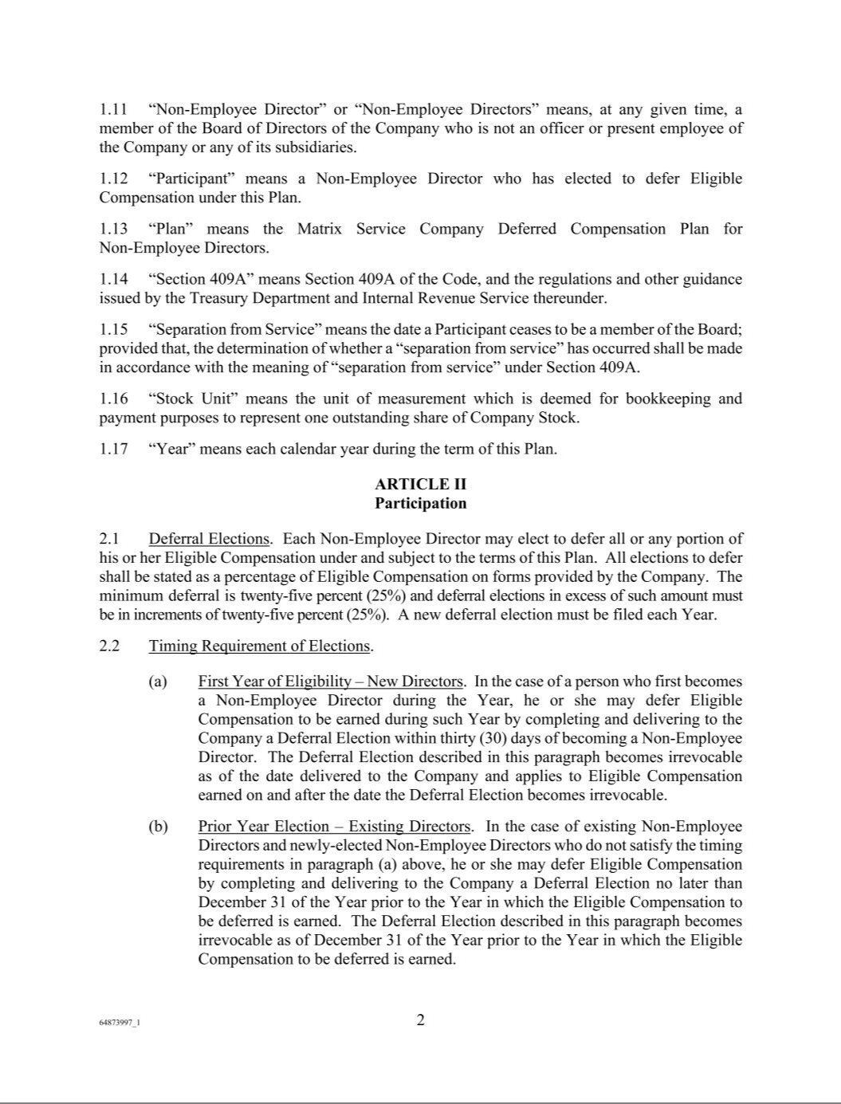

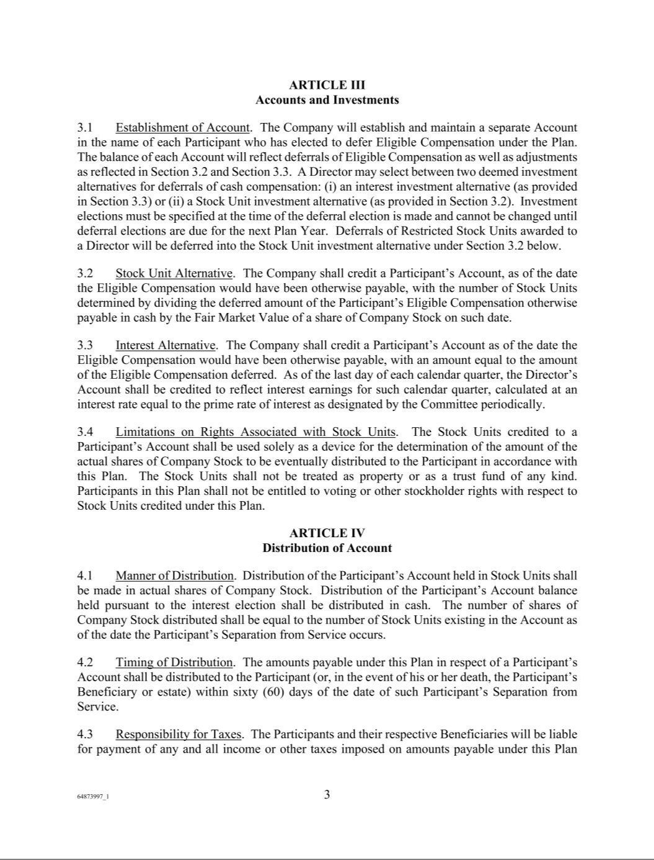

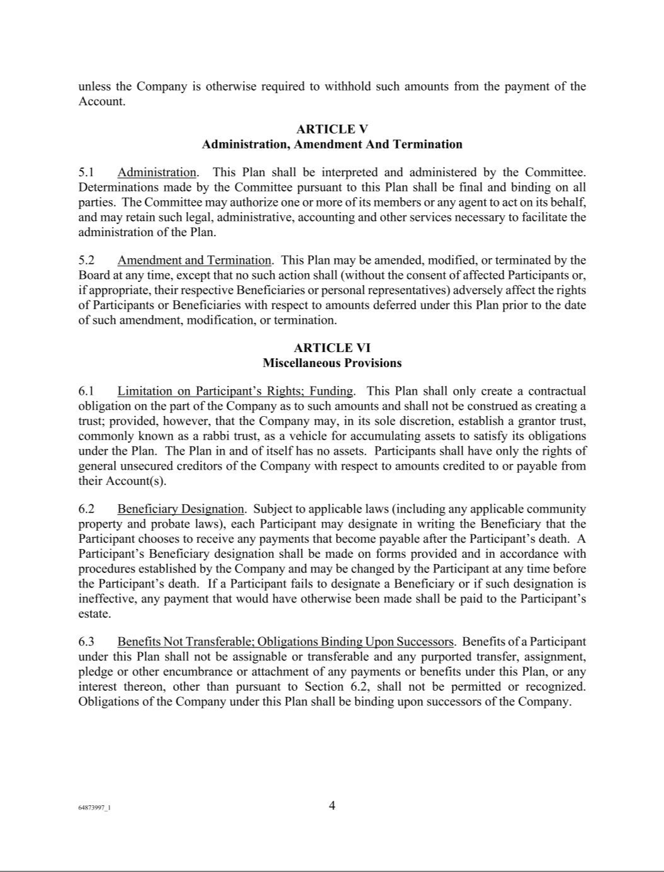

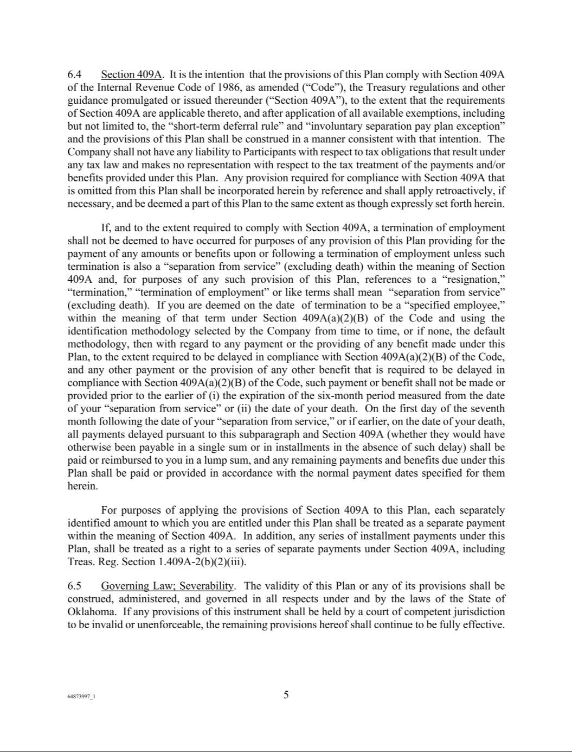

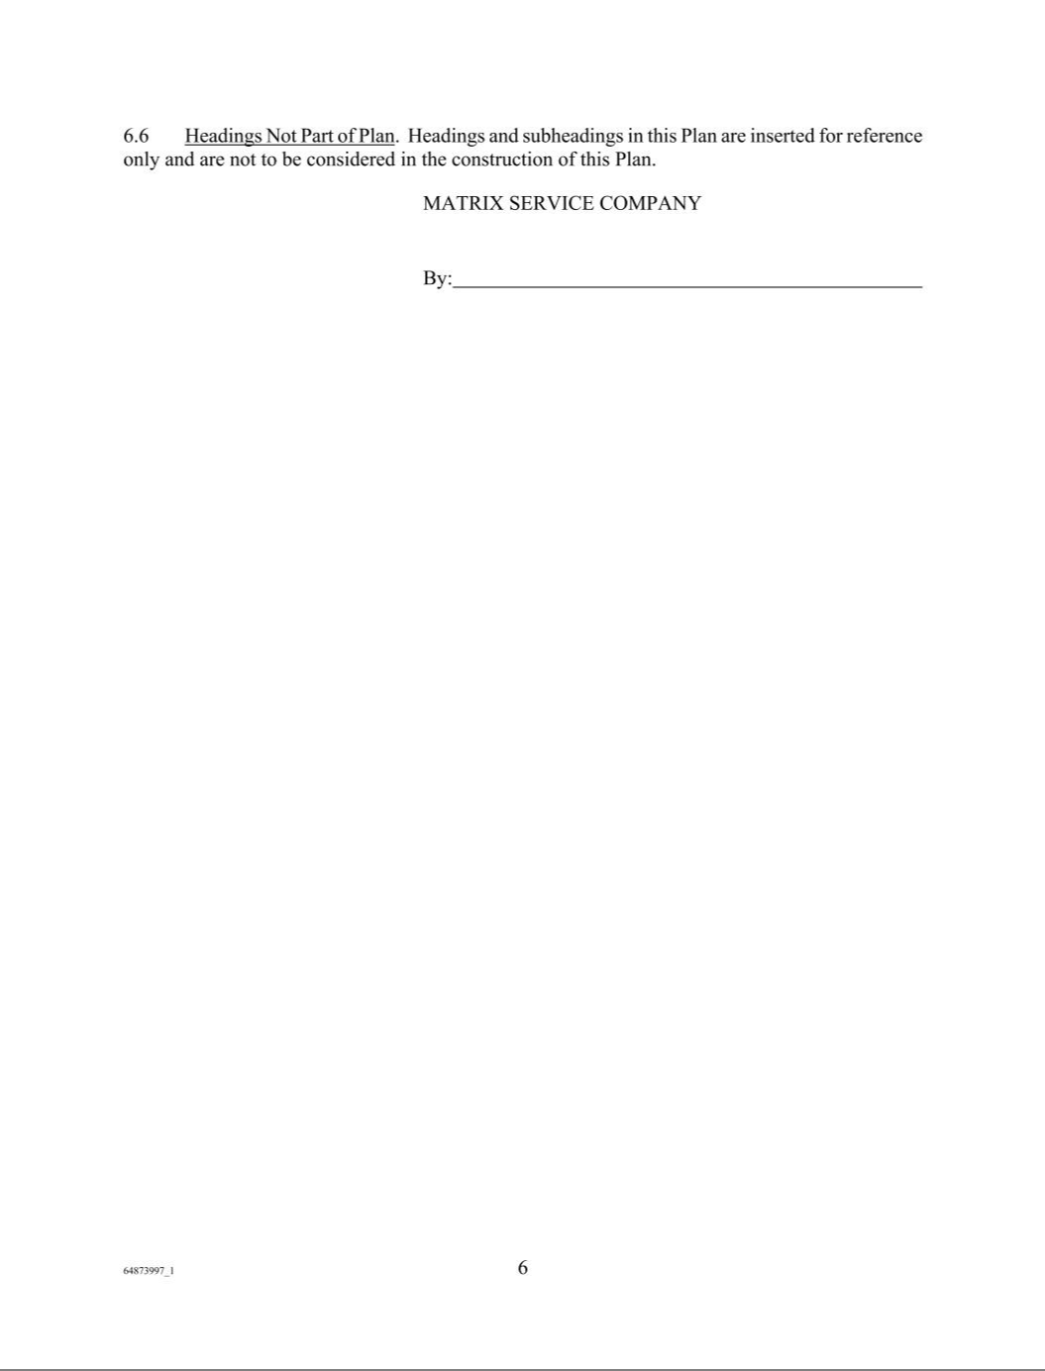

Exhibit 31.1

CERTIFICATIONS

I, John R. Hewitt, certify that:

- I have reviewed this quarterly Report on Form 10-Q of Matrix Service Company;

- Based on my knowledge, this report does not contain any untrue statement of a material fact or omit to state a material fact necessary to make the statements made, in light of the circumstances under which such statements were made, not misleading with respect to the period covered by this report;

- Based on my knowledge, the financial statements, and other financial information included in this report, fairly present in all material respects the financial condition, results of operations and cash flows of the registrant as of, and for, the periods presented in this report;

- The registrant’s other certifying officer and I are responsible for establishing and maintaining disclosure controls and procedures (as defined in Exchange Act Rules 13a-15(e) and 15d-15(e)) and internal control over financial reporting (as defined in Exchange Act Rules 13a-15(f) and 15d-15(f)) for the registrant and have:

  - Designed such disclosure controls and procedures, or caused such disclosure controls and procedures to be designed under our supervision, to ensure that material information relating to the registrant, including its consolidated subsidiaries, is made known to us by others within those entities, particularly during the period in which this report is being prepared;

  - Designed such internal control over financial reporting, or caused such internal control over financial reporting to be designed under our supervision, to provide reasonable assurance regarding the reliability of financial reporting and the preparation of financial statements for external purposes in accordance with generally accepted accounting principles;

  - Evaluated the effectiveness of the registrant’s disclosure controls and procedures and presented in this report our conclusions about the effectiveness of the disclosure controls and procedures, as of the end of the period covered by this report based on such evaluation; and

  - Disclosed in this report any change in the registrant’s internal control over financial reporting that occurred during the registrant’s most recent fiscal quarter (the registrant’s fourth fiscal quarter in the case of an annual report) that has materially affected, or is reasonably likely to materially affect, the registrant’s internal control over financial reporting; and

- The registrant’s other certifying officer and I have disclosed, based on our most recent evaluation of internal control over financial reporting, to the registrant’s auditors and the audit committee of the registrant’s board of directors (or persons performing the equivalent functions):

  - All significant deficiencies and material weaknesses in the design or operation of internal control over financial reporting which are reasonably likely to adversely affect the registrant’s ability to record, process, summarize and report financial information; and

  - Any fraud, whether or not material, that involves management or other employees who have a significant role in the registrant’s internal control over financial reporting.

Date: November 6, 2025

/s/ John R. Hewitt

John R. Hewitt

President and Chief Executive Officer

Exhibit 31.2

CERTIFICATIONS

I, Kevin S. Cavanah, certify that:

- I have reviewed this quarterly Report on Form 10-Q of Matrix Service Company;

- Based on my knowledge, this report does not contain any untrue statement of a material fact or omit to state a material fact necessary to make the statements made, in light of the circumstances under which such statements were made, not misleading with respect to the period covered by this report;

- Based on my knowledge, the financial statements, and other financial information included in this report, fairly present in all material respects the financial condition, results of operations and cash flows of the registrant as of, and for, the periods presented in this report;

- The registrant’s other certifying officer and I are responsible for establishing and maintaining disclosure controls and procedures (as defined in Exchange Act Rules 13a-15(e) and 15d-15(e)) and internal control over financial reporting (as defined in Exchange Act Rules 13a-15(f) and 15d-15(f)) for the registrant and have:

  - Designed such disclosure controls and procedures, or caused such disclosure controls and procedures to be designed under our supervision, to ensure that material information relating to the registrant, including its consolidated subsidiaries, is made known to us by others within those entities, particularly during the period in which this report is being prepared;

  - Designed such internal control over financial reporting, or caused such internal control over financial reporting to be designed under our supervision, to provide reasonable assurance regarding the reliability of financial reporting and the preparation of financial statements for external purposes in accordance with generally accepted accounting principles;

  - Evaluated the effectiveness of the registrant’s disclosure controls and procedures and presented in this report our conclusions about the effectiveness of the disclosure controls and procedures, as of the end of the period covered by this report based on such evaluation; and

  - Disclosed in this report any change in the registrant’s internal control over financial reporting that occurred during the registrant’s most recent fiscal quarter (the registrant’s fourth fiscal quarter in the case of an annual report) that has materially affected, or is reasonably likely to materially affect, the registrant’s internal control over financial reporting; and

- The registrant’s other certifying officer and I have disclosed, based on our most recent evaluation of internal control over financial reporting, to the registrant’s auditors and the audit committee of the registrant’s board of directors (or persons performing the equivalent functions):

  - All significant deficiencies and material weaknesses in the design or operation of internal control over financial reporting which are reasonably likely to adversely affect the registrant’s ability to record, process, summarize and report financial information; and

  - Any fraud, whether or not material, that involves management or other employees who have a significant role in the registrant’s internal control over financial reporting.

Date: November 6, 2025

/s/ Kevin S. Cavanah

Kevin S. Cavanah

Vice President and Chief Financial Officer

EXHIBIT 32.1

Certification Pursuant to 18 U.S.C. Section 1350,

As Adopted Pursuant

Section 906 of Sarbanes-Oxley Act of 2002

In connection with the Quarterly Report of Matrix Service Company (the “Company”) on Form 10-Q for the period ending September 30, 2025 as filed with the Securities and Exchange Commission on the date hereof (the “Report”), I, John R. Hewitt, President and Chief Executive Officer of the Company, certify, pursuant to 18 U.S.C. ss. 1350, as adopted pursuant to ss. 906 of the Sarbanes-Oxley Act of 2002, that based on my knowledge:

- The Report fully complies with the requirements of section 13(a) or 15(d) of the Securities Exchange Act of 1934 as amended; and

- The information contained in the Report fairly presents, in all material respects, the financial condition and results of operations of the Company.

Date: November 6, 2025

/s/ John R. Hewitt

John R. Hewitt

President and Chief Executive Officer

EXHIBIT 32.2

Certification Pursuant to 18 U.S.C. Section 1350,

As Adopted Pursuant

Section 906 of Sarbanes-Oxley Act of 2002

In connection with the Quarterly Report of Matrix Service Company (the “Company”) on Form 10-Q for the period ending September 30, 2025 as filed with the Securities and Exchange Commission on the date hereof (the “Report”), I, Kevin S. Cavanah, Vice President and Chief Financial Officer of the Company, certify, pursuant to 18 U.S.C. ss. 1350, as adopted pursuant to ss. 906 of the Sarbanes-Oxley Act of 2002, that based on my knowledge:

- The Report fully complies with the requirements of section 13(a) or 15(d) of the Securities Exchange Act of 1934 as amended; and

- The information contained in the Report fairly presents, in all material respects, the financial condition and results of operations of the Company.

Date: November 6, 2025

/s/ Kevin S. Cavanah

Kevin S. Cavanah

Vice President and Chief Financial Officer

Exhibit 95

Section 1503(a) of the Dodd-Frank Wall Street Reform and Consumer Protection Act (the "Dodd-Frank Act") requires domestic mine operators to disclose violations and orders issued under the Federal Mine Safety and Health Act of 1977 (the "Mine Act") by the federal Mine Safety and Health Administration ("MSHA"). We do not act as the owner of any mines, but as a result of our performing services or construction at mine sites as an independent contractor, we are considered an "operator" within the meaning of the Mine Act. The mine data retrieval system maintained by MSHA may show information that is different than what is provided herein. Any such difference may be attributed to the need to update that information on MSHA’s system and/or other factors.

The following table provides information for the three months ended September 30, 2025:

 |  |  |  |  |  |  |  |  | Received Notice of
 |  |  | Section 104(d) |  |  |  |  | Received Notice of | Potential to Have | Total Number of | Total Number of
 |  |  | Section 104(d) |  |  |  |  | Pattern of Violations | Pattern of Violations | Total Number of | Total Number of
Mine or Operating |  |  | Section 104(d) |  |  | Total Dollar Value of | Total Number of | Pattern of Violations | Pattern of Violations | Legal Actions | Legal Actions | Total Number of Legal
Mine or Operating | Section 104 S&S | Section 104(b) | Citations and | Section 110(b)(2) | Section 107(a) | Total Dollar Value of | Total Number of | Under Section 104(e) | Under Section 104(e)⁽⁷⁾ | Legal Actions | Legal Actions | Total Number of Legal
Name/MSHA |  |  |  |  |  | MSHA Assessments | Mining Related | Under Section 104(e) | Under Section 104(e)⁽⁷⁾ | Pending as of Last | Initiated During | Actions Resolved
Identification Number | Citations⁽¹⁾ | Orders⁽²⁾ | Orders⁽³⁾ | Violations⁽⁴⁾ | Orders⁽⁵⁾ | Proposed ($) | Fatalities | ⁽⁶⁾ (yes/no) | (yes/no) | Day of Period | Period | During Period
None | — | — | — | — | — | — | — | N/A | N/A | — | — | —

  - The total number of citations issued under section 104 of the Mine Act for violations of mandatory health or safety standards that could significantly and substantially contribute to a serious injury if left unabated.

  - The total number of orders issued under section 104(b) of the Mine Act, which represents a failure to abate a citation under section 104(a) within the period of time prescribed by MSHA.

  - The total number of citations and orders issued by MSHA under section 104(d) of the Mine Act for unwarrantable failure to comply with mandatory health or safety standards.

- The total number of flagrant violations identified under section 110(b)(2) of the Mine Act.

- The total number of orders issued under section 107(a) of the Mine Act for situations in which MSHA determined an imminent danger existed.

- A written notice from the MSHA regarding a pattern of violations under section 104(e) of the Mine Act.

- A written notice from the MSHA regarding a potential to have a pattern of violations under section 104(e) of the Mine Act.

