TABLE OF CONTENTS
UNITED STATES
SECURITIES AND EXCHANGE COMMISSION
WASHINGTON, D.C. 20549
SCHEDULE 14A
Proxy Statement Pursuant to Section 14(a) of the
Securities Exchange Act of 1934
Filed by the Registrant ☒ Filed by a Party other than the Registrant ☐
Check the appropriate box:
☐ |  |  | Preliminary Proxy Statement
☐ |  |  | Confidential, For Use of the Commission Only (as permitted by Rule 14a-(e)(2))
☒ |  |  | Definitive Proxy Statement
☐ |  |  | Definitive Additional Materials
☐ |  |  | Soliciting Material Under §240.14a-12
Matrix Service Company
(Name of Registrant as Specified in Its Charter)
(Name of Person(s) Filing Proxy Statement, if Other Than the Registrant)
Payment of Filing Fee (Check the appropriate box):
☒ |  |  | No fee required.
☐ |  |  | Fee paid previously with preliminary materials.
☐ |  |  | Fee computed on table in exhibit required by Item 25(b) per Exchange Act Rules 14a-6(i)(1) and 0-11.

TABLE OF CONTENTS


TABLE OF CONTENTS


TABLE OF CONTENTS
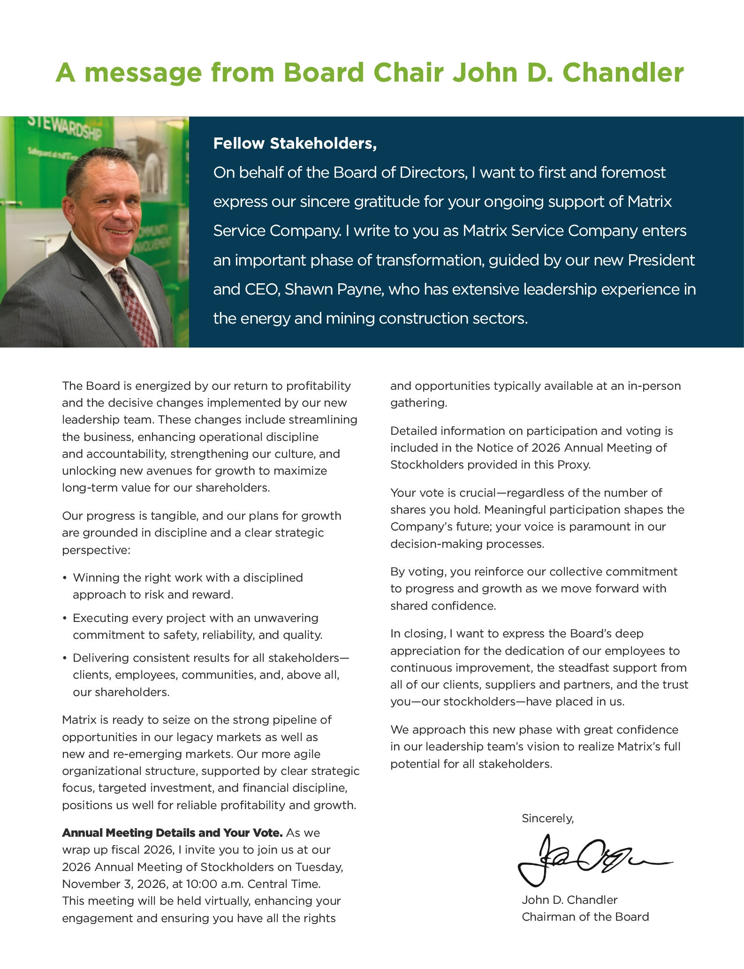

TABLE OF CONTENTS
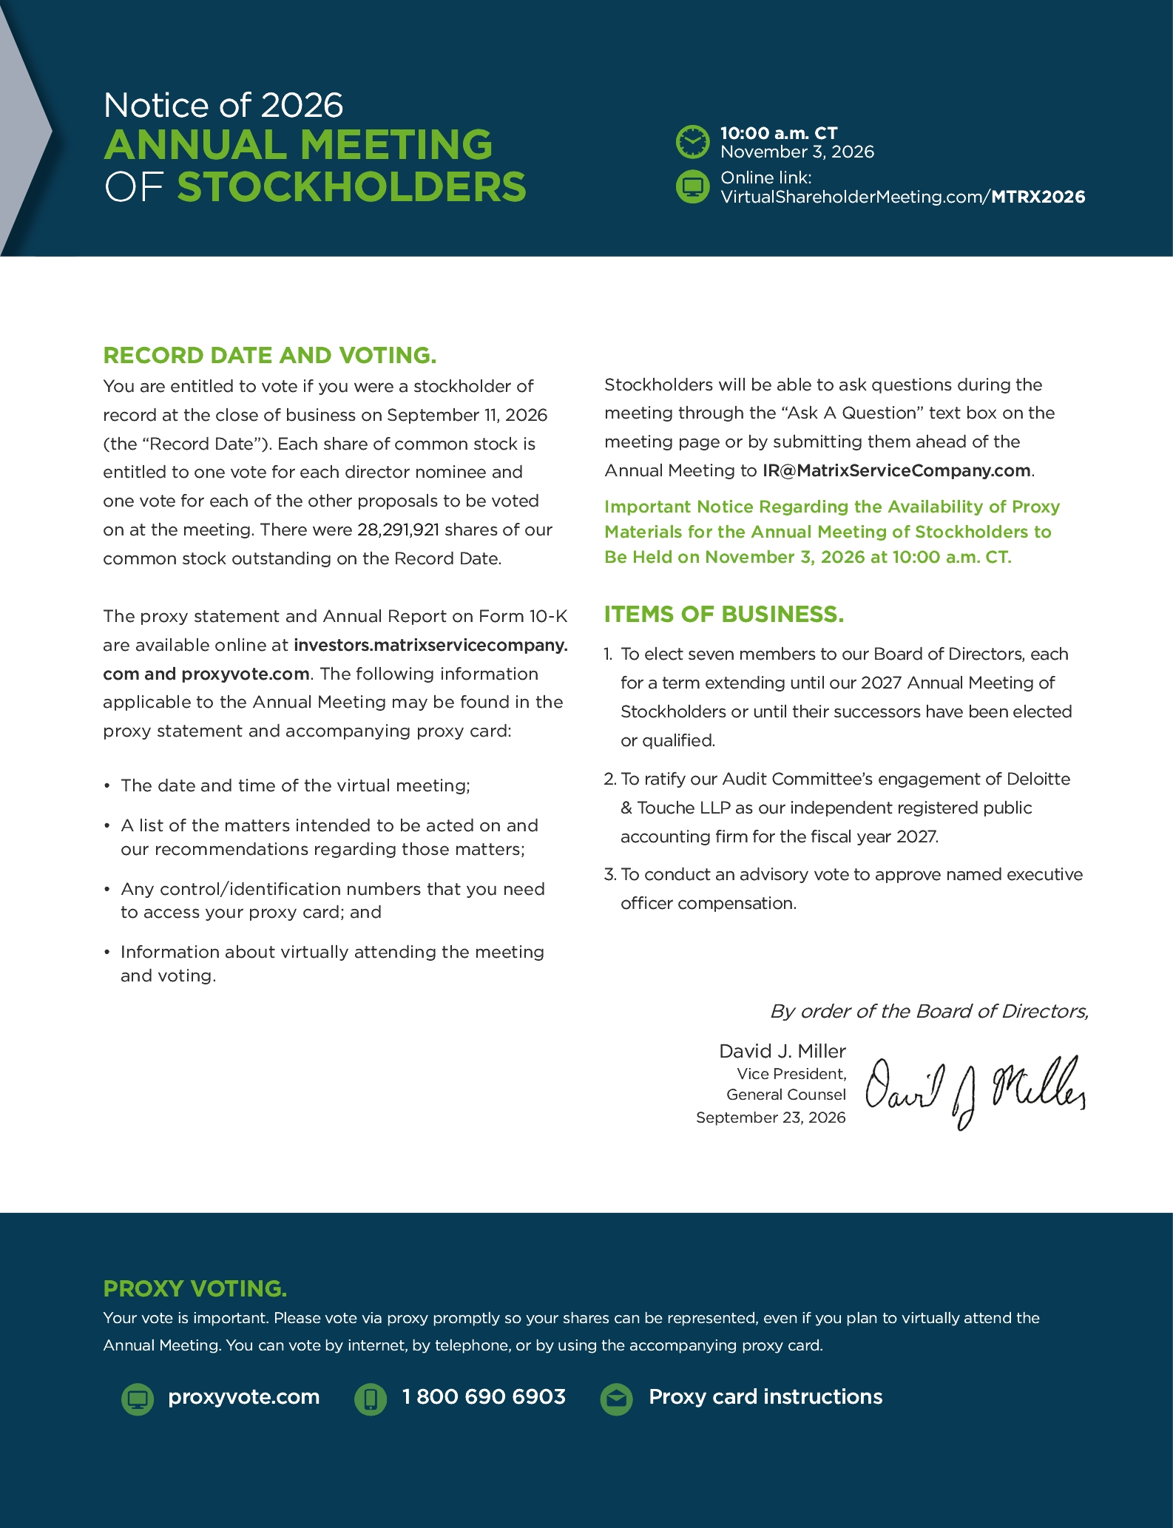

TABLE OF CONTENTS
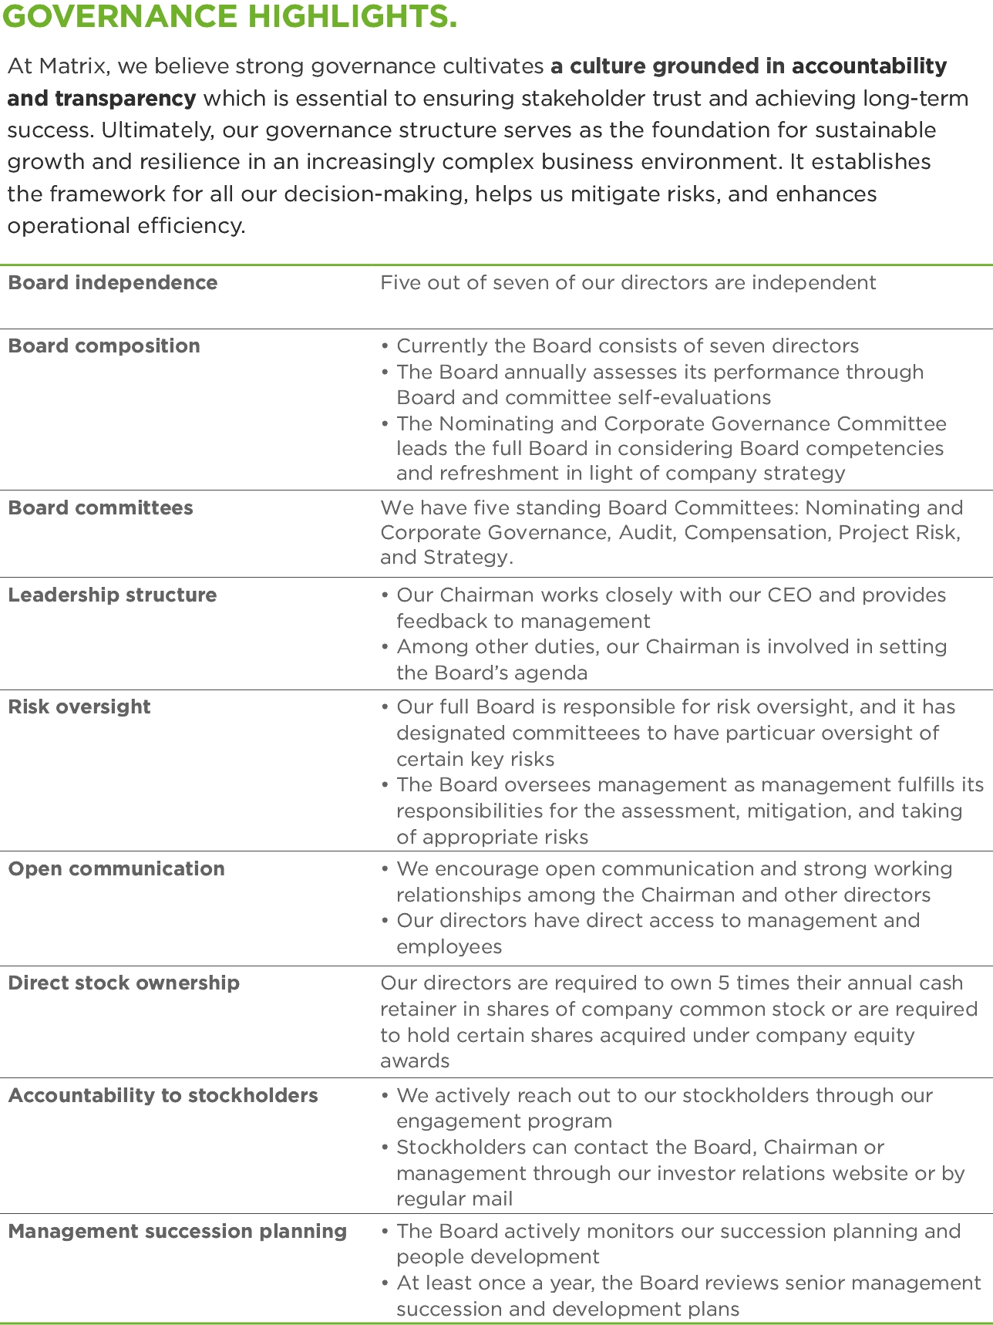

TABLE OF CONTENTS
MATRIX SERVICE COMPANY
15333 JFK Blvd., Ste. 400
Houston, TX 77032
PROXY STATEMENT - TABLE OF CONTENTS

 |  |  |  | Page
 | Solicitation and Revocation of Proxies |  |  | 1
 | Stockholders Entitled to Vote |  |  | 3
 | Proposal Number 1: Election of Directors |  |  | 4
 | Director Nominee Profiles |  |  | 5
 | Corporate Governance and Board Matters |  |  | 11
 | Director Independence Guidelines |  |  | 11
 | Board Leadership Structure and Role in Risk Oversight |  |  | 11
 | Meetings and Committees of the Board |  |  | 12
 | Director Nomination Process |  |  | 15
 | Executive Sessions |  |  | 15
 | Stockholder Engagement and Communication |  |  | 15
 | Equity Ownership Guidelines for Non-Employee Directors |  |  | 16
 | Director Compensation |  |  | 17
 | General |  |  | 17
 | Fiscal 2026 Director Compensation |  |  | 18
 | Audit Committee Matters |  |  | 19
 | Report of the Audit Committee of the Board |  |  | 19
 | Proposal Number 2: Ratification of Selection of Independent Registered Public Accounting Firm |  |  | 20
 | Fees of Independent Registered Public Accounting Firm |  |  | 20
 | Audit Committee Pre-Approval Policy |  |  | 20
 | Executive Officer Information |  |  | 21
 | Executive Officer Biographies |  |  | 21
 | Compensation Discussion and Analysis |  |  | 22
 | Executive Summary |  |  | 22
 | Compensation Philosophy and Objectives |  |  | 24
 | Committee Consideration of the 2025 Stockholder Vote on Executive Compensation |  |  | 25
 | Key Elements of Executive Compensation |  |  | 25
 | Clawback Policy |  |  | 31
 | Insider Trading Policy |  |  | 32
 | Policy on Hedging and Pledging of Company Securities |  |  | 32
 | Equity Grant Practices |  |  | 32
 | Compensation Program as it Relates to Risk |  |  | 33
 | Equity Ownership Guidelines |  |  | 33
 | Report of the Compensation Committee of the Board |  |  | 34
 | Executive Officer Compensation |  |  | 35
 | Summary Compensation Table |  |  | 35
 | Grants of Plan-Based Awards During Fiscal 2026 |  |  | 37
 | Outstanding Equity Awards at Fiscal Year-End for 2026 |  |  | 39
 | Options Exercised and Stock Vested During Fiscal 2026 |  |  | 41
 | Potential Payments Upon Termination or Change of Control |  |  | 42
 | Executive Separation |  |  | 44
 | CEO Pay Ratio |  |  | 45
 | Pay Versus Performance |  |  | 47
 | Proposal Number 3: Advisory Vote to Approve Named Executive Officer Compensation |  |  | 52
 | Certain Relationships and Related Transactions |  |  | 53
 | Transactions with Related Persons |  |  | 53
 | Review, Approval or Ratification of Transactions with Related Persons |  |  | 53
 | Security Ownership of Certain Beneficial Owners and Management |  |  | 54
 | Securities Authorized for Issuance Under Equity Compensation Plans |  |  | 55
i

TABLE OF CONTENTS
 |  |  |  | Page
 | Proposals of Stockholders |  |  | 55
 | Other Matters |  |  | 56
 | Matters That May Come Before the Annual Meeting |  |  | 56
 | Availability of Form 10-K |  |  | 56
 | Householding of Proxy Materials |  |  | 56
 | Forward-Looking Statements |  |  | 56
 | Important Notice Regarding the Availability of Proxy Materials for the Stockholders Meeting to be Held on November 3, 2026 |  |  | 57
ii

TABLE OF CONTENTS
MATRIX SERVICE COMPANY
PROXY STATEMENT FOR ANNUAL MEETING OF STOCKHOLDERS
To Be Held on November 3, 2026
This proxy statement, along with a proxy card and our 2026 Annual Report, is first being sent or made available to our stockholders on or about September 23, 2026
SOLICITATION AND REVOCATION OF PROXIES
The Board of Directors (the “Board”) of Matrix Service Company (“Matrix”, the “Company”, “we”, “our” or “us”) solicits your proxy for use at the 2026 Annual Meeting of Stockholders (the “Annual Meeting”) and any adjournment thereof. This year's Annual Meeting will be a virtual meeting conducted solely online via live webcast and can be attended by visiting www.virtualshareholdermeeting.com/MTRX2026. This proxy statement and accompanying proxy card were first sent or made available on or about September 23, 2026. Stockholders of record on September 11, 2026 (the “Record Date”) will be entitled to vote at the Annual Meeting, which will begin promptly at 10:00 a.m. (CT) on November 3, 2026. We encourage you to access the Annual Meeting webcast 15 minutes prior to the start time to provide ample time for check-in and to ensure that you can hear audio prior to the Annual Meeting. If you encounter any difficulties accessing the Annual Meeting, please call the technical support number that will be posted on the virtual annual meeting page for assistance. Technical support will be available 15 minutes prior to the start of the Annual Meeting.
To the extent you ask questions during the Annual Meeting, they must be confined to matters properly before the Annual Meeting and of general concern regarding the Company. If there are questions pertinent to matters properly before the Annual Meeting that cannot be answered during the meeting due to time constraints, we will post answers to a representative set of such questions at the “Investors” section of the Company's website at matrixservicecompany.com. The questions and answers will be available as soon as practicable after the Annual Meeting and will remain available until we file our proxy statement for the 2027 Annual Meeting of Stockholders.
If you properly execute and return the accompanying proxy card or vote your proxy by Internet or telephone, your shares will be voted in accordance with your directions. If your proxy is executed and returned with no directions, those shares will be voted FOR each of the Board's nominees in respect to Proposal 1 and FOR Proposals 2 and 3. In addition, the proxy confers authority on the persons named on the proxy card to vote, at their discretion, on any other matters properly presented at the Annual Meeting. The Board is not currently aware of any other such matters. You may revoke your proxy at any time before it is voted by executing a subsequent proxy and sending it to David J. Miller, Corporate Secretary, Matrix Service Company, 15333 JFK Blvd., Ste. 400, Houston, TX 77032, or by a later dated vote by Internet or by telephone. You may also revoke your proxy by attending and voting at the Annual Meeting. Virtual attendance at the meeting will not itself constitute revocation of a proxy.
We are making our proxy materials available by Internet to expedite your receipt of these materials, reduce the cost of printing and distributing the proxy materials and lower the cost and environmental impact of our Annual Meeting. Beginning on September 23, 2026, we mailed or e-mailed you a “Notice of Internet Availability of Proxy Materials” (“E-Proxy Notice”) with instructions on how to access our proxy materials over the Internet (or, at your preference, on how to request paper copies of the materials) and how to vote. If you received a notice and would prefer to receive paper copies of the proxy materials, please follow the instructions included in the E-Proxy Notice.
HOW TO VOTE
You can vote in any of the following ways:
• | Internet. Vote on the Internet at www.proxyvote.com by following the online instructions. If you have Internet access, we encourage you to record your vote on the Internet. The deadline for voting through the Internet is 11:59 p.m. Eastern Time on November 2, 2026.
• | Telephone. Vote by telephone by calling 1-800-690-6903 and following the instructions provided by the recorded message. The deadline for voting by telephone is 11:59 p.m. Eastern Time on November 2, 2026.
1

TABLE OF CONTENTS
• | Mail. If you requested a paper copy of the proxy materials, you may vote by completing, signing, and dating the proxy card and returning it in the enclosed, postage-paid envelope. The deadline for receipt by mail is 11:59 p.m. Eastern Time on November 2, 2026.
• | Meeting. You may attend and vote at the virtual Annual Meeting by:
• | Accessing www.virtualshareholdermeeting.com/MTRX2026;
• | If you are a registered stockholder, have your 16-digit control number located on your E-Proxy Notice or your proxy card (if you received a printed copy of the proxy materials) available; and
• | If you hold your shares in “street name”, have your 16-digit control number provided to you by your bank or broker available. If you hold your shares in “street name” and do not have your 16-digit control number, please contact your bank or broker prior to the Annual Meeting.
To vote prior to the Annual Meeting if you hold your shares in “street name”, follow the instructions of your bank or broker.
We will bear the cost of this solicitation of proxies. In addition to solicitations by mail, our directors, officers and employees may solicit proxies from stockholders by telephone, electronically or by other means but will receive no additional compensation for such solicitation. We will cause banks and brokerage firms and other custodians, nominees and fiduciaries to forward solicitation materials to the beneficial owners of our common stock they hold of record. We will reimburse all such reasonable out-of-pocket forwarding expenses.
2

TABLE OF CONTENTS
STOCKHOLDERS ENTITLED TO VOTE
At the close of business on the Record Date, there were 28,291,921 shares of our common stock, par value $0.01 per share, outstanding. Each outstanding share of our common stock is entitled to one vote upon each of the matters to be voted on at the Annual Meeting. The presence, in person or by proxy, of at least a majority of the outstanding shares of common stock as of the Record Date is required for a quorum for the transaction of business.
If you hold your shares through an account with a bank or broker, you must instruct the broker how to vote your shares. If you do not provide voting instructions, your shares will not be voted on any proposal on which your broker does not have discretionary authority. This is called a “broker non-vote”.
Abstentions and broker non-votes will be counted for purposes of determining whether a quorum has been reached. Votes will be tabulated by an inspector of election appointed by the Board. Abstentions may be specified on all proposals. The following vote is needed in order for the various proposals to be adopted:
Proposal 1 - Election of Directors: The affirmative vote of a majority of the votes cast at the meeting is required for the election of directors. This means that the number of votes cast for a director nominee must exceed the number of votes cast against that nominee in order to elect that nominee in an uncontested election. With respect to the election of directors, you may vote for or against each nominee, or you may abstain from voting for one or more nominees. If you do not instruct your broker how to vote with respect to this item, your broker is not permitted to vote your shares with respect to the election of directors. Abstentions and broker non-votes do not count as votes for or against the nominee's election.
Proposal 2 - Ratification of Independent Registered Public Accounting Firm: The ratification of the appointment of Deloitte & Touche LLP as our independent registered public accounting firm for fiscal 2027 requires the affirmative vote of holders of a majority of the issued and outstanding shares of common stock present in person or represented by proxy and entitled to vote on the matter. If you do not instruct your broker how to vote with respect to this item, your broker is permitted to vote your shares in its discretion with respect to this proposal. Abstentions will have the effect of a vote against the proposal.
Proposal 3 - Advisory Vote on Executive Compensation: The approval, on an advisory basis, of the compensation paid to our named executive officers named in this proxy statement requires the affirmative vote of holders of a majority of the issued and outstanding shares of common stock present in person or represented by proxy and entitled to vote on the matter. If you do not instruct your broker how to vote with respect to this item, your broker may not vote your shares with respect to this proposal. Abstentions will have the effect of a vote against the proposal. Broker non-votes will have no effect on the vote.
3

TABLE OF CONTENTS
PROPOSAL NUMBER 1:
Election of Directors
Our organizational documents provide that the number of directors on the Board be fixed from time to time by the Board but shall not be less than three nor more than 15 persons. Effective June 30, 2026, our former President and Chief Executive Officer, John R. Hewitt, separated from the Company and was no longer a director. Effective July 1, 2026, the Board elected Shawn P. Payne, our current President and Chief Executive Officer, as a director, keeping the Board size at seven members. Directors hold office until the next annual meeting of stockholders or until their successors have been elected and qualified.
In accordance with the recommendation of the Nominating and Corporate Governance Committee, the Board has unanimously nominated the seven nominees identified below. The Board recommends that you vote “For” the election of its seven nominees. Proxies solicited by the Board will be voted “For” all seven nominees unless stockholders specify otherwise in their proxies.
If, at the time of the Annual Meeting, any nominee is unavailable, the discretionary authority provided in the proxies solicited by the Board may be used to vote for a substitute or substitutes who may be recommended by the Nominating and Corporate Governance Committee and whom the Board may propose to replace such nominee. The Board has no reason to believe that any substitute nominee will be required.
Each of our directors possesses a combination of attributes that the Board believes qualifies him or her for service on the Board. The directors were specifically recruited for these attributes, which include business experience specifically related to the industries in which we operate, knowledge derived from specialized education or training such as accounting, legal and finance, and senior executive management experience that demonstrates leadership qualities and a practical understanding of organizations, processes, business strategies, risk management and how to drive change and growth. We believe that the qualifications, skills and experiences of the directors, individually and collectively, have resulted in the Board being highly effective. The specific skills for each director are listed below:
Board of Directors - Strategic Experience
 |  |  |  | Jose L.  Bustamante |  |  | Martha Z.  Carnes |  |  | John D.  Chandler |  |  | Carlin G.  Conner |  |  | Liane K.  Hinrichs |  |  | James H.  Miller |  |  | Shawn P.  Payne
 | Public Company Board Experience |  |  | ✔ |  |  | ✔ |  |  | ✔ |  |  | ✔ |  |  | ✔ |  |  | ✔ |  |  | ✔
 | Strategic Leadership |  |  | ✔ |  |  | ✔ |  |  | ✔ |  |  | ✔ |  |  | ✔ |  |  | ✔ |  |  | ✔
 | Financial Expertise/Literacy |  |  | ✔ |  |  | ✔ |  |  | ✔ |  |  | ✔ |  |  | ✔ |  |  | ✔ |  |  | ✔
 | Industry Experience |  |  | ✔ |  |  | ✔ |  |  | ✔ |  |  | ✔ |  |  | ✔ |  |  | ✔ |  |  | ✔
 | Risk Management Oversight |  |  | ✔ |  |  | ✔ |  |  | ✔ |  |  | ✔ |  |  | ✔ |  |  | ✔ |  |  | ✔
 | Health, Safety and Environmental |  |  | ✔ |  |  |  |  |  |  |  |  | ✔ |  |  | ✔ |  |  | ✔ |  |  | ✔
 | Executive Compensation/Human Resources |  |  | ✔ |  |  | ✔ |  |  | ✔ |  |  | ✔ |  |  | ✔ |  |  | ✔ |  |  | ✔
 | International Business |  |  | ✔ |  |  | ✔ |  |  |  |  |  | ✔ |  |  | ✔ |  |  | ✔ |  |  | ✔
 | Mergers and Acquisitions |  |  | ✔ |  |  | ✔ |  |  | ✔ |  |  | ✔ |  |  | ✔ |  |  | ✔ |  |  | ✔
 | Information Technology |  |  | ✔ |  |  | ✔ |  |  |  |  |  |  |  |  |  |  |  | ✔
4

TABLE OF CONTENTS
Director Nominee Profiles
Jose L. Bustamante
  Age: 62  Director Since:  June 2022  Committees:  ● Audit  ● Compensation  ● Nominating and  Corporate  Governance  ● Project Risk | Mr. Bustamante served as an Executive Vice President of Business Development & Strategy at Fluor Corporation (“Fluor”) from February 2015 to May 2020. Before that, Mr. Bustamante served as Senior Vice President of Business Development, Marketing and Strategic Planning - Energy & Chemicals Business at Fluor from 2013 until June 2015. From 2009 to 2013, he served as Head of Middle East Operations in Abu Dhabi at Fluor and led Business Development for Europe, Africa and Middle East Regions. He joined Fluor in 1990 and served Fluor in a number of executive assignments and international locations, including Spain, the United Kingdom, the United States of America, Puerto Rico, Chile, Brazil, Nigeria and the United Arab Emirates. While working for Fluor, Mr. Bustamante gained more than 30 years of experience in sales and operations in the engineering and construction industry, focused on oil, gas, chemicals, mining, industrial and infrastructure. From August 2023 to August 2024, Mr. Bustamante served as an Expert Consultant for Boston Consulting Group. Prior to that, he served as Country Manager for ESAsolar from January 2021 to May 2022. His previous Board memberships include Fluor Arabia Ltd (FAL) and Fluor Kuwait. Mr. Bustamante received a Bachelor's degree in Economics and Business Studies from C.U.N.E.F., Universidad Complutense, Madrid, Spain; a Master's degree in Business Administration from the University of Houston, Texas and is a graduate of the Thunderbird University International Management Program.  Skills and Qualifications:  Mr. Bustamante's extensive leadership positions of increasing responsibility with a large multi-national industrial EPC contractor led to the conclusion that Mr. Bustamante should serve as a Director. Mr. Bustamante has significant international operational experience and a thorough understanding of the challenges and risks that face industrial construction contractors. Mr. Bustamante is also knowledgeable on business development and strategy for many of the key markets that we serve.
5

TABLE OF CONTENTS
Martha Z. Carnes
  Age: 66  Director Since:  July 2017  Committees:  ● Audit (Chair)  ● Compensation  ● Nominating and  Corporate  Governance | Ms. Carnes retired from PricewaterhouseCoopers LLP (“PwC”) in June 2016, where she had a 34-year career with the firm. She was an assurance partner serving large, publicly traded companies in the energy industry. Ms. Carnes held a number of leadership positions with PwC including the Houston office Managing Partner. She also served as PwC's Energy and Mining leader in the United States where she led the firm's energy and mining assurance, tax, and advisory practices. Ms. Carnes also served as one of PwC's Risk Management Partners and was PwC's United States representative on the firm's Global Communities Board. She also serves on the Board and is the Lead Independent Director and Chair of the Audit Committee of Core Laboratories Inc., a company that provides reservoir description and production enhancement services to the oil and gas industry. In addition, she is a member of the Board of Directors and Chair of the Audit Committee of SunCoke Energy, Inc., whose principal businesses are cokemaking and logistics. Ms. Carnes is also a Member Representative of Ohio Valley Midstream LLC, a member managed limited liability company, and she is a member of the Board of Trustees at Texas Children's Hospital and the Board of the Barbara Bush Houston Literacy Foundation. From September 2017 to June 2019, she was a member of the Board of Directors and served on both the audit and conflicts committees of SunCoke Energy Partners GP LLC, the general partner of SunCoke Energy Partners LP. Ms. Carnes received her B.B.A. in accounting from the University of Texas at Austin and is a certified public accountant.  Skills and Qualifications:  The specific experience, qualifications, attributes or skills that led to the conclusion Ms. Carnes should serve as a Director include her extensive expertise in financial oversight and financial reporting, and her broad accounting knowledge gained from working with and auditing public companies in the energy industry and her operational and leadership experience at PwC. The Board has determined that Ms. Carnes qualifies as a financial expert as defined by the SEC rules adopted pursuant to the Sarbanes-Oxley Act of 2002.
6

TABLE OF CONTENTS
John D. Chandler
  Age: 56  Director Since:  June 2017  Board Chair  Committees:  • Strategy | Mr. Chandler served as Senior Vice President and Chief Financial Officer for The Williams Companies, Inc. (“Williams”) from August 2017 to December 2021. Beginning in January 2022, he served as an advisor to the CFO before retiring from Williams on March 31, 2022. Mr. Chandler served as a director for WPZ GP LLC, the general partner of Williams Partners LP, from September 2017 to August 2018 when Williams Partners LP became a wholly-owned subsidiary of Williams. Currently, Mr. Chandler serves on the board of directors and as chair of the audit committee for LSB Industries, and he also serves on the board of directors and as a member of the audit committee for EOG Resources. Previously, Mr. Chandler served as a director and as chair of the audit committee of USA Compression GP, LLC, the general partner of USA Compression Partners, LP. He also previously served on the board of directors and the audit committee of CONE Midstream GP, LLC, the general partner of CONE Midstream Partners LP, and on the board of directors and audit committee of Green Plains Holdings LLC, the general partner of Green Plains Partners LP. From 2009 until his retirement in March 2014, Mr. Chandler served as Senior Vice President and Chief Financial Officer of Magellan GP, LLC, the general partner of Magellan Midstream Partners, LP. From 2003 until 2009, he served in the same capacities for the general partner of Magellan Midstream Holdings, L.P. From 1999 to 2002, Mr. Chandler was Director of Financial Planning and Analysis and Director of Strategic Development for a subsidiary of Williams. From 1992 to 1999, Mr. Chandler held various accounting and finance positions with MAPCO Inc. Mr. Chandler received his B.S. and B.A. in accounting and finance from the University of Tulsa.  Skills and Qualifications:  The specific experience, qualifications, attributes or skills that led to the conclusion Mr. Chandler should serve as a Director include his long history of service in senior corporate leadership positions, his extensive experience in the energy industry, his extensive financial oversight expertise and his understanding of complex financial matters gained from his experience as a CFO of two large publicly traded companies.
7

TABLE OF CONTENTS
Carlin G. Conner
  Age: 58  Director Since:  August 2020  Committees:  ● Audit  ● Compensation  (Chair)  ● Nominating and  Corporate  Governance  ● Strategy | Since March 2021, Mr. Conner has served as Chief Executive Officer of International Matex Tank Terminals, Inc. (“IMTT”). Previously, from April 2020 to March 2021, Mr. Conner served as senior advisor of Riverstone Holdings. He was president, chief executive officer, and a director of SemGroup Corp. (“SemGroup”), a publicly-traded company engaged in gathering, transportation, storage, distribution, marketing and other midstream services primarily in the U.S. and Canada, from April 2014 until January 2020. He also served as chair of the board of directors, president and chief executive officer of the general partner of Rose Rock Midstream, L.P. (“Rose Rock”), a publicly traded master limited partnership and subsidiary of SemGroup, which owned and operated a diversified portfolio of midstream energy assets, from 2014 until September 2016. From 2000 to 2014, Mr. Conner served in various leadership roles with Oiltanking GmbH and affiliates (“Oiltanking”), a German-based independent worldwide storage provider of crude oil, refined petroleum products and liquid chemicals. During his nearly 14 years with Oiltanking, he focused on international business development, operations and strategy. From 2012 to 2014, Mr. Conner served as global managing director of Oiltanking, and he served as chair of the board of directors of the general partner of Oiltanking Partners, L.P., a publicly traded master limited partnership engaged in independent terminaling, storage and transportation of crude oil, refined petroleum products and liquefied petroleum gas, from 2011 to 2014. From 2012 to 2014, Mr. Conner also served as an executive board member of Marquard & Bahls, AG, the parent company of Oiltanking, where he was instrumental in defining a new strategy for the energy supply, trading, and logistics business across Europe, the Americas, Asia, and Africa. Mr. Conner holds a bachelor's degree in environmental science from McNeese State University.  Skills and Qualifications:  Mr. Conner provides more than 28 years of experience in the midstream industry and executive level experience gained through his services with SemGroup and Oiltanking and their affiliates as described above. He also has substantial board experience related to management and oversight of a publicly-traded master limited partnership. His industry knowledge and board experience allow him to be a valuable contributor to the Board.
8

TABLE OF CONTENTS
Liane K. Hinrichs
  Age: 69  Director Since:  June 2018  Committees:  ● Audit  ● Compensation  ● Nominating and  Corporate  Governance  (Chair)  ● Strategy | Ms. Hinrichs served as a member of the Executive Committee and as Senior Vice President, General Counsel and Corporate Secretary for McDermott International, Inc. from October 2008 until her retirement in August 2017. Previously, she served as McDermott's Vice President, General Counsel and Corporate Secretary from January 2007 to September 2008; Corporate Secretary and Associate General Counsel, Corporate Compliance and Transactions from January 2006 to December 2006; Associate General Counsel, Corporate Compliance and Transactions, and Deputy Corporate Secretary from June 2004 to December 2005; Assistant General Counsel, Corporate Secretary and Transactions from October 2001 to May 2004; and Senior Counsel from May 1999 to September 2001. Prior to joining McDermott in 1999, she was a partner in a New Orleans law firm. Ms. Hinrichs has also served as an independent arbitrator since 2021 and a business consultant since January 2025. Ms. Hinrichs received a Master of Law degree in Securities Regulation from Georgetown University Law Center and a J.D. from Tulane School of Law.  Skills and Qualifications:  Ms. Hinrichs brings a combination of boardroom experience, executive leadership and general counsel credentials in the international engineering and construction industry. Her deep experience and expertise in governance, enterprise risk management, compliance, international issues, operations, financial oversight and strategy ensure advocacy for best practices and contribute to the Board's deliberations on some of today's most critical issues.
James H. Miller
  Age: 71  Director Since:  May 2014  Committees:  ● Project Risk (Chair) | Mr. Miller has served as President and sole director of Kvaerner U.S. with oversight and fiduciary responsibility for all U.S.-based operations since November 2017 and as a consultant for Seajay Consulting L.L.C. since October 2018. From 2020 to 2024, Mr. Miller served as a senior advisor and consultant for Philly Shipyard Inc. From June 2011 to April 2014, Mr. Miller served as Board Chair for Aker Philadelphia Shipyard ASA (re-named Philly Shipyard ASA in 2015) and re-assumed that position from February 2016 to April 2020. From June 2011 to October 2017, Mr. Miller was Executive Vice President - Americas of Kvaerner U.S. From June 2008 to June 2011, Mr. Miller served as Chief Executive Officer & President of Aker Philadelphia Shipyard. Prior to the shipyard, Mr. Miller was President of Aker Solutions Process & Construction Americas and before that was President of Aker Construction, Inc., which was one of the largest union construction companies in North America. He previously served on the Board of Directors of San Juan Construction, a multi-disciplined full-service general contractor. Mr. Miller graduated from the University of Edinboro in Pennsylvania with a Bachelor of Arts degree.  Skills and Qualifications:  Mr. Miller's extensive progressive leadership positions with a large multi-national industrial construction contractor led to the conclusion that Mr. Miller should serve as a Director. Mr. Miller has significant operational experience and a thorough understanding of the challenges and risks that face industrial construction contractors. He is experienced with merger and acquisition activity, partnering with other companies, and the management of large multi-year construction projects. Mr. Miller is also knowledgeable in many of our key markets including power generation and heavy industry projects.
9

TABLE OF CONTENTS
Shawn P. Payne
  Age: 54  Director Since:  July 2026  Committees:  ● Project Risk  ● Strategy (Chair) | Mr. Payne is our new President and CEO. Before his recent promotion to President and CEO on July 1, 2026, he served as Chief Operating Officer from February 2026 to June 2026 and as President, Engineering & Construction from May 2025 to February 2026. Prior to that, Mr. Payne served as President of Matrix Service Inc. from 2022 to 2025, and he served as Senior Vice President of Operations for Matrix Service Inc. from 2019 to 2022. From 2016 to 2019, Mr. Payne served as Vice President of Business Services and then Senior Vice President of Finance and Business Services for Matrix Service Inc. Mr. Payne joined Matrix in 2012 as Division Manager in Tucson, Arizona, leading our entry into the minerals and mining business. Prior to joining Matrix, Mr. Payne held various leadership roles, including Director of Construction Operations for Jacobs Field Services, Vice President of Finance and Treasurer for Aker Solutions Inc. and Chief Financial Officer and Treasurer for Aker Industrial Constructors Inc. Mr. Payne holds a Bachelor of Science in Business Administration, in Finance, from the University of Arizona.  Skills and Qualifications:  As President and CEO, Mr. Payne provides a management representative on the Board with extensive knowledge of day-to-day operations. As a result, he can facilitate the Board’s access to timely and relevant information and its oversight of management’s strategy, planning and performance. In addition, Mr. Payne is an accomplished executive with over 30 years of leadership experience in the industrial engineering and construction industry. His expertise includes operations, finance, project controls, strategic planning and commercial negotiations. Throughout his career, he has successfully led teams responsible for winning and delivering complex projects, enhancing operational performance, driving revenue growth and creating long-term value for customers, shareholders and stakeholders across a variety of industrial markets.
THE BOARD UNANIMOUSLY RECOMMENDS THAT THE STOCKHOLDERS VOTE “FOR” ALL OF THE ABOVE-NAMED NOMINEES FOR ELECTION.
10

TABLE OF CONTENTS
CORPORATE GOVERNANCE AND BOARD MATTERS
The Board is committed to adopting and implementing best-in-class corporate governance practices and believes strongly that effective corporate governance practices are a key component of its efforts to focus the entire organization on generating long-term stockholder value through conscientious, safe and ethical operations.
In furtherance of this commitment, the Board has adopted and implemented Corporate Governance Guidelines and a Code of Business Conduct and Ethics. The Code of Business Conduct and Ethics applies to all of our directors, officers and employees. The Corporate Governance Guidelines and Code of Business Conduct and Ethics are available on the Corporate Governance page included in the “Investor Relations” section of our website at matrixservicecompany.com.
Director Independence Guidelines
The Board is in compliance with the NASDAQ Global Market System (“NASDAQ”) rules, which require the Board to have a majority of independent directors. NASDAQ rules provide that an “independent director” is a director that the Board has determined to have no relationship with us which would interfere with the exercise of his or her independent judgment in carrying out the responsibilities of a director. In addition, the Board has adopted guidelines in accordance with NASDAQ rules that specify criteria by which the independence of our directors will be determined, including strict guidelines for directors and their immediate families with respect to past employment or affiliation with us or our independent registered public accounting firm.
The Board has affirmatively determined that each of Mr. Bustamante, Ms. Carnes, Mr. Chandler, Mr. Conner and Ms. Hinrichs is “independent” under NASDAQ, SEC and Board guidelines. In making such determination, the Board considered Mr. Conner's position as Chief Executive Officer of IMTT. In fiscal 2026, we performed services for IMTT, which provided total revenue of less than $120,000 to us, and Mr. Conner was not involved in negotiating such services. The Board determined Mr. Conner's relationship with IMTT does not impair Mr. Conner's independence. The Board determined Mr. Miller was a non-independent director because his son is our Vice President, General Counsel and Corporate Secretary. Although he is a non-independent director, the Board recognizes the importance of maintaining Mr. Miller on the Board due to his significant operational experience and his thorough understanding of the challenges and risks that face industrial construction contractors. Mr. Hewitt, who served on the board until June 30, 2026, was not independent because of his employment during fiscal 2026 as President and Chief Executive Officer. Mr. Payne is not independent because of his current employment as our President and Chief Executive Officer.
The full text of our director independence guidelines is included in our Corporate Governance Guidelines, which is available on the Corporate Governance page included in the “Investor Relations” section of our website at matrixservicecompany.com.
Board Leadership Structure and Role in Risk Oversight
The Board has no policy mandating the separation of the offices of Board Chair and Chief Executive Officer. However, as the oversight responsibilities of directors continue to increase, we believe it is beneficial to have an independent Board Chair whose sole role is leading the Board. We believe the separation of the Board Chair and Chief Executive Officer roles provides strong leadership for our Board, while positioning our Chief Executive Officer as our leader in the eyes of our customers, employees and other stakeholders.
The Board has five independent members and two non-independent members. A number of our independent Board members have served as members of senior management or as directors of other public companies. Our Audit, Compensation and Nominating and Corporate Governance Committees are comprised solely of independent directors, each with a different independent director serving as chair of the committee. We believe that the number of independent, experienced directors that make up our Board, along with the independent oversight of the Board by the non-executive Board Chair, benefits our Company and our stockholders.
11

TABLE OF CONTENTS
The full Board, its Audit Committee and its Project Risk Committee jointly oversee our risk management processes. The Audit Committee receives regular reports from management regarding our assessment of risks. The Project Risk Committee oversees operational and financial risks associated with significant projects. In addition, the Audit Committee and the full Board focus on our most significant risks and seek to ensure that risks we undertake are consistent with the Board’s tolerance for risk. While the Board oversees our risk management, our management is responsible for day-to-day risk management processes. We believe this division of responsibilities is the most effective approach for addressing the risks that we face.
Our Board, with assistance from our IT Steering Committee, also oversees cybersecurity and the risks associated with it. Our Board receives reports as needed, but no less than biannually, from management on various cybersecurity and IT topics, including trends, data security policies and practices, cybersecurity incidents, current and projected threat assessments, regulatory developments and ongoing efforts to protect, detect and respond to critical threats. Furthermore, we have protocols in place by which certain cybersecurity incidents are reported to our Board as part of their cybersecurity oversight.
Meetings and Committees of the Board
Our Board met 14 times during fiscal 2026. The Board has five standing committees – the Audit Committee, the Compensation Committee, the Nominating and Corporate Governance Committee, the Project Risk Committee and the Strategy Committee. Each of the members of each of the committees, except for the Project Risk Committee and the Strategy Committee, qualifies as an “independent director” under the NASDAQ rules. During fiscal 2026, each director attended a minimum of 75% of the total number of meetings of the Board and of the total number of meetings held by all committees of which he or she was a member during the term of his or her service.
Our Corporate Governance Guidelines provide that each director is expected to attend the annual meetings of stockholders. All of the members of our Board who were on the Board at the time of the 2025 Annual Meeting of Stockholders attended the 2025 Annual Meeting of Stockholders.
Audit Committee
 | Director |  |  | Fiscal 2026 Committee Service
 | Martha Z. Carnes, Chair |  |  | Served all of fiscal 2026
 | Jose L. Bustamante, Member |  |  | Served all of fiscal 2026
 | Carlin G. Conner, Member |  |  | Served all of fiscal 2026
 | Liane K. Hinrichs, Member |  |  | Served all of fiscal 2026
The Audit Committee assists the Board in monitoring the integrity of our financial statements and qualifications and independence of our registered public accounting firm. The Audit Committee also monitors the performance of our internal audit function and the independent registered public accounting firm and our compliance with legal and regulatory requirements. In carrying out these responsibilities, the Audit Committee, among other things, appoints, evaluates and approves the compensation of our independent registered public accounting firm, reviews and approves the scope of the annual audit and the audit fee, pre-approves all auditing services and permitted non-audit services, annually considers the qualifications and independence of the independent registered public accounting firm, oversees the required rotation of the lead audit partner, reviews and approves the annual internal audit plan and the results of internal audits, reviews compliance with certain of our written policies and procedures and the adequacy of our system of internal accounting controls, including controls and procedures with respect to Sustainability and Corporate Responsibility disclosures, prepares the Audit Committee report for inclusion in the annual proxy statement and annually reviews the Audit Committee Charter and the Audit Committee’s performance. The Audit Committee has also established procedures for the receipt, retention and treatment of complaints regarding accounting, internal controls and auditing matters and any confidential, anonymous submissions by our employees or others of concerns regarding accounting, internal controls or auditing matters.
12

TABLE OF CONTENTS
The Audit Committee operates under a written charter. We have made a copy of our Audit Committee Charter available on the Corporate Governance page included in the “Investor Relations” section of our website at matrixservicecompany.com. The Audit Committee reviews its charter annually. The Audit Committee held four meetings during fiscal 2026.
Compensation Committee
 | Director |  |  | Fiscal 2026 Committee Service
 | Carlin G. Conner, Chair |  |  | Served all of fiscal 2026
 | Jose L. Bustamante, Member |  |  | Served all of fiscal 2026
 | Martha Z. Carnes, Member |  |  | Served all of fiscal 2026
 | Liane K. Hinrichs, Member |  |  | Served all of fiscal 2026
The Compensation Committee’s functions include reviewing and approving salary, short-term and long-term incentive awards, and other benefits for our executive officers, and reviewing and recommending to the full board for approval the compensation of non-employee directors. In addition, the Compensation Committee, in conjunction with the Board, reviews our strategic and financial plans to determine their relationship to our compensation program. Additional information describing the Compensation Committee’s processes and procedures for considering and determining executive compensation, including the role of our Chief Executive Officer and consultants in determining or recommending the amount or form of executive compensation, is included in the Compensation Discussion and Analysis. The Compensation Committee also oversees the newly formed Matrix Service Company Health and Welfare Committee, which was established in November 2025 to provide management and administrative oversight of the ERISA-covered health and welfare plans sponsored by Matrix Service Company.
The Compensation Committee operates under a written charter. We have made a copy of our Compensation Committee Charter available on the Corporate Governance page included in the “Investor Relations” section of our website at matrixservicecompany.com. The Compensation Committee reviews its charter annually. The Compensation Committee held seven meetings during fiscal 2026.
The Compensation Committee continued to engage Pay Governance as its independent compensation consultant during fiscal 2026 to advise on all matters related to director and executive compensation. In particular, Pay Governance collected and provided quantitative competitive market data for peer companies and advised in the selection of the peer groups of companies for compensation levels and performance-based long-term incentives. The Compensation Committee has sole authority to retain and terminate consultants such as Pay Governance and determines the interaction between consultants and our management and personnel. Pay Governance provides no other services for us other than compensation consulting services and valuing unvested performance units for the purpose of applying generally accepted accounting principles. The Compensation Committee regularly met with Pay Governance without any of our officers or employees present.
Nominating and Corporate Governance Committee
 | Director |  |  | Fiscal 2026 Committee Service
 | Liane K. Hinrichs, Chair |  |  | Served all of fiscal 2026
 | Jose L. Bustamante, Member |  |  | Served all of fiscal 2026
 | Martha Z. Carnes, Member |  |  | Served all of fiscal 2026
 | Carlin G. Conner, Member |  |  | Served all of fiscal 2026
The Nominating and Corporate Governance Committee assists the Board in identifying qualified individuals to become directors, recommends to the Board qualified director nominees for election by the stockholders or to fill vacancies on the Board, recommends to the Board membership on Board committees, and recommends to the Board proposed changes to the Corporate Governance Guidelines and certain other corporate policies. The Nominating and Corporate Governance Committee also oversees succession planning of our executive officers, including our Chief Executive Officer. In addition, the Nominating and Corporate Governance Committee receives quarterly reports from management on, provides oversight of and reports to the Board on our Sustainability and Corporate Responsibility strategy.
13

TABLE OF CONTENTS
The Nominating and Corporate Governance Committee operates under a written charter. We have made a copy of our Nominating and Corporate Governance Committee Charter available on the Corporate Governance page included in the “Investor Relations” section of our website at matrixservicecompany.com. The Nominating and Corporate Governance Committee reviews its charter annually. The Nominating and Corporate Governance Committee has the authority under its charter to retain a professional search firm to identify candidates. The Nominating and Corporate Governance Committee held six meetings during fiscal 2026.
Project Risk Committee
 | Director |  |  | Fiscal 2026 Committee Service
 | James H. Miller, Chair |  |  | Served all of fiscal 2026
 | Jose L. Bustamante, Member |  |  | Served all of fiscal 2026
 | Shawn P. Payne, Member(1) |  |  | Not applicable
(1) | Effective June 30, 2026, John R. Hewitt, who served on the Project Risk Committee for all of fiscal 2026, separated from the Company and was no longer a director. Effective July 1, 2026, Mr. Payne, our President and Chief Executive Officer, joined the Project Risk Committee.
The Project Risk Committee's primary functions are to assist the Board in fulfilling its oversight responsibilities with respect to our operational and financial risks associated with the estimating, planning, execution and performance of any Significant Project, which primarily consists of projects in which the bid and/or performance of the contract requires Board approval pursuant to our Delegation of Authority, or, in the sole judgment of the Board or Project Risk Committee, may pose a financial or other risk, is a first of its kind or is otherwise designated as a Significant Project by the Board. The Project Risk Committee apprises the Board of the status of any Significant Project and, when necessary, promptly reports any issues that may have significant financial implications to the Audit Committee.
The Project Risk Committee operates under a written charter. We have made a copy of our Project Risk Committee Charter available on the Corporate Governance page included in the “Investor Relations” section of our website at matrixservicecompany.com. The Project Risk Committee conducts an annual evaluation of the performance of its duties under its charter and presents the results of the evaluation to the Board. The Project Risk Committee held five meetings during fiscal 2026.
Strategy Committee
 | Director |  |  | Fiscal 2026 Committee Service
 | Shawn P. Payne, Chair(1) |  |  | Not applicable
 | John D. Chandler, Member |  |  | Served all of fiscal 2026
 | Carlin G. Conner, Member |  |  | Served all of fiscal 2026
 | Liane K. Hinrichs, Member |  |  | Served all of fiscal 2026
(1) | Effective June 30, 2026, John R. Hewitt, who served as Chair of the Strategy Committee for all of fiscal 2026, separated from the Company and was no longer a director. Effective July 1, 2026, Mr. Payne, our President and Chief Executive Officer, joined as Chair of the Strategy Committee.
The Strategy Committee's primary functions are to assist the Board in consideration of potential strategic transactions to ensure alignment with our long-term goals. The Strategy Committee reviews and, if applicable, recommends strategic investments, acquisitions, divestitures and other transactions to the Board and assesses such transactions for strategic alignment, short and long-term impact on the Company's objectives and stockholder value and other considerations. The Strategy Committee apprises the Board of the status and strategic alignment of any potential transactions and reports its actions to the Board.
The Strategy Committee operates under a written charter. We have made a copy of our Strategy Committee Charter available on the Corporate Governance page included in the “Investor Relations” section of our website at matrixservicecompany.com. The Strategy Committee conducts an annual evaluation of the performance of its duties under its charter and presents the results of the evaluation to the Board. The Strategy Committee held seven meetings during fiscal 2026.
14

TABLE OF CONTENTS
Director Nomination Process
The Nominating and Corporate Governance Committee will consider director candidates submitted to it by directors, employees and stockholders using the same evaluation criteria. In evaluating such nominations, the Nominating and Corporate Governance Committee seeks to achieve a balance of knowledge, experience and capability to address the director qualifications discussed below.
The Nominating and Corporate Governance Committee regularly assesses the appropriate size of the Board and whether any vacancies on the Board are expected due to retirement or otherwise. In the event that vacancies are anticipated or otherwise arise, the Committee considers various potential candidates based on the organization's oversight needs and strategic direction of the business. Candidates may come to the attention of the Committee through current directors, senior management, professional search firms, stockholders or other persons.
Once a prospective nominee has been identified, the Committee makes an initial determination as to whether to conduct a full evaluation of the candidate. The initial determination involves an evaluation of the candidate against the qualifications set forth in the Corporate Governance Guidelines, which require broad experience, wisdom, integrity, the ability to make independent analytical inquiries, an understanding of our business environment and a willingness to devote adequate time to Board duties, including service on no more than three other public company boards.
The Committee does not assign specific weights to particular criteria and no particular criterion is a prerequisite for each prospective nominee. Our Board believes that the backgrounds and qualifications of its directors, considered as a group, should provide a composite mix of experience, knowledge and abilities that will allow it to fulfill its responsibilities. The Board also strives to identify candidates with diversity of thought and background, experience, qualifications, attributes and skills. We believe that the judgment and perspectives offered by a diverse Board improves the quality of decision-making and enhances our business performance.
The Committee also assesses the candidate’s qualifications as an “independent director” under NASDAQ’s current director independence standards and our director independence guidelines. If the Committee determines that additional consideration is warranted, it may request a professional search firm to gather additional information about the candidate. The Committee designates, after consultation with the CEO, which candidates are to be interviewed. After completing its evaluation, the Committee makes a recommendation to the full Board as to the persons who should be nominated by the Board and the Board determines the nominees after considering the recommendation of the Committee.
Holders of common stock wishing to recommend a person for consideration as a nominee for election to the Board can do so in accordance with our Bylaws by giving timely written notice to David J. Miller, Corporate Secretary of Matrix Service Company, at 15333 JFK Blvd., Ste. 400, Houston, TX 77032. The stockholder’s notice must be delivered not later than the close of business on the 90th day and not earlier than the close of business on the 120th day prior to the first anniversary of the preceding year’s Annual Meeting and contain the information specified in our Bylaws.
You may find our Bylaws on the Corporate Governance page included in the “Investor Relations” section of our website at matrixservicecompany.com.
Executive Sessions
The independent directors of the Board have the opportunity to meet in executive session in conjunction with each Board meeting and meet no fewer than two times each year. The sessions are chaired by the independent, non-executive Board Chair. Any non-management director may request that an additional executive session be scheduled.
Stockholder Engagement and Communication
The Board believes effective governance includes transparent and constructive communication with our stockholders. Throughout the year, the Company regularly engages with our stockholders, customers, subcontractors, suppliers and others and discusses a variety of topics, including our operating and
15

TABLE OF CONTENTS
financial performance, strategy and other important matters. Our engagement process includes formal and informal channels of communication, including quarterly investor calls, investor presentations, one-on-one meetings and community and industry events, among others.
The Board values the opinions of our stockholders, with our directors engaging directly with our stockholders as requested. We are committed to regularly engaging with our stockholders to better understand their viewpoints and consider their feedback in future compensation and governance program design. More information about investor relations is available on our website at https://investors.matrixservicecompany.com.
The Board provides a process by which stockholders and other interested parties may communicate with the Board, the independent directors or any individual director. Stockholders and other interested parties may send written communications to the Board, the independent directors or any individual director at the following address: Board of Matrix Service Company c/o Matrix Service Company, 15333 JFK Blvd., Ste. 400, Houston, TX 77032. Stockholders and other interested parties may also contact the Board via our online submission form by clicking on the “Contact the Board” link included on the Corporate Governance page included in the “Investor Relations” section of our website at matrixservicecompany.com. All communications will be compiled by our Corporate Secretary and submitted to the Board, the independent directors or the individual director on a periodic basis.
Equity Ownership Guidelines for Non-Employee Directors
The Company’s equity ownership provisions of our Corporate Governance Guidelines require each non-employee director to own a number of shares of our common stock equal in value to five times the annual cash retainer. For purposes of determining compliance with the guideline, the cash retainer does not include fees earned as Board Chair or as a Committee Chair. For more information, see section entitled “Compensation Discussion and Analysis - Equity Ownership Guidelines.”
16

TABLE OF CONTENTS
DIRECTOR COMPENSATION
General
Management directors receive no additional compensation for their service on the Board or any committee thereof.
The elements of our non-employee director compensation consist of cash and equity. Our objective in establishing director compensation is to attract and retain individuals who have relevant business and leadership backgrounds and experience by providing a competitive package of cash and equity compensation.
Total compensation for our non-employee directors is determined in a manner similar to that for executives, which is described under the caption “Compensation Discussion and Analysis.” The Compensation Committee of the Board (the “Committee”) engages a third-party compensation consultant to periodically review director compensation and make recommendations. The Committee reviews comparative data from the outside consultant and makes recommendations regarding director compensation to the full Board for approval.
Director compensation is generally reviewed on a biennial basis. It was most recently reviewed in August 2025 when the Committee engaged its third-party compensation consultant, Pay Governance, to conduct a market study of director compensation. Pay Governance obtained comparative data using proxy analysis of selected companies similar in size, location and industry. The companies included in the analysis are consistent with those that we use to review executive compensation.
Upon careful consideration of the consultant's recommendations, peer practices and our stated compensation objectives, the Committee approved the following for fiscal 2026:
• | The cash retainer remained at $85,000 for each non-employee director.
• | The annual equity grant remained in the form of restricted stock units (“RSUs”), but the grant value increased from $95,000 to $105,000. The vesting period of the grant remained unchanged at one year.
• | The additional cash retainers increased as follows:
 | Additional Cash Retainer |  |  | Fiscal 2025  Amount  ($) |  |  | Fiscal 2026  Amount  ($)
 | Board Chair |  |  | 75,000 |  |  | 100,000
 | Audit Committee Chair |  |  | 15,000 |  |  | 20,000
 | Compensation Committee Chair |  |  | 10,000 |  |  | 15,000
 | Nominating and Corporate Governance Committee Chair |  |  | 7,500 |  |  | 12,500
 | Project Risk Committee Chair |  |  | 7,500 |  |  | 12,500
We also provide a Deferred Compensation Plan for Non-Employee Directors (the “Deferred Compensation Plan”), which was adopted effective October 1, 2025 and replaced the Deferred Fee Plan for Members of the Board of Directors of Matrix Service Company (the “Deferred Fee Plan”), which was frozen as to new deferrals effective October 1, 2025. The Deferred Compensation Plan allows our non-employee directors to elect the following:
• | Defer all or a portion of their annual cash retainer with interest;
• | Receive their annual cash retainer as deferred stock units (“DSUs”); and
• | Receive their annual equity award as DSUs rather than RSUs.
The effective interest rate applicable to deferred cash retainers for the subsequent calendar year is researched and approved by the Committee at a regularly scheduled meeting, the most recent of which took place on November 4, 2025. At that meeting, the Committee approved a decrease in the average interest rate from 8.0% to 7.25% for the 2026 calendar year. The average interest rate of 7.25% was based on JPMorgan Chase Bank's Prime Rate of 7.25% as of September 18, 2025.
17

TABLE OF CONTENTS
If DSUs are elected, the shares of our common stock subject to the DSUs are distributed to the non-employee director within 60 days after the date of the director's separation from the Board of Directors.
Directors are reimbursed for out-of-pocket expenses incurred in attending Board and committee meetings.
Fiscal 2026 Director Compensation
The compensation earned by each of our non-employee directors in fiscal 2026 is summarized in the table below:
 | Name |  |  | Fees Earned  or Paid in Cash  ($)(1) |  |  | Stock  Awards  ($)(2) |  |  | Change in  Pension Value  and  Nonqualified  Deferred  Compensation  Earnings  ($)(3) |  |  | Total  ($)
 | John D. Chandler |  |  | 185,000(4) |  |  | 121,946 |  |  | — |  |  | 306,946
 | Jose L. Bustamante |  |  | 85,000(5) |  |  | 121,946 |  |  | 960 |  |  | 207,906
 | Martha Z. Carnes |  |  | 105,000(6) |  |  | 121,946 |  |  | — |  |  | 226,946
 | Carlin G. Conner |  |  | 100,000(7) |  |  | 121,946 |  |  | — |  |  | 221,946
 | Liane K. Hinrichs |  |  | 97,500(8) |  |  | 121,946 |  |  | — |  |  | 219,446
 | James H. Miller |  |  | 97,500(9) |  |  | 121,946 |  |  | 1,234 |  |  | 220,680
(1) | Includes retainer fees earned in fiscal 2026 but paid after the completion of the fiscal year.
(2) | The amounts shown represent the grant date fair value of the RSUs granted in fiscal 2026 determined in accordance with the applicable accounting guidance for equity-based awards. For further information on the valuation of these RSUs, see Notes 1 and 10 to the Consolidated Financial Statements included in our fiscal 2026 Annual Report on Form 10-K. Each director received a grant of 7,986 RSUs, which was determined by dividing the target value of $105,000 by the average share price over the 20-day period ending five days prior to the grant date. The grant date fair value was determined by multiplying the 7,986 RSUs granted by the closing share price on the grant date. As of June 30, 2026, the only equity award held by each director was the 7,986 RSUs.
(3) | The amounts shown represent above-market interest earned under the Deferred Fee Plan on deferrals made by the directors prior to October 1, 2025 when the plan was frozen as to new deferrals. For fiscal 2026, the market rate for the deferrals was 4.416% as compared to the actual average rate earned under the plan of 8.0% and 7.25% for the first six months and last six months of fiscal 2026, respectively.
(4) | Mr. Chandler's fees represent his annual retainer of $85,000, plus the additional retainer of $100,000 for his service as Board Chair. Mr. Chandler's fees were paid in cash.
(5) | Mr. Bustamante's fees represent his annual retainer of $85,000. Mr. Bustamante's fees were paid in cash.
(6) | Ms. Carnes' fees represent her annual retainer of $85,000, plus the additional retainer of $20,000 for her service as Chair of the Audit Committee. Ms. Carnes' fees were paid in cash.
(7) | Mr. Conner's fees represent his annual retainer of $85,000, plus the additional retainer of $15,000 for his service as Chair of the Compensation Committee. Mr. Conner's fees were paid in cash.
(8) | Ms. Hinrichs' fees represent her annual retainer of $85,000, plus the additional retainer of $12,500 for her service as Chair of the Nominating and Corporate Governance Committee. Ms. Hinrichs' fees were paid in cash.
(9) | Mr. Miller's fees represent his annual retainer of $85,000, plus the additional retainer of $12,500 for his service as Chair of the Project Risk Committee. Mr. Miller's fees were paid in cash.
18

TABLE OF CONTENTS
AUDIT COMMITTEE MATTERS
Report of the Audit Committee of the Board
The Audit Committee oversees our financial reporting process, including the system of internal controls, on behalf of the Board of Directors. Management has the primary responsibility for the financial statements and the associated system of internal controls. Our independent registered public accounting firm is responsible for performing an independent audit of our financial statements and internal control over financial reporting in accordance with the Public Company Accounting Oversight Board standards and to issue a report thereon. The Audit Committee monitors these processes. The Audit Committee’s role does not provide any special assurance with regard to our financial statements, nor does it involve a professional evaluation of the quality of the audits performed by the independent registered public accounting firm. As part of its oversight responsibilities, the Audit Committee has:
• | reviewed and discussed with our internal auditors and independent registered public accounting firm, with and without management present, their evaluations of our internal accounting controls and the overall quality of our financial reporting;
• | reviewed and discussed with management and the independent registered public accounting firm our audited financial statements as of and for the year ended June 30, 2026;
• | discussed with the independent registered public accounting firm the matters required to be discussed by AS 1301: Communications with Audit Committees of the Public Company Accounting Oversight Board; and
• | received and reviewed the written disclosures and the letter from the independent registered public accounting firm required by the applicable requirements of the Public Company Accounting Oversight Board regarding the independent registered public accounting firm’s communications with the Audit Committee concerning independence, and has discussed with the independent registered public accounting firm its independence.
Based on the reviews and discussions above, the Audit Committee recommended to the Board of Directors that the audited financial statements referred to above be included in our Annual Report on Form 10-K for the year ended June 30, 2026 for filing with the Securities and Exchange Commission.
As part of the Audit Committee's annual review of Deloitte & Touche LLP and consideration to reappoint them as our independent auditor, the Audit Committee reviewed and considered, among other factors, their performance, professional qualifications, independence, audit quality, appropriateness of fees and succession planning. After careful consideration of these factors, the Audit Committee concluded that it would be in the best interests of the Company and its stockholders to retain Deloitte & Touche LLP as our independent registered public accounting firm for the year ending June 30, 2027 and recommends that such appointment be ratified by stockholders at the 2026 Annual Meeting.
The Audit Committee is governed by a written charter. The Board of Directors has determined that the members of the Audit Committee are independent and financially literate as defined by the applicable standards. The Board has also determined that Martha Z. Carnes qualifies as a financial expert as defined by the SEC rules adopted pursuant to the Sarbanes-Oxley Act of 2002.
Members of the Audit Committee:
Martha Z. Carnes, Chair
Jose L. Bustamante
Carlin G. Conner
Liane K. Hinrichs
19

TABLE OF CONTENTS
PROPOSAL NUMBER 2:
Ratification of Selection of Independent Registered Public Accounting Firm
The Audit Committee of the Board has engaged the firm of Deloitte & Touche LLP as our independent registered public accounting firm for the fiscal year ending June 30, 2027. Deloitte & Touche LLP has served as our independent auditors since January 2006.
A proposal will be presented at the Annual Meeting asking the stockholders to ratify the appointment of Deloitte & Touche LLP as our independent registered public accounting firm. If the stockholders do not ratify the appointment of Deloitte & Touche LLP, the Audit Committee will reconsider the appointment. If the appointment is ratified, the Audit Committee, in its discretion, may direct the appointment of a different independent registered public accounting firm at any time during the year if the Audit Committee determines that such a change would be in the best interests of the Company and our stockholders.
A representative of Deloitte & Touche LLP is expected to be present at the Annual Meeting and will have an opportunity to make a statement, if he or she desires to do so, and to respond to appropriate questions from those attending the meeting.
Fees of Independent Registered Public Accounting Firm
Audit fees in fiscal 2026 and fiscal 2025 include fees associated with the annual audit, the reviews of our quarterly reports on Form 10-Q, the audit of our internal controls and services performed in connection with other filings with the SEC, and fees associated with consents issued in connection with registration statements filed by us. Audit fees for fiscal 2026 and fiscal 2025 were $1,505,625 and $1,491,098, respectively. No other fees were paid to Deloitte & Touche LLP during fiscal 2026 or fiscal 2025.
Audit Committee Pre-Approval Policy
The Audit Committee’s policy is to pre-approve all audit, audit-related, tax and permissible non-audit services provided by the independent registered public accounting firm on a periodic basis up to a specified dollar amount in order to assure that the provision of such services does not impair the auditor’s independence. If the dollar amount of any anticipated services is expected to exceed the predetermined limit, pre-approval of the Audit Committee is required.
The affirmative vote of holders of a majority of the issued and outstanding shares of common stock present in person or represented by proxy and entitled to vote on the matter is required for the adoption of this proposal. The Board unanimously recommends that the stockholders vote “For” ratification of Deloitte & Touche LLP’s engagement.
20

TABLE OF CONTENTS
EXECUTIVE OFFICER INFORMATION
Executive Officer Biographies
In addition to Mr. Payne, our President and Chief Executive Officer, who serves on the Board and whose biographical information is set forth under the caption, “Director Nominee Profiles,” our executive officers are:
Andrew J. Smith, age 39, has served as Chief Financial Officer on an interim basis since September 2026. Prior to his recent appointment, Mr. Smith served as the Senior Director of Accounting and Treasury for the Company since October 2025. From February 2023 to October 2025, Mr. Smith served as the Company's Corporate Controller. Prior to joining Matrix, he was a senior manager in the audit practice at Ernst & Young. Mr. Smith holds a Bachelor of Business Administration degree and a Master of Accountancy degree from the University of Oklahoma. Mr. Smith is a Certified Public Accountant and Certified Treasury Professional.
Justin D. Sheets, age 48, has served as Senior Vice President, Enterprise Services since May 2026 with responsibility for the centralized, enterprise-wide support organization serving Matrix Service Company and its operating subsidiaries. Since joining the Company in June 2010, he has held roles of increasing responsibility, including most recently, Vice President of Legal and Operations Services from August 2025 to May 2026; Vice President and General Counsel from September 2019 to August 2025; Corporate Secretary from October 2018 to May 2026; and Corporate Compliance Officer from September 2015 to May 2026. Mr. Sheets began his career with Matrix Service Company in 2002 and served in various roles from 2002 to 2008 and again beginning in 2010. From 2008 to 2010, he provided consulting services to the Company while also consulting with Conway, McKenzie and Dunleavy, where he represented construction clients with a primary focus on mergers and acquisitions, restructuring and liquidations. Mr. Sheets holds a Bachelor of Science degree in Environmental Health and Safety Sciences from Indiana State University and a Juris Doctorate from the University of Tulsa and is licensed to practice law in the State of New Jersey.
David J. Miller, age 46, has served as Vice President, General Counsel, Corporate Secretary and Corporate Compliance Officer since May 2026. From August 2025 to May 2026, he served as General Counsel. From March 2023 to August 2025, Mr. Miller served as Deputy General Counsel. Between November 2020 and March 2023, Mr. Miller served as Director, Commercial Legal for the Company. From February 2020 to November 2020, Mr. Miller was Director, Regional Operations of Matrix North American Construction, Inc. (“Matrix NAC”), an operating subsidiary of the Company. From December 2013 to February 2020, he was Director, Commercial of Matrix NAC. Before joining Matrix NAC, Mr. Miller was Director, Commercial and Legal for Kvaerner North American Construction Inc. from October 2012 to December 2013. Between September 2005 and October 2012, Mr. Miller practiced construction law at DFL Legal LLP and Duane Morris LLP. Mr. Miller holds a Bachelor of Arts degree in Political Science from Ohio University and a Juris Doctorate from Thomas R. Kline School of Law of Duquesne University and is licensed to practice law in the Commonwealth of Pennsylvania.
21

TABLE OF CONTENTS
COMPENSATION DISCUSSION AND ANALYSIS
Executive Summary
This Compensation Discussion and Analysis explains our compensation philosophy, objectives and practices in place for our President and Chief Executive Officer (“CEO”), our Chief Financial Officer (“CFO”) and our other named executive officers (collectively, the “Named Executive Officers” or “NEOs”) during fiscal 2026. Compensation for our Named Executive Officers is determined by the Compensation Committee of the Board (the “Committee”).
In fiscal 2026, our Named Executive Officers were the President and CEO, John R. Hewitt, who served as CEO throughout fiscal 2026 before he separated from the Company on June 30, 2026; the CFO, Kevin S. Cavanah, who served as CFO throughout fiscal 2026 before he separated from the Company on September 10, 2026; the Chief Operating Officer (“COO”), Shawn P. Payne, who assumed the role of President and CEO effective July 1, 2026; the Senior Vice President of Enterprise Services, Justin D. Sheets; and the former Chief Administrative Officer (“CAO”), Nancy E. Austin, who separated from the Company on May 7, 2026.
• | Base Salaries: Consistent with normal practice, the Committee reviewed Named Executive Officer compensation in August 2025. In determining base salary adjustments for fiscal 2026, the Committee considered many factors, including market data provided by Pay Governance. Given the business environment at the time, the Committee decided not to increase the base salary of the CEO. However, the Committee approved salary increases of 10% for the President of Engineering & Construction (Mr. Payne's previous role) and 3% for the CFO, CAO and Vice President of Legal and Operations Services (Mr. Sheets's previous role). These salary adjustments were effective on August 25, 2025. Neither Mr. Payne, upon his promotion to COO on February 2, 2026, nor Mr. Sheets, upon his promotion to Senior Vice President of Enterprise Services on May 5, 2026, received an additional base salary increase during fiscal 2026.
• | Fiscal 2026 Short-Term Incentive Compensation Targets: The target bonus opportunities for the Named Executive Officers remain unchanged. The fiscal 2026 plan ties incentives to financial goals, strategic objectives and safety goals. For a financial bonus to be paid, a positive amount of adjusted operating income and net interest income must be achieved. For the Vice President of Legal and Operations Services, adjusted operating income and net interest income is measured exclusively at the operating company level for our three subsidiaries as follows: 65% for Matrix Service Inc. (“MSI”), 30% for Matrix North American Construction, Inc. (“MNAC”) and 5% for Matrix PDM Engineering, Inc. (“Matrix PDM”). For the CEO, President of Engineering & Construction, CFO and CAO, adjusted operating income and net interest income is measured exclusively at the consolidated level.
• | Fiscal 2026 Short-Term Incentive Compensation Payout: The combination of adjusted operating income and net interest income was positive for our largest operating company, MSI, and at the consolidated level. Therefore, four of the NEOs, including the CEO, received payouts related to financial performance. For safety performance, four of the NEOs, including the CEO, received partial payouts since one of the two safety metrics was achieved. The CEO, Mr. Hewitt, in accordance with his February 2, 2026 Transition and Separation Agreement, remained eligible to earn short-term incentives. The CAO, Ms. Austin, was not eligible to earn any short-term incentives due to her separation from the Company on May 7, 2026. In addition, a transition bonus of $50,000 was awarded to Mr. Payne in connection with his expanded leadership role and significant contributions during the transition of the Company's CEO responsibilities in fiscal 2026.
• | Fiscal 2026 Vesting of Long-Term Incentive Performance Share Units (“PSUs”) Award: The potential payout was based on our relative Total Shareholder Return (“TSR”) for the performance period from July 1, 2024 through June 30, 2026, as measured against a designated peer group. Our TSR ranked below threshold performance; therefore, no PSUs were paid out.
22

TABLE OF CONTENTS
• | Fiscal 2026 Long-Term Incentive Awards: The long-term incentive awards for fiscal 2026 for the Named Executive Officers were comprised of the following:
• | For the CEO, 40% of the award consisted of service-based RSUs, and for the other NEOs, 50% of the award consisted of service-based RSUs. The RSUs settle half in stock and half in cash. The RSUs vest in four equal annual installments, subject to continued employment with us. In addition, if an NEO who is retirement eligible retires during the final three years of the vesting period, the NEO continues to vest into the RSUs on the normal vesting schedule, subject to the NEO's continued compliance with the confidentiality, non-competition, non-solicitation and non-disparagement provisions that apply to the NEO.
• | For the CEO, 60% of the award consisted of PSUs, and for the other NEOs, 50% of the award consisted of PSUs. The NEOs may earn between zero and two shares of our common stock for each PSU on the third anniversary of the grant date based on our relative Total Shareholder Return in comparison to a peer group of companies over a performance period consisting of fiscal years 2026, 2027 and 2028. If an NEO who is retirement eligible retires before the third anniversary of the grant date, then the NEO will remain eligible to earn the PSUs based on actual performance for the full performance period, as prorated to reflect the portion of the three-year performance period that the NEO was employed, subject to the NEO's continued compliance with the confidentiality, non-competition, non-solicitation and non-disparagement provisions that apply to the NEO.
• | In addition to his annual award, Mr. Payne received an award of service-based RSUs that settle in stock, which include the same vesting and retirement eligibility provisions as described above for his other service-based RSUs. The additional award was granted in connection with the Board's long-term succession planning process and reflects its commitment to ensuring a successful leadership transition.
The following graphs illustrate the allocation of the fiscal 2026 target compensation opportunity for our Chief Executive Officer, Mr. Hewitt, and the weighted average of our other Named Executive Officers:
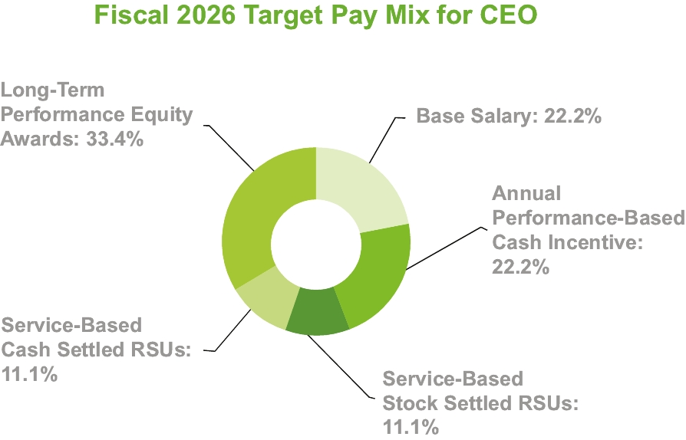

23

TABLE OF CONTENTS
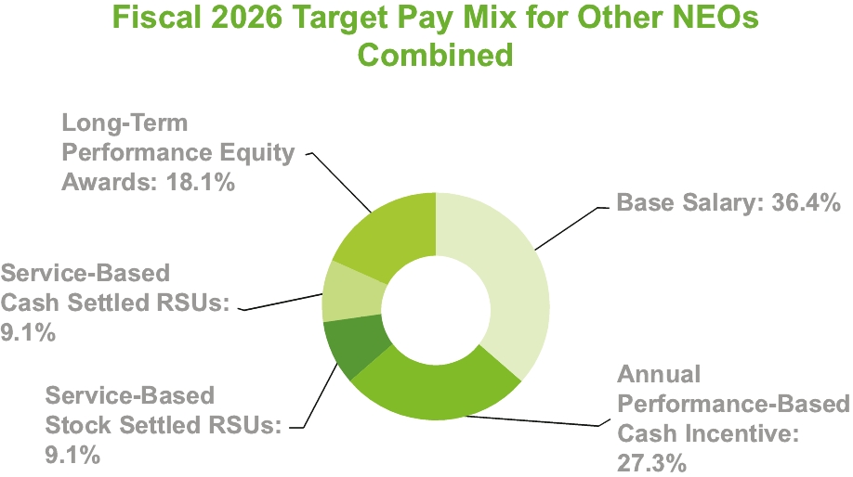

Compensation Philosophy and Objectives
We are focused on building and maintaining a sustainable business model that consistently delivers superior returns to our stockholders. To be successful, we must attract, retain and motivate key talent to provide the needed leadership capabilities to develop and execute our business strategy. Our compensation philosophy and approach are designed to support these objectives.
Our compensation philosophy is to provide the opportunity for outstanding compensation when superior performance is demonstrated. This pay-for-performance philosophy is reflected in each aspect of the compensation package for executive officers and other management team members. All components of compensation for executive officers and key management are reviewed periodically to ensure consistency with our compensation philosophy and to verify that the overall level of compensation is competitive. We use the following principles in the design and administration of our executive compensation program:
• | Competitiveness – Our compensation programs are designed to attract, motivate and retain the talent needed to lead and grow the business. Targets for base salary and short-term and long-term incentive compensation are generally aligned with median (50th percentile) market levels.
• | Support Business Objectives, Strategy and Values – Ultimately, our compensation program is designed to drive the achievement of short- and long-term business objectives, support the creation of long-term value for our stockholders, and promote and encourage behavior consistent with our core values and guiding principles.
• | Pay for Performance – While we establish target pay levels at or near the median (50th percentile) market levels for target level performance, our plans provide the opportunity for significantly greater rewards for outstanding performance. At the same time, performance that does not meet expectations is not rewarded.
• | Individual Performance – In addition to company-wide, operating subsidiary and business unit measures, our programs emphasize individual performance and the achievement of personal objectives.
• | Integrated Approach – We look at compensation in total and strive to achieve an appropriate balance of short-term and long-term incentive compensation components, with the ultimate goal of aligning executive compensation with the creation of long-term stockholder value.
Our executive compensation program is administered by the Committee. The role of the Committee is to provide oversight and direction to ensure the establishment of executive compensation programs that are competitive in nature, enable us to attract and retain top talent, and align the interests of our executive officers with those of our stockholders.
24

TABLE OF CONTENTS
The Committee is supported by our Vice President, Human Resources in the design, review and administration of our executive compensation programs. The Committee engaged Pay Governance to evaluate the Company's executive officer compensation program in relation to other companies and to provide associated recommendations.
The CEO considers all relevant information and provides recommendations to the Committee regarding compensation for review, discussion and approval for all executive officers other than himself. The Committee establishes CEO compensation. The Committee reviews the performance and approves the compensation of the executive officers based on the CEO’s recommendations and then reviews the performance and establishes appropriate compensation for the CEO in executive session without the CEO present.
In implementing our compensation philosophy, the Committee also compares our CEO’s total compensation to the total compensation of the other Named Executive Officers. The Committee also considers internal pay equity among the other Named Executive Officers, and in relation to the next lower tier of management, to maintain compensation levels that are consistent with the individual contributions and responsibilities of those officers.
Committee Consideration of the 2025 Stockholder Vote on Executive Compensation
We conducted our advisory vote on executive compensation last year at our 2025 Annual Meeting of Stockholders. At that meeting, 93% of the votes cast on the say-on-pay proposal were in favor of our Named Executive Officers' compensation as disclosed in our proxy statement. While this vote was not binding on us, we believe that it is important for our stockholders to have an opportunity to vote on this proposal on an annual basis as a means of expressing their views regarding our executive compensation philosophy, our compensation policies and programs, and our decisions regarding executive compensation, all as disclosed in our proxy statement.
We will continue to identify opportunities to engage with our stockholders and further discuss our executive compensation programs and pay decisions, as we focus on ensuring the alignment of our executive compensation programs with the interests of our stockholders.
The Committee intends to continue making executive compensation decisions with a focus on aligning pay with performance and promoting stockholder value.
Key Elements of Executive Compensation
The primary elements of our executive compensation program include:
• | Base Salary;
• | Annual/Short-Term Cash Incentive Compensation;
• | Long-Term Incentive Compensation;
• | Other Benefits; and
• | Change of Control/Severance Agreements.
The Compensation Committee engaged Pay Governance throughout fiscal 2026 to ensure that our compensation package is consistent with those of our competitors. Pay Governance was engaged exclusively by the Committee and does not provide other services to us or senior management. The Committee has assessed the independence of Pay Governance pursuant to SEC rules and concluded that Pay Governance is independent from the Company and their work for the Committee does not raise any conflict of interest.
25

TABLE OF CONTENTS
In May 2025, Pay Governance evaluated and recommended the compensation benchmarking and Total Shareholder Return (“TSR”) peer groups and discussed general trends in executive compensation. Pay Governance's executive compensation practices analysis included a review of general industry survey data, proxy information and other public filings for the following companies:
 | Ameresco Inc. |  |  | Limbach Holdings Inc.
 | Arcosa Inc. |  |  | Mistras Group Inc.
 | Argan Inc. |  |  | MYR Group Inc.
 | Babcock & Wilcox Enterprises Inc. |  |  | NPK International Inc.
 | Concrete Pumping Holdings Inc. |  |  | NV5 Global Inc.(1)
 | Granite Construction Inc. |  |  | NWPX Infrastructure Inc.
 | Great Lakes Dredge and Dock Corporation(1) |  |  | Orion Group Holdings Inc.
 | IES Holdings Inc. |  |  | Sterling Infrastructure Inc.
(1) | Great Lakes Dredge and Dock Corporation and NV5 Global Inc. are no longer part of our compensation peer group after those companies were acquired on April 1, 2026 and August 4, 2025, respectively.
Base Salary
Base salary is the foundation of our executive compensation package. Our practice in establishing executive base salary, and that for other managers and employees, is to determine, through Pay Governance, the market median, or “50th percentile”, among comparable companies. Base salary is then established based on the Named Executive Officer’s responsibilities, role in the organization, level and type of work experience, and individual and business performance.
We utilize a market-based job evaluation system to establish and ensure equitable, competitive pay levels throughout the organization. Salary grades and ranges are established by evaluating positions based on the external market data and internal equity. Most of our employees, including the Named Executive Officers, are assigned to a salary grade. Broad ranges of salaries are associated with each grade and are based on market data.
Base salary and salary grade also play a factor in determining other short- and long-term incentive compensation awards. Short- and long-term target incentive awards are set at a percentage of base salary.
Consistent with the Committee's normal practice, executive compensation was reviewed in August 2025. The Committee discussed but approved no change to the base salary of Mr. Hewitt, whose fiscal 2026 base salary remained $800,000. After considering many factors, including market data provided by Pay Governance, the Committee approved the following base salary increases for the other Named Executive Officers:
 | Name |  |  | Original Base  Salary  ($) |  |  | Increased Base  Salary  ($) |  |  | Increase  (%) |  |  | Increase  ($)
 | Shawn P. Payne |  |  | 495,475 |  |  | 545,023 |  |  | 10% |  |  | 49,548
 | Kevin S. Cavanah |  |  | 498,750 |  |  | 513,713 |  |  | 3% |  |  | 14,963
 | Justin D. Sheets |  |  | 393,750 |  |  | 405,563 |  |  | 3% |  |  | 11,813
 | Nancy E. Austin |  |  | 393,750 |  |  | 405,563 |  |  | 3% |  |  | 11,813
Neither Mr. Payne, upon his promotion to COO on February 2, 2026, nor Mr. Sheets, upon his promotion to Senior Vice President of Enterprise Services on May 5, 2026, received an additional base salary increase during fiscal 2026.
26

TABLE OF CONTENTS
Annual/Short-Term Incentive Compensation
Our annual/short-term incentive compensation plan is designed to offer the opportunity for annual cash incentive awards for delivering outstanding performance. Generally, rewards under our short-term incentive compensation plan are based on overall Company, business unit and individual performance, as compared to pre-established objectives that are tied to enhancement of stockholder value. Our short-term incentive compensation objectives are designed to:
• | support and drive performance toward achieving our strategic objectives;
• | emphasize overall company and business unit performance in the structuring of reward opportunities;
• | motivate and reward superior performance; and
• | provide incentive compensation opportunities that are competitive with the industry.
The base calculation of incentives is generally tied to quantitative measures for financial results, strategic objectives and safety performance. Target incentive opportunities for our NEOs are established by the Committee based on competitive market data provided by Pay Governance. The target incentive compensation percentage of base salary for the CEO is determined solely by the Committee in executive session, without the CEO present.
For fiscal 2026, the Committee approved the following key provisions of the annual/short-term incentive compensation plan:
• | Under the plan's profit-sharing design, NEOs may earn a financial incentive only if a positive amount of adjusted operating income combined with net interest income is achieved at the consolidated level or, for Mr. Sheets, at the operating subsidiary level. Payouts related to safety metrics and strategic objectives may be earned regardless of financial performance provided enough adjusted operating income and net interest income is achieved to fund any earned incentives related to safety or strategic objectives.
• | Incentives are weighted at 70% for performance against financial metrics, 20% for performance against strategic objectives and 10% for performance against safety metrics.
• | To increase the focus on project execution and improved bottom line performance, financial incentives are based on adjusted operating income combined with net interest income. Adjusted operating income is defined as operating income adjusted for operational activities affecting operating income. Such adjustments may be considered and approved by the Committee, including, but not limited to, impairments, restructuring charges, acquired business results (net of acquisition and integration costs), unforecast strategic initiatives and other unusual or one-time items. Net interest income represents interest income net of interest expense.
• | Incentives tied to strategic objectives are based on two objectives:
• | Project Awards; and
• | Gross Margin Improvement.
• | Safety incentives are based on two metrics:
• | Days Away, Restricted, or Transferred (“DART”); and
• | Quality, Health, Safety and Environment (“QHSE”) Corrective Action Completion, which is measured and reported based on the average days for QHSE corrective actions to be identified, investigated and completed within a required timeframe.
• | Payouts of short-term financial, strategic objectives and safety incentives for Messrs. Hewitt, Payne and Cavanah and Ms. Austin are based on our consolidated performance.
27

TABLE OF CONTENTS
• | For Mr. Sheets, payouts of short-term financial incentives are based on the performance of our operating subsidiaries with 65% tied to MSI performance, 30% tied to MNAC performance and 5% tied to Matrix PDM performance.
• | For short-term safety incentives for Mr. Sheets, 50% (related to QHSE Corrective Action Completion) is based on the performance of Matrix Project Services, and the other 50% (related to DART) is based on our consolidated performance. Also, short-term incentives related to strategic objectives are based on our consolidated performance for Mr. Sheets.
Fiscal 2026 short-term incentive targets for our NEOs are as follows:
 | Name |  |  | Target Bonus as  Percentage of  Salary |  |  | Target Bonus  Amount  ($)
 | John R. Hewitt |  |  | 100% |  |  | 800,000
 | Shawn P. Payne |  |  | 75% |  |  | 408,767
 | Kevin S. Cavanah |  |  | 75% |  |  | 385,285
 | Justin D. Sheets |  |  | 75% |  |  | 304,172
 | Nancy E. Austin |  |  | 75% |  |  | 304,172
Financial incentive targets and actual performance - 70% of the total incentive opportunity
The combination of adjusted operating income and net interest income was the single financial performance metric for the annual/short-term incentive compensation plan. Positive consolidated financial performance was used to fund the plan through a profit-sharing design with payouts determined by both consolidated and operating subsidiary results. For any financial incentive to be paid to our NEOs, a positive amount of adjusted operating income and net interest income had to be achieved at either the consolidated level or, for Mr. Sheets, at the operating subsidiary level.
In fiscal 2026, the combination of adjusted operating income and net interest income was positive for MSI and at the consolidated level. Therefore, four of our five NEOs earned a financial incentive. Ms. Austin was not eligible to earn any short-term incentives due to her separation from the Company on May 7, 2026.
Strategic Objectives incentive targets and actual performance - 20% of the total incentive opportunity
Each strategic objective represented one-half of the short-term incentive opportunity related to strategic objectives. For Project Awards, specific targets were set at both the consolidated and operating subsidiary levels and were as follows:
 |  |  |  | Project Awards ($)
 |  |  |  | (in thousands)
 | MSI |  |  | 622,000
 | MNAC |  |  | 326,000
 | Matrix PDM |  |  | 52,000
 | Consolidated |  |  | 1,000,000
For Gross Margin Improvement, targets were set at both the consolidated and operating subsidiary levels and represented an improvement of approximately 100 basis points above budgeted levels.
In fiscal 2026, the performance of both Project Awards and Gross Margin Improvement fell short of the specific targets. Therefore, none of our NEOs earned any incentives related to strategic objectives.
Safety incentive targets and actual performance - 10% of the total incentive opportunity
Each safety metric represented one-half of the short-term safety incentive opportunity. For DART, the target metric was 0.25 or lower. For QHSE Corrective Action Completion, the target average days was 5 days or less.
28

TABLE OF CONTENTS
In fiscal 2026, we achieved a consolidated DART of 0.33. Also, on QHSE Corrective Action Completion, the average days achieved by Matrix Project Services was 4.92 days while the average days achieved at the consolidated level was 2.79 days. Therefore, four of our five NEOs earned one-half of their safety incentive opportunity.
For each NEO who was eligible to earn short-term incentives for fiscal 2026, details of the calculated incentives, which were approved by the Committee at the August 2026 Compensation Committee Meeting, are as follows:
 | Name |  |  | Safety  Incentive  ($) |  |  | Financial  Incentive  ($) |  |  | Total  Incentive  ($)
 | John R. Hewitt |  |  | 40,000 |  |  | 251,478 |  |  | 291,478
 | Shawn P. Payne |  |  | 20,438 |  |  | 128,495 |  |  | 148,933
 | Kevin S. Cavanah |  |  | 19,264 |  |  | 121,113 |  |  | 140,377
 | Justin D. Sheets |  |  | 15,209 |  |  | 91,071 |  |  | 106,280
Performance measures are established shortly after the beginning of the fiscal year and do not include the impact of any acquisitions, positive or negative, completed within the fiscal year. The Committee will evaluate any acquisitions which may be completed during the fiscal year on a case-by-case basis to determine their impact on the plan and adjust performance measures appropriately. In addition, the Committee has authority with respect to actual payout of annual short-term incentive awards and can reduce awards regardless of whether performance targets are achieved.
The Committee reviews and evaluates the Annual/Short-Term Incentive Compensation Plan periodically to ensure that it meets our objectives and may be modified, discontinued or replaced based on our changing objectives and requirements.
Long-Term Incentive Compensation
We provide long-term incentive compensation to executive officers to tie executive rewards directly to the enhancement of long-term stockholder value and our profitability. Offering the opportunity for executive officers and other key members of management to earn an ownership position in the Company along with a long-term cash incentive enables us to remain competitive and attract, retain and motivate top executive and management talent. We believe that long-term incentive awards help to create and maintain a long-term perspective among executive officers and provide a direct link between executive compensation and our long-term growth and profitability.
The Committee reviews and evaluates long-term incentive awards periodically to ensure that they continue to meet our objectives and may be modified, discontinued or replaced based on our changing objectives and requirements. The Committee's most recently completed review, which occurred in August 2025, carefully considered the Pay Governance study, trends of our peer companies, compensation objectives of retention and value creation, and the objective of conserving shares available for grant under our equity incentive plan and reducing earnings dilution.
The Committee concluded that a combination of service-based RSUs and performance units is the most appropriate equity award structure to achieve our stated objectives.
Service-based RSUs strongly and directly link management and stockholder interests and are an excellent tool to promote retention. As a full value award, service-based stock-settled RSUs are less dilutive to stockholders than stock options, since we are able to issue fewer shares in order to attain the desired level of equity compensation for our executive officers and key leaders. Service-based cash-settled RSUs limit dilution in our earnings per share, promote employee retention and align management and stockholder interests. Performance units with performance criteria link the realized value of the equity reward to achievement of stockholder value.
Under the long-term incentive program, all awards are issued on an annual basis. Specific, individual grants vary by level and role in the organization. The amount of each award corresponds to the respective salary grade for each executive officer and is based on market data.
29

TABLE OF CONTENTS
The Committee approved the following structure for the fiscal 2026 long-term incentive grant for NEOs:
• | A portion of the grant (20% for the CEO and 25% for the other NEOs) consisted of service-based RSUs settled in stock. Vesting will occur ratably over a four-year period beginning on the first anniversary of the grant date. In addition, the award agreements contain a provision that allows a retirement eligible NEO to retire on or after the first anniversary of the grant date and continue to vest into RSUs on the normal vesting schedule, subject to the NEO's continued compliance with the confidentiality, non-competition, non-solicitation and non-disparagement provisions that apply to the NEO.
• | In addition to his annual award, Mr. Payne received an award that consisted of only service-based RSUs that settle in stock and included the same restrictions and retirement eligibility provisions as described above. The additional award was granted in connection with the Board's long-term succession planning process and reflects its commitment to ensuring a successful leadership transition.
• | A portion of the grant (20% for the CEO and 25% for the other NEOs) consisted of service-based RSUs settled in cash, which have the same vesting terms (including retirement vesting) as described above for the service-based RSUs settled in stock.
• | The remaining portion of the grant (60% for the CEO and 50% for the other NEOs) was in the form of PSUs. The PSUs cliff vest on the third anniversary of the grant. The shares of our common stock received can vary from zero to two for each performance unit based on the relative Total Shareholder Return (“TSR”) of our common stock as compared to the TSR of a group of peer companies over the performance period. If an NEO who is retirement eligible retires before the third anniversary of the grant date, the NEO will remain eligible to earn the PSUs based on actual performance for the full performance period, as prorated to reflect the portion of the three-year performance period that the NEO was employed, subject to the NEO's continued compliance with the confidentiality, non-competition, non-solicitation and non-disparagement provisions that apply to the NEO. The potential award levels, which were adjusted for fiscal 2026, were as follows:
 | Shareholder Return Goal |  |  | Total Shareholder Return |  |  | Shares of Common  Stock for Each  Performance Unit
 | Threshold |  |  | 25th percentile of Peer Group |  |  | 0.50
 | Target |  |  | 50th percentile of Peer Group |  |  | 1.00
 | Maximum |  |  | 75th percentile of Peer Group |  |  | 2.00
In the event our actual TSR for the performance period is negative, the payout the NEOs will receive is capped at 1.5 shares for each performance unit, regardless of our TSR percentile ranking within the peer group. Additionally, in the event our actual TSR is 25% or greater for the performance period, the payout the NEOs will receive will be at least 1.0 share (Target) for each performance unit, regardless of our TSR percentile ranking within the peer group.
The peer group for the fiscal 2026 performance unit award was as follows:
 | Ameresco Inc. |  |  | Limbach Holdings Inc.
 | Arcosa Inc. |  |  | MasTec Inc.
 | Argan, Inc. |  |  | Mistras Group Inc.
 | Babcock and Wilcox Enterprises Inc. |  |  | MYR Group Inc.
 | Concrete Pumping Holdings Inc. |  |  | NPK International Inc.
 | Dycom Industries Inc. |  |  | NV5 Global Inc.(1)
 | EMCOR Group Inc. |  |  | NWPX Infrastructure Inc.
 | Granite Construction Inc. |  |  | Orion Group Holdings Inc.
 | Great Lakes Dredge and Dock Corporation(1) |  |  | Primoris Services Corporation
 | IES Holdings Inc. |  |  | Sterling Infrastructure Inc.
 | KBR Inc.
(1) | Great Lakes Dredge and Dock Corporation and NV5 Global Inc. are no longer part of our TSR peer group after those companies were acquired on April 1, 2026 and August 4, 2025, respectively.
30

TABLE OF CONTENTS
Based on our relative Total Shareholder Return for fiscal 2024 through fiscal 2026 in comparison to a group of peer companies, our performance was below the amount required for Threshold payout; therefore, no PSUs vested in August 2026.
Grants made during fiscal 2026 to our Named Executive Officers are shown in the Grants of Plan-Based Awards table under the caption “Executive Officer Compensation.”
Perquisites and Other Benefits
Our executive officers do not receive significant compensation in the form of perquisites or supplemental benefits. In general, our executive officers are eligible to participate in the same retirement and health and welfare plans as all of our other eligible employees. We offer the following benefits to executive officers:
• | We sponsor the Matrix Service Company 401(k) Savings Plan, which allows executive officers and other employees to contribute up to 75% of their salary (up to the annual IRS maximum). Our safe harbor matching contribution is a 100% matching contribution on salary deferrals up to the first 3% of compensation deferred and 50% on the next 2% of compensation deferred. All matching contributions are 100% vested at all times. Executive officers participate and receive benefits under the plan in the same manner as all other eligible participants. We do not sponsor or maintain any other pension, deferred compensation or other supplemental retirement plans for executive officers.
• | In addition to the group term life insurance policy offered to all eligible employees, we provide additional life insurance to our executive officers, at no cost to the officer. Specifically, we provide a fully portable supplemental Group Variable Universal Life (GVUL) insurance policy equal to two times base salary up to a maximum of $1.5 million. For the CEO, we provide additional corporate term life insurance policies of $500,000 with us as the beneficiary and $500,000 with a designee of the CEO as the beneficiary.
• | We provide long-term disability to all administrative employees. Under this plan, the employee may receive disability payments of up to 60% of base salary subject to a maximum of $12,000 per month. Additionally, we provide a fully portable supplemental executive long-term disability plan to the Named Executive Officers. Under this plan, the Named Executive Officers may receive additional disability payments of up to 60% of the sum of their base salary and the average of their prior two years short-term incentive cash bonuses, subject to a maximum of $15,000 per month. The combined plans may provide a long-term disability benefit up to a maximum of $27,000 per month for the Named Executive Officers.
Change of Control/Severance Agreements
We have entered into Change of Control/Severance Agreements with each of our Named Executive Officers and other executive officers. These agreements are designed to promote stability, continuity and focus for key members of leadership during periods of uncertainty that may be created by change of control situations. Additionally, the use of such agreements is a competitive practice that enhances our ability to attract and retain leadership talent. For further details regarding our Change of Control/Severance Agreements, see the discussion under the caption “Potential Payments Upon Termination or Change of Control.”
Clawback Policy
Effective August 29, 2023, our Board adopted a new Clawback Policy applicable to our officers that are required to file ownership reports pursuant to Section 16 of the Exchange Act (“Covered Executives”). The Clawback Policy is triggered in the event the Company is required to prepare an accounting restatement of its financial statements due to the Company's material noncompliance with any financial reporting requirement under the securities laws (a “Triggering Event”).
If a Triggering Event occurs, the Company is required to recoup all erroneously awarded “incentive-based compensation” paid to Covered Executives during the three completed fiscal years immediately preceding
31

TABLE OF CONTENTS
the date on which the Company is required to prepare an accounting restatement and during any transition period that results from a change in the Company’s fiscal year, if applicable. “Incentive-based compensation” is any compensation that is granted, earned, or vested based wholly or in part upon the attainment of a financial reporting measure.
The amount of erroneously awarded incentive-based compensation is the difference between the amount of incentive-based compensation paid to a Covered Executive that exceeds the incentive-based compensation that such Covered Executive would have been paid had it been based on the restated results without regard to taxes paid.
The Clawback Policy is administered by our Board, or such Board committee as it may designate, which shall determine, in its sole discretion, the timing and method for recouping erroneously awarded incentive-based compensation.
A copy of our Clawback Policy is available on the Corporate Governance page included in the “Investor Relations” section of our website at matrixservicecompany.com.
Insider Trading Policy
On May 5, 2026, our Board adopted an amended Insider Trading Policy, which prohibits directors, officers, employees, consultants and contractors of the Company from trading in Company securities when in possession of material non-public information unless an approved 10b5-1 Plan is in place. The Insider Trading Policy is intended to promote compliance with insider trading laws, rules and regulations and any listing standards applicable to the Company. A copy of our Insider Trading Policy is included as Exhibit 19 to our 2026 Annual Report on Form 10-K.
Policy on Hedging and Pledging of Company Securities
Hedging transactions may permit a director, officer or employee to continue to own our securities obtained through employee benefit plans or otherwise, but without the full risks and rewards of ownership. When that occurs, the director, officer or employee may no longer have the same objectives as our other stockholders. Our Insider Trading Policy specifically prohibits our directors, Named Executive Officers and all other employees from purchasing any securities or other financial instruments or engaging in transactions that hedge or offset, or that are designed to hedge or offset, any decrease in the value of any of our equity securities that are held by any such person, directly or indirectly. This hedging policy also applies to family members and entities controlled by our directors, Named Executive Officers and all other employees.
Securities held in a margin account as collateral for a margin loan may be sold by the broker without the customer’s consent if the customer fails to meet a margin call. Similarly, securities pledged as collateral for a loan may be sold in foreclosure if the borrower defaults on the loan. Because a margin sale or foreclosure sale may occur at a time when the pledgor is aware of material non-public information or otherwise is not permitted to trade in our securities, our Insider Trading Policy prohibits directors, Named Executive Officers and other employees from holding our securities in a margin account or otherwise pledging our securities.
Equity Grant Practices
Our Compensation Committee meets annually during the first quarter following the end of each fiscal year to review the performance of the Company as well as the executives of the Company. During these annual meetings, all compensation recommendations are made, including recommendations regarding potential adjustments to the annual base salaries of the executive officers along with determination of annual incentive payments and equity awards. To the extent our Compensation Committee approves new equity-based awards for employees (including NEOs) during the first quarter of a fiscal year, the grant date of such awards is typically in late August. Our Compensation Committee does not take material non-public information into account when determining the timing and terms of equity awards, nor does the Company time the disclosure of material non-public information for the purpose of affecting the value of executive compensation. In an effort to minimize the impact of stock price volatility on equity award
32

TABLE OF CONTENTS
grants, our Compensation Committee uses a 20-day average closing stock price for purposes of calculating equity award grant amounts for employees (including NEOs). Currently, we do not grant stock options, stock appreciation rights or similar option-like awards.
Compensation Program as it Relates to Risk
Our Board has reviewed our compensation policies and practices for both executives and non-executives as they relate to risk and has determined that they are not reasonably likely to have a material adverse effect on our operations or financial condition. In reaching this conclusion, we considered the various elements of our compensation program that are designed to help mitigate excessive risk taking, including:
• | Components of Compensation: We use a mix of compensation elements including base salary, short-term incentives and long-term incentives to avoid placing too much emphasis on any one component of compensation.
• | Short-term Incentive Compensation: Our short-term incentive compensation plan does not allow for unlimited payouts. For fiscal 2026, short-term incentive payments could not exceed 200% of target levels.
• | Long-term Incentive Awards: Our service-based long-term incentive awards drive a long-term perspective and vest over a period of four years. Our performance-based long-term incentive awards, which may vest after a period of three years, are capped and cannot exceed 200% of target levels.
• | Committee Oversight: The Committee reviews and administers all awards under short- and long-term incentive plans and engages a compensation consultant on an annual basis to ensure that our compensation package is consistent with that of our competitors.
• | Performance Measures: Our performance goal setting process is aligned with our business strategy and the interests of our stockholders.
• | Clawback Policy: We have the right to recover erroneously awarded incentive-based compensation paid to our executive officers in the event we are required to prepare an accounting restatement of our financial statements due to our material non-compliance with any financial reporting requirement under securities laws.
• | Insider Trading Policy: Our insider trading policy prohibits our directors, officers, employees, consultants and contractors from trading any shares of our common stock while in possession of material non-public information unless an approved 10b5-1 Plan is in place.
• | Hedging and Pledging Policy: Our hedging and pledging policy requires our senior management to retain the full risks and rewards associated with owning our common stock with respect to all of the shares they are required to retain.
• | Equity Ownership Guidelines: Our equity ownership guidelines require our senior management to maintain significant ownership in our common stock for the duration of their employment with our Company.
Our compensation program is designed to motivate our Named Executive Officers and other officers to achieve business objectives that generate strong stockholder returns and to encourage ethical behaviors.
Equity Ownership Guidelines
The Board believes that our directors and executive officers should demonstrate their commitment to and belief in our long-term profitability. Accordingly, each director and executive officer is expected to maintain a significant investment in us through the ownership of our common stock. Equity ownership more closely aligns our directors' and executive officers’ interests and actions with the interests of our stockholders.
33

TABLE OF CONTENTS
In our Corporate Governance Guidelines, we have formal equity ownership guidelines that require minimum equity ownership levels. The equity ownership guidelines require the following minimum equity ownership levels:
 | Non-Employee Directors |  |  | 5 times annual cash retainer
 | President/CEO |  |  | 5 times base salary
 | CFO |  |  | 2 times base salary
 | Senior Vice President, Enterprise Services |  |  | 1.5 times base salary
 | Vice President & General Counsel |  |  | 1 times base salary
Directors and executive officers are prohibited from selling stock received via Company awards if and to the extent they do not meet these guidelines, with certain limited exceptions. Once guideline levels have been reached, directors and officers are expected to retain this level of ownership during their tenure. Compliance is evaluated on a biannual basis in November and May of each year.
As of our most recent evaluation date in May 2026, all of our NEOs and non-employee directors met their equity ownership guidelines.
The following are eligible forms of equity under our Equity Ownership Guidelines:
• | shares owned separately or owned either jointly with, or separately by, the director's or executive officer's immediate family members residing in the same household;
• | shares held in trust for the benefit of the director or executive officer or immediate family members; and
• | vested and unvested service-based restricted stock or RSUs; however, unvested and unearned PSUs are not included in the calculation of equity ownership.
Report of the Compensation Committee of the Board
The Compensation Committee of the Board has reviewed and discussed the Compensation Discussion and Analysis required by Item 402(b) of Regulation S-K with management and, based on such review and discussions, the Compensation Committee recommended to the Board that the Compensation Discussion and Analysis be included in this proxy statement.
Members of the Compensation Committee:
Carlin G. Conner, Chair
Jose L. Bustamante
Martha Z. Carnes
Liane K. Hinrichs
34

TABLE OF CONTENTS
EXECUTIVE OFFICER COMPENSATION
The following tables set forth certain information regarding compensation of our Named Executive Officers, or “NEOs”, for fiscal 2026. The executive officers listed below, except for the former CAO who separated from the Company on May 7, 2026, were serving as executive officers on June 30, 2026.
Summary Compensation Table
 | Name and  Principal Position |  |  | Year |  |  | Salary  ($) |  |  | Bonus  ($)(2) |  |  | Stock  Awards  ($)(3) |  |  | Non-Equity  Incentive Plan  Compensation  ($)(6) |  |  | All Other  Compensation  ($) |  |  | Total  ($)
 | John R. Hewitt  Chief Executive Officer |  |  | 2026 |  |  | 800,000 |  |  | — |  |  | 3,981,443(4) |  |  | 291,478 |  |  | 1,668,544(7) |  |  | 6,741,465
 | John R. Hewitt  Chief Executive Officer |  |  | 2025 |  |  | 800,000 |  |  | — |  |  | 2,236,270 |  |  | — |  |  | 33,189 |  |  | 3,069,459
 | John R. Hewitt  Chief Executive Officer |  |  | 2024 |  |  | 800,000 |  |  | — |  |  | 3,264,777 |  |  | — |  |  | 32,510 |  |  | 4,097,287
 | Kevin S. Cavanah  Chief Financial Officer |  |  | 2026 |  |  | 510,836(1) |  |  | — |  |  | 924,769 |  |  | 140,377 |  |  | 25,431(8) |  |  | 1,601,413
 | Kevin S. Cavanah  Chief Financial Officer |  |  | 2025 |  |  | 493,269 |  |  | — |  |  | 731,501 |  |  | — |  |  | 24,512 |  |  | 1,249,282
 | Kevin S. Cavanah  Chief Financial Officer |  |  | 2024 |  |  | 475,000 |  |  | — |  |  | 1,039,996 |  |  | — |  |  | 23,585 |  |  | 1,538,581
 | Shawn P. Payne  Chief Operating Officer |  |  | 2026 |  |  | 535,494(1) |  |  | 50,000 |  |  | 1,765,518 |  |  | 148,933 |  |  | 23,296(8) |  |  | 2,523,241
 | Shawn P. Payne  Chief Operating Officer |  |  | 2025 |  |  | 459,868 |  |  | — |  |  | 482,898 |  |  | — |  |  | 20,209 |  |  | 962,975
 | Shawn P. Payne  Chief Operating Officer |  |  | 2024 |  |  | 433,423 |  |  | — |  |  | 686,554 |  |  | — |  |  | 19,211 |  |  | 1,139,188
 | Justin D. Sheets  Senior Vice President,  Enterprise Services |  |  | 2026 |  |  | 403,292(1) |  |  | — |  |  | 521,490 |  |  | 106,280 |  |  | 18,633(8) |  |  | 1,049,695
 |  |  |  | 2025 |  |  | 389,423 |  |  | — |  |  | 412,499 |  |  | — |  |  | 18,348 |  |  | 820,270
 |  |  |  | 2024 |  |  | 375,000 |  |  |  |  |  | 586,453 |  |  | — |  |  | 17,339 |  |  | 978,792
 | Nancy E. Austin  Former Chief Administrative  Officer |  |  | 2026 |  |  | 362,735(1) |  |  | — |  |  | 769,165(5) |  |  | — |  |  | 694,255(9) |  |  | 1,826,155
 | Nancy E. Austin  Former Chief Administrative  Officer |  |  | 2025 |  |  | 389,423 |  |  | — |  |  | 412,499 |  |  | — |  |  | 21,096 |  |  | 823,018
 | Nancy E. Austin  Former Chief Administrative  Officer |  |  | 2024 |  |  | 375,000 |  |  | — |  |  | 586,453 |  |  | — |  |  | 20,249 |  |  | 981,702
(1) | The base salary of Mr. Payne for fiscal 2026 represents 10 months of his current base salary of $545,023 and two months of his prior base salary. The base salary of Mr. Cavanah for fiscal 2026 represents 10 months of his current base salary of $513,713 and two months of his prior base salary. The base salary of Mr. Sheets for fiscal 2026 represents 10 months of his current base salary of $405,563 and two months of his prior base salary. The base salary of Ms. Austin for fiscal 2026 represents her base salary received through her separation date of May 7, 2026.
(2) | A transition bonus of $50,000 was awarded to Mr. Payne in connection with his expanded leadership role and significant contributions during the transition of the Company's CEO responsibilities in fiscal 2026.
(3) | The amounts shown represent the grant date fair value for awards of RSUs to be settled in stock, RSUs to be settled in cash and performance units granted during the period determined in accordance with FASB Accounting Standards Codification ASC Topic 718 – Compensation – Stock Compensation (“ASC718”). A portion of the awards that were granted in fiscal years 2024, 2025 and 2026 are subject to certain market conditions; accordingly, the grant date fair value of these awards is based upon the probable outcome of those conditions, which is the Target performance level. For further information on the assumptions used in the valuation of these awards, see Notes 1 and 10 included in the Notes to Consolidated Financial Statements included in our fiscal 2026 Annual Report on Form 10-K.
(4) | For Mr. Hewitt, the original grant date fair value of his stock-settled and cash-settled RSU awards was $823,033. In accordance with his February 2, 2026 Transition and Separation Agreement, his RSU awards granted in fiscal 2026 were modified to stipulate that he was no longer required to provide additional services for the RSUs to vest. This resulted in the original grants being deemed to be cancelled, and the RSU awards deemed to be regranted with a modified grant date fair value of $760,381. Per SEC rules, both the original grant date fair value and the modified grant date fair value are included in the total value of awards issued, even though only the modified RSU awards for Mr. Hewitt will vest. Additionally, the original grant date fair value of Mr. Hewitt's stock-settled PSU award granted in August 2025 was $1,851,399. In accordance with his February 2, 2026 Transition and Separation Agreement, Mr. Hewitt's stock-settled PSU awards granted in August 2023 and August 2024 were modified, and in lieu of receiving pro-rata treatment, the service condition was deemed fully satisfied. This resulted in a portion of those two PSU awards deemed to be regranted with a modified grant date fair value of $546,630. Per SEC rules, the modified grant date fair value for the two modified PSU awards is included in the total value of awards issued.
(5) | For Ms. Austin, the original grant date fair value of her stock-settled and cash-settled RSU awards was $208,632. Upon her separation from the Company on May 7, 2026, her unvested RSU awards were modified to stipulate that she was no longer required to provide additional services for the RSUs originally scheduled to vest in August 2026 (including RSUs for grants from the prior three fiscal years) to vest while the remaining unvested RSUs were forfeited. This resulted in some or all of the original grants deemed to be cancelled, and a portion of the RSU awards deemed to be reissued with a modified grant date fair value of $247,675. Per SEC rules, both the original grant date fair value and the modified grant date fair value are included in the total value of awards issued, even though only the modified RSU awards for Ms. Austin will vest. Additionally, the original grant date fair value of Ms. Austin's stock-settled PSU award granted in August 2025 was $312,858. Upon her separation from the Company on May 7, 2026, Ms. Austin's stock-settled PSU award granted in August 2023 was modified to accelerate vesting of the service condition of the award. This resulted in the original grant from August 2023 being deemed to be cancelled, and the PSU award deemed to be regranted with a modified grant date fair value of $0.
35

TABLE OF CONTENTS
(6) | Represents amounts payable to the Named Executive Officer under the annual/short-term incentive compensation plan for the applicable fiscal year's performance. The annual/short-term incentive compensation plan is discussed in further detail in the preceding section “Compensation Discussion and Analysis - Annual/Short-Term Incentive Compensation.”
(7) | In accordance with his February 2, 2026 Transition and Separation Agreement, Mr. Hewitt received cash severance in the amount of $1,600,000, representing two years of base salary. Also included are company-paid life insurance and disability premiums totaling $22,122, matching 401(k) contributions of $16,669 and COBRA premiums totaling $29,753.
(8) | Represents amounts paid by us on behalf of the Named Executive Officer for life insurance and disability premiums and matching contributions to the Named Executive Officer’s account in our qualified 401(k) plan. Life insurance and disability premiums in fiscal 2026 totaled $7,774, $11,132 and $4,397 for Messrs. Payne, Cavanah and Sheets, respectively. Matching contributions to our 401(k) plan in fiscal 2026 totaled $15,522, $14,299 and $14,236 for Messrs. Payne, Cavanah, and Sheets, respectively.
(9) | In accordance with her May 7, 2026 Separation Agreement, Ms. Austin received cash severance in the amount of $608,345, representing one and one-half years of base salary. Also included are company-paid life insurance and disability premiums totaling $7,259, matching 401(k) contributions of $13,342, COBRA premiums totaling $47,113 and earned, unused paid time off totaling $18,196.
36

TABLE OF CONTENTS
Grants of Plan-Based Awards During Fiscal 2026
 |  |  |  |  |  |  | Estimated Future Payouts  Under Non-Equity Incentive  Plan Awards(1) |  |  |  |  |  |  |  |  | Estimated Future Payouts  Under Equity Incentive  Plan Awards(3) |  |  |  |  |  |  |  |  | All Other  Stock Awards:  Number of  shares of  Stock or Units  (#)(6) |  |  | Grant Date  Fair Value of  Stock and  Option Awards  ($)(9)
 | Name |  |  | Grant  Date |  |  | Threshold  ($)(2) |  |  | Target  ($) |  |  | Maximum  ($) |  |  | Threshold  (#) |  |  | Target  (#) |  |  | Maximum  (#)
 | John R. Hewitt |  |  | 8/27/2025 |  |  | — |  |  | 800,000 |  |  | 1,600,000 |  |  | — |  |  | — |  |  | — |  |  | — |  |  | —
 |  |  |  | 8/27/2025 |  |  | — |  |  | — |  |  | — |  |  | 40,161 |  |  | 80,321 |  |  | 160,642 |  |  | 53,548(7) |  |  | 2,674,432
 |  |  |  | 2/2/2026 |  |  | — |  |  | — |  |  | — |  |  | 14,450 |  |  | 57,798 |  |  | 115,596(4) |  |  | 53,548(7) |  |  | 1,307,011
 | Kevin S. Cavanah |  |  | 8/27/2025 |  |  | — |  |  | 385,285 |  |  | 770,570 |  |  | — |  |  | — |  |  | — |  |  | — |  |  | —
 |  |  |  | 8/27/2025 |  |  | — |  |  | — |  |  | — |  |  | 12,035 |  |  | 24,070 |  |  | 48,140 |  |  | 24,070 |  |  | 924,769
 | Shawn P. Payne |  |  | 8/27/2025 |  |  | — |  |  | 408,767 |  |  | 817,535 |  |  | — |  |  | — |  |  | — |  |  | — |  |  | —
 |  |  |  | 8/27/2025 |  |  | — |  |  | — |  |  | — |  |  | 16,416 |  |  | 32,831 |  |  | 65,662 |  |  | 65,632 |  |  | 1,765,518
 | Justin D. Sheets |  |  | 8/27/2025 |  |  | — |  |  | 304,172 |  |  | 608,345 |  |  | — |  |  | — |  |  | — |  |  | — |  |  | —
 |  |  |  | 8/27/2025 |  |  | — |  |  | — |  |  | — |  |  | 6,787 |  |  | 13,573 |  |  | 27,146 |  |  | 13,574 |  |  | 521,490
 | Nancy E. Austin |  |  | 8/27/2025 |  |  | — |  |  | 304,172 |  |  | 608,345 |  |  | — |  |  | — |  |  | — |  |  | — |  |  | —
 |  |  |  | 8/27/2025 |  |  | — |  |  | — |  |  | — |  |  | 6,787 |  |  | 13,573 |  |  | 27,146 |  |  | 13,574(8) |  |  | 521,490
 |  |  |  | 5/7/2026 |  |  | — |  |  | — |  |  | — |  |  | 6,965 |  |  | 27,860 |  |  | 55,720(5) |  |  | 20,368(8) |  |  | 247,675
(1) | The amounts shown are the potential cash incentive compensation awards for each Named Executive Officer under our annual/short-term incentive compensation plan described above under the caption “Compensation Discussion and Analysis”. Actual payouts to the Named Executive Officers for the applicable fiscal year are reported in the Summary Compensation Table under the column “Non-Equity Incentive Plan Compensation.”
(2) | The fiscal 2026 annual/short-term incentive compensation plan used a profit-sharing design funded by positive consolidated financial performance and, therefore, did not include a minimum threshold performance level.
(3) | Represents the number of shares which may be issued pursuant to fiscal 2026 performance unit awards to the Named Executive Officers that cliff vest three years after the grant date. The number of shares of common stock received upon vesting of the performance units will range between 0% and 200% of the target number of performance units awarded as determined by the three-year Total Shareholder Return on our common stock when compared to the Total Shareholder Return on the common stock of a group of peer companies selected by the Compensation Committee of the Board. The fiscal 2026 performance unit awards are described above under the caption “Compensation Discussion and Analysis”.
(4) | A portion of the PSU awards originally granted to Mr. Hewitt on August 29, 2023 and August 27, 2024 were deemed to be cancelled when they were modified in accordance with his February 2, 2026 Transition and Separation Agreement, which deemed the service condition to be fully satisfied in lieu of receiving pro-rata treatment. Since performance for the PSUs granted to Mr. Hewitt on August 29, 2023 was below the amount required for a threshold payout, none of the 9,761 PSUs related to that grant that were modified on February 2, 2026 were paid out in August 2026. If target performance is achieved for the PSUs granted to Mr. Hewitt on August 27, 2024, 48,037 of the PSUs modified on February 2, 2026 will be settled in stock on August 27, 2027.
(5) | The PSU award originally granted to Ms. Austin on August 29, 2023 was deemed to be cancelled when it was modified to accelerate vesting of the service condition of the award and reissued upon her separation from the Company on May 7, 2026. Since performance for the PSUs was below the amount required for a threshold payout, none of the PSUs modified on May 7, 2026 were paid out in August 2026.
(6) | Amounts shown represent service-based RSUs granted to the Named Executive Officers in fiscal 2026. The RSUs vest in four equal annual installments beginning one year after the grant date subject to the Named Executive Officer's continued employment with us. For Messrs. Cavanah and Sheets, half of the RSUs will be settled in stock while the other half will be settled in cash. For Mr. Payne, 49,216 of the RSUs will be settled in stock while the other 16,416 RSUs will be settled in cash.
(7) | RSU awards granted on August 27, 2025 for Mr. Hewitt were deemed cancelled when they were modified to stipulate that he was no longer required to provide additional services for the RSUs to vest, and the RSUs were reissued on February 2, 2026 when Mr. Hewitt signed his Transition and Separation Agreement. Half of the RSUs modified on February 2, 2026 will be settled in stock while the other half of the RSUs will be settled in cash, in each case, in four equal annual installments beginning one year after the original grant date.
(8) | RSU awards granted on August 27, 2025 for Ms. Austin were deemed cancelled when they were modified to stipulate that she was no longer required to provide additional services for the RSUs scheduled to vest in August 2026 (including RSUs for grants from the prior three fiscal years) to vest, and the RSUs were reissued on her separation date of May 7, 2026. In August 2026, half of the RSUs modified on May 7, 2026 were settled in stock, and the other half of the RSUs were settled in cash.
37

TABLE OF CONTENTS
(9) | Amounts shown are calculated based upon the grant date fair value calculated in accordance with ASC 718. The grant date fair value of the service-based RSUs was calculated by multiplying the number of RSUs awarded by the closing stock price on the date of grant. The grant date fair value of the performance units was calculated using a Monte Carlo model. The model estimated the fair value of the award based on approximately 50,000 simulations of the future prices of our common stock compared to the future prices of our peer companies based on historical volatilities. The model also took into account the expected dividends over the performance period for the peer companies which pay cash dividends. See Notes 1 and 10 of the Notes to the Consolidated Financial Statements included in our fiscal 2026 Annual Report on Form 10-K for a full discussion of our stock-based compensation accounting policies. The specific grant date fair values are as follows:
 |  |  |  | Service-Based Awards |  |  |  |  |  |  |  |  |  |  |  |  |  |  | Performance-Based Awards |  |  |  |  |  |  |  |  |  |  |  |  |  |  |  |  |  |  |  |  | Total  Grant  Date  Fair  Value  ($)
 | Name |  |  | Service-  Based  Awards  (#) |  |  | Value  per  Share  ($) |  |  | Service-  Based  Awards  (#) |  |  | Value  per  Share  ($) |  |  | Grant  Date  Fair  Value  ($) |  |  | Shares  at  Target  (#) |  |  | Value  per  Share  ($) |  |  | Shares  at  Target  (#) |  |  | Value  per  Share  ($) |  |  | Shares  at  Target  (#) |  |  | Value  per  Share  ($) |  |  | Grant  Date  Fair  Value  ($) |  |  | Total  Grant  Date  Fair  Value  ($)
 | John R. Hewitt |  |  | 53,548 |  |  | 15.37 |  |  | 53,548 |  |  | 14.20 |  |  | 1,583,414 |  |  | 80,321 |  |  | 23.05 |  |  | 9,761 |  |  | 10.43 |  |  | 48,037 |  |  | 9.26 |  |  | 2,398,029 |  |  | 3,981,443
 | Kevin S. Cavanah |  |  | 24,070 |  |  | 15.37 |  |  | — |  |  | — |  |  | 369,956 |  |  | 24,070 |  |  | 23.05 |  |  | — |  |  | — |  |  | — |  |  | — |  |  | 554,813 |  |  | 924,769
 | Shawn P. Payne |  |  | 65,632 |  |  | 15.37 |  |  | — |  |  | — |  |  | 1,008,764 |  |  | 32,831 |  |  | 23.05 |  |  | — |  |  | — |  |  | — |  |  | — |  |  | 756,754 |  |  | 1,765,518
 | Justin D. Sheets |  |  | 13,574 |  |  | 15.37 |  |  | — |  |  | — |  |  | 208,632 |  |  | 13,573 |  |  | 23.05 |  |  | — |  |  | — |  |  | — |  |  | — |  |  | 312,858 |  |  | 521,490
 | Nancy E. Austin |  |  | 13,574 |  |  | 15.37 |  |  | 20,368 |  |  | 12.16 |  |  | 456,307 |  |  | 13,573 |  |  | 23.05 |  |  | 27,860 |  |  | — |  |  | — |  |  | — |  |  | 312,858 |  |  | 769,165
38

TABLE OF CONTENTS
Outstanding Equity Awards at Fiscal Year-End for 2026
 |  |  |  | Stock Awards
 | Name |  |  | Number of  Shares or Units of  Stock That Have  Not Vested  (#) |  |  | Market Value of  Shares or Units of  Stock That Have  Not Vested  ($)(1) |  |  | Equity Incentive Plan  Awards: Number  of Unearned Shares,  Units or Other Rights  That Have Not Vested  (#) |  |  | Equity Incentive Plan  Awards: Market Value  of Unearned Shares,  Units or Other Rights  That Have Not Vested  ($)(1)
 | John R. Hewitt |  |  | 197,146 |  |  | 2,700,900 |  |  | 42,244 |  |  | 578,743
 | Kevin S. Cavanah |  |  | 83,752 |  |  | 1,147,402 |  |  | 20,649 |  |  | 282,891
 | Shawn P. Payne |  |  | 104,632 |  |  | 1,433,458 |  |  | 22,102 |  |  | 302,797
 | Justin D. Sheets |  |  | 47,226 |  |  | 646,996 |  |  | 11,644 |  |  | 159,523
 | Nancy E. Austin |  |  | 20,368 |  |  | 279,042 |  |  | — |  |  | —
(1) | Based on the closing price of our common stock on June 30, 2026 of $13.70 per share.
39

TABLE OF CONTENTS
The stock awards vest according to the following schedule:
 |  |  |  | Number of Shares  or Units of Stock  That Have Not Vested |  |  |  |  |  | Equity Incentive Plan  Awards: Number of Unearned  Shares, Units or Other Rights  That Have Not Vested
 | Name |  |  | Shares |  |  | Vest Date |  |  | Shares |  |  | Vest Date
 | John R. Hewitt |  |  | 20,726 |  |  | 8/27/2026(1) |  |  | —(3) |  |  | 8/29/2026
 |  |  |  | 13,388 |  |  | 8/27/2026(1) |  |  | 31,088(3) |  |  | 8/27/2027
 |  |  |  | 29,718 |  |  | 8/29/2026(1) |  |  | 11,156(3) |  |  | 8/27/2028
 |  |  |  | 21,988 |  |  | 8/30/2026(1)
 |  |  |  | 20,726 |  |  | 8/27/2027(1)
 |  |  |  | 13,388 |  |  | 8/27/2027(1)
 |  |  |  | 29,716 |  |  | 8/29/2027(1)
 |  |  |  | 20,724 |  |  | 8/27/2028(1)
 |  |  |  | 13,386 |  |  | 8/27/2028(1)
 |  |  |  | 13,386 |  |  | 8/27/2029(1)
 | Kevin S. Cavanah |  |  | 8,614 |  |  | 8/27/2026(1) |  |  | —(3) |  |  | 8/29/2026
 |  |  |  | 6,018 |  |  | 8/27/2026(1) |  |  | 8,614(3) |  |  | 8/27/2027
 |  |  |  | 12,352 |  |  | 8/29/2026(1) |  |  | 12,035(3) |  |  | 8/27/2028
 |  |  |  | 9,138 |  |  | 8/30/2026(1)
 |  |  |  | 8,614 |  |  | 8/27/2027(1)
 |  |  |  | 6,018 |  |  | 8/27/2027(1)
 |  |  |  | 12,350 |  |  | 8/29/2027(1)
 |  |  |  | 8,614 |  |  | 8/27/2028(1)
 |  |  |  | 6,018 |  |  | 8/27/2028(1)
 |  |  |  | 6,016 |  |  | 8/27/2029(1)
 | Shawn P. Payne |  |  | 5,686 |  |  | 8/27/2026(1) |  |  | —(3) |  |  | 8/29/2026
 |  |  |  | 8,208 |  |  | 8/27/2026(1) |  |  | 5,686(3) |  |  | 8/27/2027
 |  |  |  | 8,200 |  |  | 8/27/2026(2) |  |  | 16,416(3) |  |  | 8/27/2028
 |  |  |  | 8,154 |  |  | 8/29/2026(1)
 |  |  |  | 5,634 |  |  | 8/30/2026(1)
 |  |  |  | 5,686 |  |  | 8/27/2027(1)
 |  |  |  | 8,208 |  |  | 8/27/2027(1)
 |  |  |  | 8,200 |  |  | 8/27/2027(2)
 |  |  |  | 8,154 |  |  | 8/29/2027(1)
 |  |  |  | 5,686 |  |  | 8/27/2028(1)
 |  |  |  | 8,208 |  |  | 8/27/2028(1)
 |  |  |  | 8,200 |  |  | 8/27/2028(2)
 |  |  |  | 8,208 |  |  | 8/27/2029(1)
 |  |  |  | 8,200 |  |  | 8/27/2029(2)
 | Justin D. Sheets |  |  | 4,858 |  |  | 8/27/2026(1) |  |  | —(3) |  |  | 8/29/2026
 |  |  |  | 3,394 |  |  | 8/27/2026(1) |  |  | 4,858(3) |  |  | 8/27/2027
 |  |  |  | 6,964 |  |  | 8/29/2026(1) |  |  | 6,786(3) |  |  | 8/27/2028
 |  |  |  | 5,152 |  |  | 8/30/2026(1)
 |  |  |  | 4,858 |  |  | 8/27/2027(1)
 |  |  |  | 3,394 |  |  | 8/27/2027(1)
 |  |  |  | 6,964 |  |  | 8/29/2027(1)
 |  |  |  | 4,856 |  |  | 8/27/2028(1)
 |  |  |  | 3,394 |  |  | 8/27/2028(1)
 |  |  |  | 3,392 |  |  | 8/27/2029(1)
 | Nancy E. Austin |  |  | 4,858 |  |  | 8/27/2026(1) |  |  | —(3) |  |  | 8/29/2026
 |  |  |  | 3,394 |  |  | 8/27/2026(1)
 |  |  |  | 6,964 |  |  | 8/29/2026(1)
 |  |  |  | 5,152 |  |  | 8/30/2026(1)
(1) | Represents 50% vesting of stock-settled RSUs and 50% vesting of cash-settled RSUs. The RSUs vest in four equal annual installments beginning one year from the date of the grant. For Mr. Hewitt, his RSUs granted on August 27, 2025 were
40

TABLE OF CONTENTS
modified on February 2, 2026 to stipulate that he was no longer required to provide additional services for the RSUs to vest, and the RSUs will be settled in four equal annual installments beginning one year from the original grant date. For Mr. Hewitt, his RSUs granted in the three fiscal years prior to his August 27, 2025 grant are being treated as vested pursuant to his transition and separation agreement and will be settled on their originally scheduled vesting dates. For Mr. Cavanah, his RSUs granted in the past four fiscal years will be treated as vested pursuant to his transition and separation agreement and will be settled on their originally scheduled vesting dates. For Ms. Austin, her RSUs granted in the past four fiscal years that were scheduled to vest in August 2026 were modified on May 7, 2026 to stipulate that she was no longer required to provide additional services for the RSUs to vest, and the RSUs were settled in August 2026. Vesting dates reflected in this table for Messrs. Hewitt and Cavanah and Ms. Austin reflect the date such RSU awards will be settled, subject to satisfaction of the conditions set forth in their respective transition and separation agreements.
(2) | Represents vesting of stock-settled RSUs only.
(3) | Represents fiscal 2024, 2025 and 2026 performance unit awards to the Named Executive Officers that cliff vest three years after the grant date. If at least threshold performance is achieved, the performance units are paid out in the form of our common stock upon vesting. The number of shares of common stock received for each performance unit will vary from zero to two based on the Total Shareholder Return on our common stock when compared to Total Shareholder Return on common stock of peer companies selected by the Compensation Committee of the Board. For performance unit awards granted in fiscal 2024 and fiscal 2025, the Total Shareholder Return Goals are as follows:
 | Shareholder Return Goal |  |  | Total Shareholder Return |  |  | Shares of Common Stock for Each Performance Unit
 | Threshold |  |  | 25th percentile of Peer Group |  |  | 0.25
 | Above Threshold |  |  | 35th percentile of Peer Group |  |  | 0.50
 | Target |  |  | 50th percentile of Peer Group |  |  | 1.00
 | Above Target |  |  | 75th percentile of Peer Group |  |  | 1.50
 | Maximum |  |  | 90th percentile of Peer Group |  |  | 2.00
For performance unit awards granted in fiscal 2026, the Total Shareholder Return Goals are as follows:
 | Shareholder Return Goal(a) |  |  | Total Shareholder Return |  |  | Shares of Common Stock for Each Performance Unit
 | Threshold |  |  | 25th percentile of Peer Group |  |  | 0.50
 | Target |  |  | 50th percentile of Peer Group |  |  | 1.00
 | Maximum |  |  | 75th percentile of Peer Group |  |  | 2.00
a. | In the event our actual Total Shareholder Return is 25% or greater for the performance period, the payout NEOs will receive is at least 1.0 share (Target) for each performance unit, regardless of our TSR percentile ranking within the peer group.
The performance period (fiscal 2024, 2025 and 2026) for the fiscal 2024 performance unit award has been completed. In August 2026, the Compensation Committee certified that our relative Total Shareholder Return for the performance period was below the amount required for a Threshold payout. Accordingly, the number of shares presented for the fiscal 2024 performance unit award is zero. Based on our relative Total Shareholder Return for fiscal 2025 and 2026 (two-thirds of the performance period for the fiscal 2025 award), the fiscal 2025 award is presented at the Threshold performance level of 25%. Based on our relative Total Shareholder Return for fiscal 2026 (one-third of the performance period for the fiscal 2026 award), the fiscal 2026 award is presented at the Threshold performance level of 50%. For Mr. Hewitt, the number of shares presented for the fiscal 2026 award is a pro-rata amount based on time worked with the Company through his separation date of June 30, 2026.
Options Exercised and Stock Vested During Fiscal 2026
 |  |  |  | Stock Awards
 | Name |  |  | Number of Shares  or Units of Stock  Acquired on  Vesting  (#)(1) |  |  | Value Realized on  Vesting  ($)(2)
 | John R. Hewitt |  |  | 234,687 |  |  | 3,555,789
 | Kevin S. Cavanah |  |  | 77,619 |  |  | 1,176,443
 | Shawn P. Payne |  |  | 47,069 |  |  | 713,519
 | Justin D. Sheets |  |  | 43,773 |  |  | 663,451
 | Nancy E. Austin |  |  | 43,773 |  |  | 663,451
(1) | Stock-settled RSUs, cash-settled RSUs and stock-settled PSUs were settled. The number of stock-settled RSUs that were settled in fiscal 2026 totaled 45,441, 18,886, 11,251, 10,651 and 10,651 for Messrs. Hewitt, Cavanah, Payne and Sheets and Ms. Austin, respectively. The number of cash-settled RSUs that were settled in fiscal 2026 totaled 45,441, 18,886, 11,251, 10,651 and 10,651, which resulted in cash payouts of $690,009, $286,779, $170,910, $161,733 and $161,733 for Messrs. Hewitt, Cavanah, Payne and Sheets and Ms. Austin, respectively. The number of stock-settled PSUs that were settled in fiscal 2026 totaled 143,805, 39,847, 24,567, 22,471 and 22,471 for Messrs. Hewitt, Cavanah, Payne and Sheets and Ms. Austin, respectively.
41

TABLE OF CONTENTS
(2) | The value realized is the closing sales price of the common stock on the vesting date, multiplied by the number of shares for which the restrictions lapsed. The stock awards that vested in fiscal 2026 relate to service-based and performance-based awards and were as follows:
 |  |  |  | Service-Based  Awards |  |  |  |  |  | Performance-Based Awards |  |  |  |  |  | Total
 | Name |  |  | Shares  or Units  of Stock  (#) |  |  | Value  ($) |  |  | Shares  or Units  of Stock  (#) |  |  | Value  ($) |  |  | Shares  or Units  of Stock  (#) |  |  | Value  ($)
 | John R. Hewitt |  |  | 90,882 |  |  | 1,380,019 |  |  | 143,805 |  |  | 2,175,770 |  |  | 234,687 |  |  | 3,555,789
 | Kevin S. Cavanah |  |  | 37,772 |  |  | 573,558 |  |  | 39,847 |  |  | 602,885 |  |  | 77,619 |  |  | 1,176,443
 | Shawn P. Payne |  |  | 22,502 |  |  | 341,820 |  |  | 24,567 |  |  | 371,699 |  |  | 47,069 |  |  | 713,519
 | Justin D. Sheets |  |  | 21,302 |  |  | 323,465 |  |  | 22,471 |  |  | 339,986 |  |  | 43,773 |  |  | 663,451
 | Nancy E. Austin |  |  | 21,302 |  |  | 323,465 |  |  | 22,471 |  |  | 339,986 |  |  | 43,773 |  |  | 663,451
Potential Payments Upon Termination or Change of Control
In September 2021, the Board of Directors approved a General Severance Protection Plan for all Officers that aligns with the market, our peers and best practice. The Change of Control and Severance benefits for NEOs are included in the table below:
 |  |  | General Severance |  |  |  |  |  | Change of Control
Executive |  |  | Payout  Multiple |  |  | Payout  Definition |  |  | Protection  Window |  |  | Payout  Multiple |  |  | Payout  Definition
CEO(1) |  |  | 2x |  |  | Base |  |  | 24 months |  |  | 2x |  |  | (Base + Target Bonus)
COO |  |  | 1.5x |  |  | Base |  |  | 24 months |  |  | 2x |  |  | (Base + Target Bonus)
CFO |  |  | 1.5x |  |  | Base |  |  | 24 months |  |  | 2x |  |  | (Base + Target Bonus)
SVP, Enterprise Services |  |  | 1x |  |  | Base |  |  | 24 months |  |  | 1x |  |  | (Base + Target Bonus)
(1) | Our former CEO, John R. Hewitt, separated from the Company on June 30, 2026 and received severance according to the terms and conditions set forth in Mr. Hewitt's February 2, 2026 Transition and Separation Agreement.
Under the General Severance Protection Plan for all Officers, payment of benefits may occur under two circumstances:
• | If we experience a “Change of Control” and the executive resigns for “Good Reason” or is terminated without “Cause” during the period that commences 180 days prior to, and that ends 24 months following, the Change of Control date (the “Change of Control Period”); or
• | The executive is terminated without Cause at any time other than during the Change of Control Period.
“Change of Control” means (i) the acquisition by any “person” or “group” (as defined pursuant to Section 13(d) under the Securities Exchange Act) of “beneficial ownership” (as defined in Rule 13d-3 under the Exchange Act) of in excess of 35% of the combined voting power of the outstanding voting securities of the Company entitled to vote generally in the election of directors (the “Voting Securities”); (ii) during any one (1) year period, individuals who at the beginning of such period constituted the Board of the Company (the “Board”) together with any new directors whose election by the Board or nomination for election by our stockholders was approved by a vote of at least two-thirds (2/3) of our directors then still in office who either were directors at the beginning of such period or whose election or nomination for election was previously so approved (but excluding, for purposes of this definition, any such individual whose initial assumption of office occurs as a result of an actual or threatened election contest with respect to the election or removal of directors or other actual or threatened solicitation of proxies or consents by or on behalf of a person other than the Board) cease for any reason to constitute a majority of the members of the Board; (iii) consummation of a merger, consolidation, recapitalization or reorganization of the Company, other than a merger, consolidation, recapitalization or reorganization which would result in our Voting Securities outstanding immediately prior thereto continuing to represent, either by remaining outstanding or by being converted into voting stock of the surviving entity (or if the surviving entity is a subsidiary of another entity, then of the parent entity of such surviving entity), more than fifty percent (50%) of the total voting power represented by the voting stock of the surviving entity (or
42

TABLE OF CONTENTS
parent entity) outstanding immediately after such merger, consolidation, recapitalization or reorganization; or (iv) our stockholders approve a plan of complete liquidation or an agreement for our sale or disposition (in one transaction or a series of related transactions) of all or substantially all of our assets to any Person.
“Cause” means, with reference to a severance event, that the executive has been severed from employment with us because of the executive’s theft of our property, embezzlement or dishonesty that results in harm to us; continued gross or willful neglect of his or her job responsibilities after receiving written warnings regarding such neglect; conviction of a felony or pleading nolo contendere to a felony charged under state or federal law; or willful violation of Company policy. A determination by our Board that an event constituting “Cause” under this Agreement has occurred is binding.
“Good Reason” means the executive's resignation on account of any one or more of the following actions or omissions that, unless otherwise specified, occurs following a Change of Control: (i) a material reduction in the rate of annual base compensation or a material reduction in target annual incentive compensation; (ii) a change in the location of the executive’s principal place of employment by more than thirty-five (35) miles from the location where the executive was principally employed immediately prior to the date on which a Change of Control occurs; (iii) a material adverse reduction in the nature or scope of the executive’s office, position, duties, functions, responsibilities or authority (including reporting responsibilities and authority) from those immediately prior to the date on which a Change of Control occurs; or (iv) the failure at any time of the successor company explicitly to assume and agree to be bound by the Plan.
In the event payment of benefits is triggered under the General Severance Protection Plan, the executive officer will be paid in the manner outlined below. All benefits paid under the General Severance Protection Plan are conditioned upon the executive executing waiver and release in form and substance satisfactory to us, within sixty (60) days after separation from service. Failure to execute such an agreement prior to the payment date is considered an absolute forfeiture of the severance benefit.
In the event an executive is terminated without Cause or resigns for Good Reason during the Change of Control Period, benefits are paid as follows:
• | Messrs. Cavanah and Payne – Paid an amount equal to two times the sum of the executive's annual base salary and annual target bonus. All forms of long-term incentive awards vest and restrictions on such benefits lapse in accordance with the change of control vesting provisions set forth in the award agreements governing such long-term incentive awards.
• | Mr. Sheets – Paid an amount equal to one times the sum of the executive's annual base salary and annual target bonus. All long-term incentive awards vest and restrictions on such benefits lapse in accordance with the change of control vesting provisions set forth in the award agreements governing such long-term incentive awards.
Accelerated vesting of awards will occur only upon a double-trigger consisting of either (i) a Change of Control and one of several other occurrences, including the termination of a Named Executive Officer not for Cause or if the Named Executive Officer suffers an adverse event in connection with or within two years of the Change of Control or (ii) a Change of Control in which the successor company elects not to assume or replace the award with an award of equal value.
In the absence of a Change of Control, in the event an executive is terminated from employment for reasons other than Cause, benefits are paid as follows:
• | Messrs. Cavanah and Payne – Paid an amount equal to one and one-half years of annual base salary.
• | Mr. Sheets – Paid an amount equal to one year of annual base salary.
Benefits will be paid in the calendar year the triggering event occurs and, generally, within 60 days after the date of the triggering event. In no case shall the payment of the severance benefits be paid later than December 31 of the second calendar year following the calendar year in which the separation from service occurs.
43

TABLE OF CONTENTS
The following table shows potential payments to our Named Executive Officers under existing contracts, agreements, plans or arrangements, whether written or unwritten for various scenarios involving a termination of each of such Named Executive Officers, assuming a June 30, 2026 termination date and, where applicable, using the closing price of our common stock on June 30, 2026 of $13.70. These amounts are estimates only. The actual amounts to be paid can only be determined at the time of such executive officer’s separation from our employment. Mr. Hewitt and Ms. Austin are not included in the table since they separated from the Company on June 30, 2026 and May 7, 2026, respectively.
 |  |  |  | Change of Control with  Termination for  Reasons Other than Cause |  |  |  |  |  |  |  |  |  |  |  | Termination by  the Company at  any Time for  Reasons Other  than Cause |  |  | Retirement |  |  | Death or  Disability
 | Name |  |  | Salary  Severance  ($)(1) |  |  | Annual/  Short-Term  Incentive Plan  Severance  ($)(2) |  |  | Value  Realized on  Acceleration  of Vesting  ($)(3) |  |  | Total  ($) |  |  | Salary  Severance  ($)(4) |  |  | Value  Realized on  Acceleration  of Vesting  ($)(5) |  |  | Value  Realized on  Acceleration  of Vesting  ($)(3)
 | Kevin S. Cavanah |  |  | 1,027,426 |  |  | 770,570 |  |  | 2,626,071 |  |  | 4,424,067 |  |  | 770,570 |  |  | 1,839,540 |  |  | 2,626,071
 | Shawn P. Payne |  |  | 1,090,046 |  |  | 817,535 |  |  | 2,641,689 |  |  | 4,549,270 |  |  | 817,535 |  |  | — |  |  | 2,641,689
 | Justin D. Sheets |  |  | 405,563 |  |  | 304,172 |  |  | 1,480,819 |  |  | 2,190,554 |  |  | 405,563 |  |  | — |  |  | 1,480,819
(1) | Represents payment of two years of base salary for Messrs. Cavanah and Payne or one year of base salary for Mr. Sheets for the event specified based on base salary as of June 30, 2026.
(2) | Represents payment of two years of target annual/short-term incentives for Messrs. Cavanah and Payne or one year of target annual/short-term incentives for Mr. Sheets for the event specified based on annual target bonus compensation as of June 30, 2026.
(3) | Represents the value the Named Executive Officer would realize upon the lapsing of restrictions on RSUs settled in stock, RSUs settled in cash and PSUs due to the specified event. The value shown is the number of unvested RSUs and PSUs, assuming a target performance level, at June 30, 2026 multiplied by the market price of common stock at the close of business on June 30, 2026.
(4) | Represents payment of one and one-half years of base salary for Messrs. Cavanah and Payne or one year of base salary for Mr. Sheets for the event specified based on base salary as of June 30, 2026.
(5) | Represents the value Mr. Cavanah would realize upon the lapsing of restrictions on RSUs settled in stock, RSUs settled in cash and PSUs due to his retirement. The value shown is the value of RSUs settled in stock that would vest, the value of RSUs settled in cash that would vest and the value of PSUs that would vest (assuming a target performance level). For RSUs settled in stock, RSUs settled in cash and PSUs, the value represents the shares received multiplied by the market price of common stock at the close of business on June 30, 2026. Messrs. Payne and Sheets were not eligible for retirement at June 30, 2026.
There are no other agreements, arrangements or plans that entitle the Named Executive Officers to severance, perquisites or other enhanced benefits upon their termination of employment.
Executive Separation
In connection with the Board's succession planning, on February 2, 2026, John R. Hewitt and the Company entered into a Transition and Separation Agreement (the “Transition Agreement”) providing for Mr. Hewitt to transition his role as President and CEO when he separated from the Company on June 30, 2026. The Transition Agreement also provided for Mr. Hewitt to no longer be a director of the Company effective June 30, 2026. Mr. Hewitt's separation from the Company was not the result of any disagreements with the Company or any of its directors, officers or employees. In accordance with the Transition Agreement, the Company provided Mr. Hewitt with the following:
• | a cash severance payment of $1.6 million;
• | payment of his fiscal 2026 annual/short-term incentives in the amount of $291,478;
• | vesting of his outstanding stock-settled and cash-settled RSUs, including his fiscal 2026 RSUs;
• | the service condition was deemed satisfied for his stock-settled PSUs awarded in 2023 and 2024, which will remain eligible to vest;
• | 22,311 of his stock-settled PSUs awarded in 2025 remained eligible to vest (58,010 stock-settled PSUs were forfeited); and
• | 18 months of COBRA coverage.
44

TABLE OF CONTENTS
Additionally, during the fourth quarter of fiscal 2026, in connection with broader organizational changes across the Company, it was announced that both Kevin S. Cavanah (CFO) and Nancy E. Austin (CAO) would separate from the Company.
On April 29, 2026, Mr. Cavanah and the Company entered into a transition and separation agreement (the “Cavanah Agreement”) pursuant to which he would continue to serve as Vice President of Finance and CFO through the earlier of the date that is one week after the filing of our Annual Report on Form 10-K for the fiscal year ending June 30, 2026 or the date on which his employment is terminated by the Company without Cause. Mr. Cavanah's separation from the Company was not the result of any disagreements with the Company or any of its directors, officers or employees. In accordance with the Cavanah Agreement, the Company provided Mr. Cavanah with the following:
• | a lump sum cash payment of $771,000;
• | vesting of his outstanding stock-settled and cash-settled RSUs;
• | the service condition was deemed satisfied for a pro-rata portion of his outstanding PSUs, which will remain eligible to vest; and
• | 18 months of COBRA coverage.
On May 7, 2026, Ms. Austin and the Company entered into a separation agreement (the “Austin Agreement”) pursuant to which she would no longer be Vice President and CAO effective May 7, 2026. Ms. Austin's separation from the Company was not the result of any disagreements with the Company or any of its directors, officers or employees. In accordance with the Austin Agreement, the Company provided Ms. Austin with the following:
• | a lump sum cash payment of $608,345;
• | vesting of 20,368 of her outstanding stock-settled and cash-settled RSUs;
• | the service condition was deemed satisfied for her stock-settled PSUs awarded in 2023, which remained eligible to vest; and
• | 18 months of COBRA coverage.
Amounts paid to Mr. Hewitt and Ms. Austin as a result of their separation are included in the Summary Compensation Table above for 2026. Amounts paid to Mr. Cavanah as a result of his separation will be included in his total compensation for 2027.
CEO Pay Ratio
As of the end of fiscal 2026:
• | the median of the annual total compensation of all employees (other than our CEO) was $118,186;
• | the annual total compensation of our CEO was $6,741,465, which included severance paid in connection with his separation from the Company at the end of the fiscal year; and
• | based on this information, the ratio of the annual total compensation of our CEO to the median of the annual total compensation of all employees was 57 to 1. If the severance amount was removed from the calculation, the ratio would have been 44 to 1.
To identify the median of the annual total compensation of all our employees, as well as to determine the annual total compensation of our median employee, the methodology and the material assumptions, adjustments, and estimates that we used are described below.
We determined that, as of June 30, 2026, our employee population consisted of 2,370 individuals working at the Company and its consolidated subsidiaries, 2,191 of whom were U.S. employees and 179 of whom were non-U.S. employees.
45

TABLE OF CONTENTS
As permitted under SEC rules, for purposes of identifying our median employee, we excluded 32 non-U.S. employees, or approximately 1.4% of our total employee population. Seven of the excluded employees were located in Australia, one was located in Dubai, and 24 were located in South Korea. After this adjustment, our employee population consisted of 2,338 individuals.
Per Item 402(u) of Regulation S-K, a registrant is required to identify its median employee only once every three years provided that there has been no change in its employee population or employee compensation arrangements that it reasonably believes would result in a significant change to its pay ratio disclosure. For this year’s pay ratio disclosure, we intended to use the same substituted median employee identified in June 2025. However, we believe it is no longer appropriate to use that substituted median employee as he reported a significant increase in overtime hours for fiscal 2026. As a result, we elected to use another employee from the June 30, 2024 analysis whose compensation is substantially similar to the median employee originally selected based on the compensation measure described below.
Using a consistently applied compensation measure, which included base pay, overtime, and short-term incentives but excluded the value of health and welfare benefits, we ranked our employees from the highest paid to the lowest paid. Our employee population was evaluated as of June 30, 2024 and reflects compensation paid from July 1, 2023 through June 30, 2024. We applied a Canadian to U.S. dollar exchange rate to the compensation elements paid in Canadian currency to our Canadian employees. We did not use any cost-of-living adjustments. Where allowed under SEC rules, we have annualized compensation through June 30, 2024 for employees newly hired after July 1, 2023.
The resulting ratio of 57:1 is a reasonable estimate calculated in a manner consistent with SEC rules using the data and assumptions summarized above. The SEC rules for identifying the median compensated employee and calculating the pay ratio based on that employee’s annual total compensation allow companies to adopt a variety of methodologies, to apply certain exclusions, and to make reasonable estimates and assumptions that reflect their compensation practices. As such, the pay ratio reported by other companies may not be comparable to the pay ratio reported above, as other companies may have different employment and compensation practices and may utilize different methodologies, exclusions, estimates and assumptions in calculating their own pay ratios.
46

TABLE OF CONTENTS
Pay Versus Performance
Pay Versus Performance Table
The following table presents certain information regarding compensation paid to our CEO and our non-CEO NEOs, and certain measures of financial performance, for the five fiscal years ended June 30, 2026. The amounts shown below are calculated in accordance with Item 402(v) of Regulation S-K.
In this table, executive pay is presented in two ways: (1) total compensation as disclosed in the Summary Compensation Table (“SCT”) for the relevant year and (2) “compensation actually paid” for the same year. “Compensation actually paid,” calculated as required by SEC rules, reflects the adjustments to unvested and vested equity awards during the years shown in the table below, and does not reflect the actual amount of compensation earned by or paid to our CEO and our non-CEO NEOs during a relevant year. “Compensation actually paid” generally fluctuates due to increases or decreases in our stock price.
Value of Initial Fixed $100
Investment Based On:
 | Year |  |  | Summary  Compensation  Table Total for  CEO  ($)(1) |  |  | Compensation  Actually Paid  to CEO  ($)(2) |  |  | Average  Summary  Compensation  Table Total for  non-CEO NEOs  ($)(3) |  |  | Average  Compensation  Actually Paid to  non-CEO NEOs  ($)(2) |  |  | Company  Total  Shareholder  Return  ($)(4) |  |  | Peer Group  Total  Shareholder  Return  ($)(5) |  |  | Net  Income/(Loss)  (in thousands)  ($)(6) |  |  | Adjusted  Operating  Income/(Loss)  (in thousands)  ($)(7)
 | 2026 |  |  | 6,741,465 |  |  | (375,439)(8) |  |  | 1,750,126 |  |  | 478,463(8) |  |  | 130.48 |  |  | 555.03 |  |  | (2,580) |  |  | 5,521
 | 2025 |  |  | 3,069,459 |  |  | 5,451,521(9) |  |  | 1,344,893 |  |  | 1,519,008(9) |  |  | 128.67 |  |  | 275.78 |  |  | (29,462) |  |  | (31,442)
 | 2024 |  |  | 4,097,287 |  |  | 6,022,997(10) |  |  | 1,333,387 |  |  | 1,855,787(10) |  |  | 94.57 |  |  | 188.79 |  |  | (24,976) |  |  | (29,562)
 | 2023 |  |  | 2,401,993 |  |  | 2,020,843(11) |  |  | 842,893 |  |  | 783,207(11) |  |  | 56.10 |  |  | 134.53 |  |  | (52,361) |  |  | (37,335)
 | 2022 |  |  | 3,459,103 |  |  | 278,978(12) |  |  | 1,147,962 |  |  | 329,134(12) |  |  | 48.19 |  |  | 87.88 |  |  | (63,900) |  |  | (68,894)
(1) | The amounts in this column are the amounts of total compensation reported for Mr. Hewitt for each corresponding year in the “Total” column of the Summary Compensation Table on page 35.
(2) | In calculating the “compensation actually paid” (“CAP”) amounts reflected in these columns, the fair value or change in fair value, as applicable, of the equity award adjustments included in such calculations was computed in accordance with ASC718. The valuation assumptions used to calculate such fair values, such as assumed volatility and risk-free rate differ from those used at the time of grant due to the fluctuation in the stock price and the corresponding Monte Carlo Value simulations valued as of the corresponding dates in accordance with Item 402(v) of Regulation S-K.
(3) | The amounts in this column represent the average amounts reported for our NEOs as a group (excluding Mr. Hewitt) in the “Total” column of the Summary Compensation Table in each applicable year. The names of our NEOs (excluding Mr. Hewitt) included for the purposes of calculating the average amounts in each applicable year are as follows: (i) for 2026, Ms. Austin and Messrs. Cavanah, Payne and Sheets; (ii) for 2025, Ms. Austin and Messrs. Cavanah, Montalbano, Payne, Rodgers and Updyke; (iii) for 2024, Messrs. Cavanah, Payne, Rodgers and Updyke; (iv) for 2023, Messrs. Cavanah, Payne, Rinehart, Rodgers and Updyke; and (v) for 2022, Messrs. Cavanah, Rinehart, Rodgers and Updyke.
(4) | Our Company TSR reflected in this column for each applicable fiscal year is calculated based on a fixed investment of $100 at the applicable measurement point on the same cumulative basis as is used in Item 201(e) of Regulation S-K.
(5) | Represents the weighted peer group TSR, weighted according to the respective company's stock market capitalization at the beginning of each period for which a return is indicated. The peer group used for this purpose is our fiscal 2024 Performance Peer Group, which included Argan Inc., Babcock and Wilcox Enterprises Inc., Concrete Pumping Holdings Inc., Dycom Industries Inc., EMCOR Group Inc., Granite Construction Inc., Great Lakes Dredge and Dock Corporation, IES Holdings Inc., KBR Inc., Limbach Holdings Inc., MasTec Inc., Mistras Group Inc., MYR Group Inc., NPK International Inc., NV5 Global Inc., NWPX Infrastructure Inc., Orion Group Holdings Inc., Primoris Services Corporation, Sterling Infrastructure Inc. and Team Inc. Our peer group changed from the prior year to continue to align with the relevant peer group for PSUs scheduled to vest in the current fiscal year. Compared to the fiscal 2024 Performance Peer Group, the prior year peer group also included AECOM and Quanta Services Inc. The weighted peer group TSR for our fiscal 2023 Performance Peer Group was $537.05 for 2026, $293.79 for 2025, $202.60 for 2024, $154.15 for 2023 and $102.42 for 2022.
(6) | The amounts represent net income (loss) reflected in our audited GAAP financial statements for each applicable fiscal year.
(7) | Adjusted operating income is the performance measure from the tabular list of most important measures shown on page 49, which, in our assessment, represents for fiscal 2026 the most important performance measure used to link compensation actually paid to our CEO and non-CEO NEOs to our performance. Adjusted operating income is defined in “Compensation Discussion & Analysis” - “Key Elements of Executive Compensation” - Annual/Short-Term Incentive Compensation” and is a non-GAAP financial measure.
47

TABLE OF CONTENTS
(8) | For fiscal 2026, the “compensation actually paid” to our CEO and the “average compensation actually paid” to our non-CEO NEOs reflect each of the following adjustments made to the total compensation amounts reported in the Summary Compensation Table for fiscal 2026, computed in accordance with Item 402(v) of Regulation S-K.
 |  |  |  | CEO  ($) |  |  | Average Non-  CEO NEOs  ($)
 | Total Compensation Reported in 2026 SCT |  |  | 6,741,465 |  |  | 1,750,126
 | Less: Grant Date Fair Value of Stock Awards Reported in the 2026 SCT |  |  | (3,981,443) |  |  | (995,235)
 | Plus: Year-End Fair Value of Awards Granted in 2026 that are Outstanding and Unvested |  |  | 1,155,231 |  |  | 638,074
 | Plus: Change in Fair Value of Awards Granted in Prior Years that are Outstanding and Unvested |  |  | (3,957,980) |  |  | (695,203)
 | Plus: Vesting Date Fair Value of Awards Granted in 2026 that Vested in 2026 |  |  | — |  |  | —
 | Plus: Change in Fair Value of Awards Granted in Prior Years that Vested in 2026 |  |  | 385,170 |  |  | 87,377
 | Less: Prior Year-End Fair Value of Awards Forfeited in 2026 |  |  | (717,882) |  |  | (306,676)
 | Total Adjustments |  |  | (7,116,904) |  |  | (1,271,663)
 | Compensation Actually Paid for Fiscal 2026 |  |  | (375,439) |  |  | 478,463
(9) | For fiscal 2025, the “compensation actually paid” to our CEO and the “average compensation actually paid” to our non-CEO NEOs reflect each of the following adjustments made to the total compensation amounts reported in the Summary Compensation Table for fiscal 2025, computed in accordance with Item 402(v) of Regulation S-K.
 |  |  |  | CEO  ($) |  |  | Average Non-  CEO NEOs  ($)
 | Total Compensation Reported in 2025 SCT |  |  | 3,069,459 |  |  | 1,344,893
 | Less: Grant Date Fair Value of Stock Awards Reported in the 2025 SCT |  |  | (2,236,270) |  |  | (651,825)
 | Plus: Year-End Fair Value of Awards Granted in 2025 that are Outstanding and Unvested |  |  | 3,030,053 |  |  | 496,345
 | Plus: Change in Fair Value of Awards Granted in Prior Years that are Outstanding and Unvested |  |  | 1,584,345 |  |  | 287,975
 | Plus: Vesting Date Fair Value of Awards Granted in 2025 that Vested in 2025 |  |  | — |  |  | 109,891
 | Plus: Change in Fair Value of Awards Granted in Prior Years that Vested in 2025 |  |  | 3,934 |  |  | 29,778
 | Less: Prior Year-End Fair Value of Awards Forfeited in 2025 |  |  | — |  |  | (98,049)
 | Total Adjustments |  |  | 2,382,062 |  |  | 174,115
 | Compensation Actually Paid for Fiscal 2025 |  |  | 5,451,521 |  |  | 1,519,008
(10) | For fiscal year 2024, the “compensation actually paid” to our CEO and the “average compensation actually paid” to our non-CEO NEOs reflect each of the following adjustments made to the total compensation amounts reported in the Summary Compensation Table for fiscal year 2024, computed in accordance with Item 402(v) of Regulation S-K.
 |  |  |  | CEO  ($) |  |  | Average Non-  CEO NEOs  ($)
 | Total Compensation Reported in 2024 SCT |  |  | 4,097,287 |  |  | 1,333,387
 | Less: Grant Date Fair Value of Stock Awards Reported in the 2024 SCT |  |  | (3,264,777) |  |  | (860,535)
 | Plus: Year-End Fair Value of Awards Granted in 2024 that are Outstanding and Unvested |  |  | 3,755,118 |  |  | 996,258
 | Plus: Change in Fair Value of Awards Granted in Prior Years that are Outstanding and Unvested |  |  | 1,275,932 |  |  | 333,477
 | Plus: Vesting Date Fair Value of Awards Granted in 2024 that Vested in 2024 |  |  | — |  |  | —
 | Plus: Change in Fair Value of Awards Granted in Prior Years that Vested in 2024 |  |  | 159,437 |  |  | 53,200
 | Less: Prior Year-End Fair Value of Awards Forfeited in 2024 |  |  | — |  |  | —
 | Total Adjustments |  |  | 1,925,710 |  |  | 522,400
 | Compensation Actually Paid for Fiscal 2024 |  |  | 6,022,997 |  |  | 1,855,787
48

TABLE OF CONTENTS
(11) | For fiscal year 2023, the “compensation actually paid” to our CEO and the “average compensation actually paid” to our non-CEO NEOs reflect each of the following adjustments made to the total compensation amounts reported in the Summary Compensation Table for fiscal year 2023, computed in accordance with Item 402(v) of Regulation S-K.
 |  |  |  | CEO  ($) |  |  | Average Non-  CEO NEOs  ($)
 | Total Compensation Reported in 2023 SCT |  |  | 2,401,993 |  |  | 842,893
 | Less: Grant Date Fair Value of Stock Awards Reported in the 2023 SCT |  |  | (1,565,141) |  |  | (327,025)
 | Plus: Year-End Fair Value of Awards Granted in 2023 that are Outstanding and Unvested |  |  | 1,251,585 |  |  | 271,532
 | Less: Change in Fair Value of Awards Granted in Prior Years that are Outstanding and Unvested |  |  | (108,735) |  |  | (8,994)
 | Plus: Vesting Date Fair Value of Awards Granted in 2023 that Vested in 2023 |  |  | — |  |  | —
 | Plus: Change in Fair Value of Awards Granted in Prior Years that Vested in 2023 |  |  | 41,141 |  |  | 12,179
 | Less: Prior Year-End Fair Value of Awards Forfeited in 2023 |  |  | — |  |  | (7,378)
 | Total Adjustments |  |  | (381,150) |  |  | (59,686)
 | Compensation Actually Paid for Fiscal 2023 |  |  | 2,020,843 |  |  | 783,207
(12) | For fiscal year 2022, the “compensation actually paid” to our CEO and the “average compensation actually paid” to our non-CEO NEOs reflect each of the following adjustments made to the total compensation amounts reported in the Summary Compensation Table for fiscal year 2022, computed in accordance with Item 402(v) of Regulation S-K.
 |  |  |  | CEO  ($) |  |  | Average Non-  CEO NEOs  ($)
 | Total Compensation Reported in 2022 SCT |  |  | 3,459,103 |  |  | 1,147,962
 | Less: Grant Date Fair Value of Stock Awards Reported in the 2022 SCT |  |  | (2,629,879) |  |  | (686,816)
 | Plus: Year-End Fair Value of Awards Granted in 2022 that are Outstanding and Unvested |  |  | 693,354 |  |  | 198,264
 | Less: Change in Fair Value of Awards Granted in Prior Years that are Outstanding and Unvested |  |  | (1,272,727) |  |  | (337,568)
 | Plus: Vesting Date Fair Value of Awards Granted in 2022 that Vested in 2022 |  |  | — |  |  | —
 | Plus: Change in Fair Value of Awards Granted in Prior Years that Vested in 2022 |  |  | 29,127 |  |  | 7,292
 | Less: Prior Year-End Fair Value of Awards Forfeited in 2022 |  |  | — |  |  | —
 | Total Adjustments |  |  | (3,180,125) |  |  | (818,828)
 | Compensation Actually Paid for Fiscal 2022 |  |  | 278,978 |  |  | 329,134
Relationship Disclosure to Pay Versus Performance Table
As described in more detail above under “Key Elements of Executive Compensation,” our executive compensation program reflects a performance-driven compensation philosophy and we generally seek to incentivize long-term performance, and therefore do not specifically align our performance measures with “compensation actually paid” (as computed in accordance with Item 402(v) of Regulation S-K) for a particular year. In accordance with Item 402(v) of Regulation S-K, we are providing the following descriptions of the relationships between information presented in the Pay Versus Performance table.
Tabular List of Company Performance Measures
The following table lists the performance measures that we believe represent the most important performance measures used to link compensation actually paid to our CEO and non-CEOs for fiscal 2026 to our performance:
Adjusted Operating Income
Relative Total Shareholder Return
Safety Performance
49

TABLE OF CONTENTS
Compensation Actually Paid and Performance Measures
The following charts show, for the past five years, the relationship between the compensation actually paid to our CEO and the average compensation actually paid to our non-CEO NEOs to (i) our cumulative TSR; (ii) our peer group TSR; (iii) our net income; and (iv) our adjusted operating income.
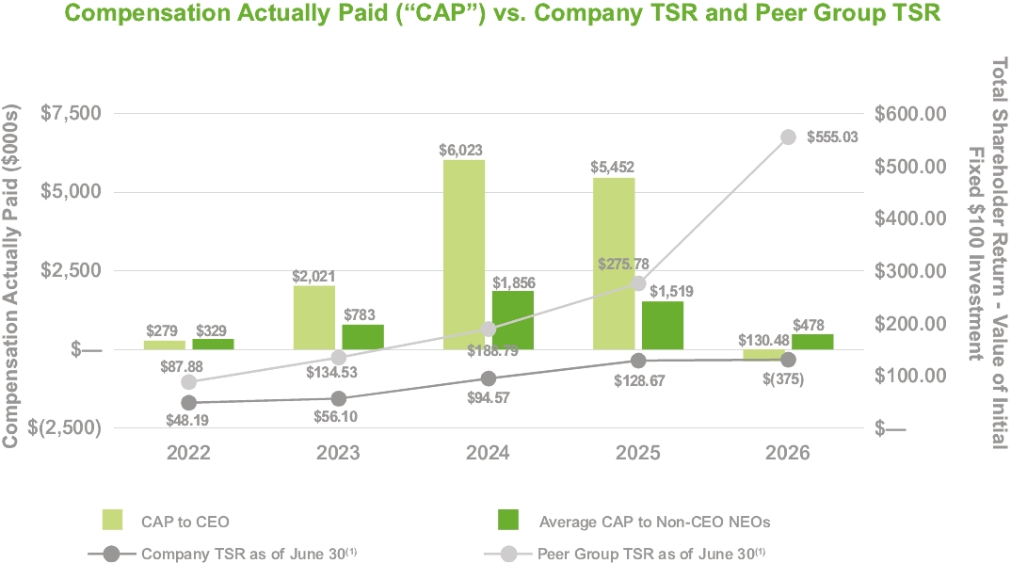

(1) | Cumulative TSR is calculated based on the value of an initial fixed investment of $100 on June 30, 2021.
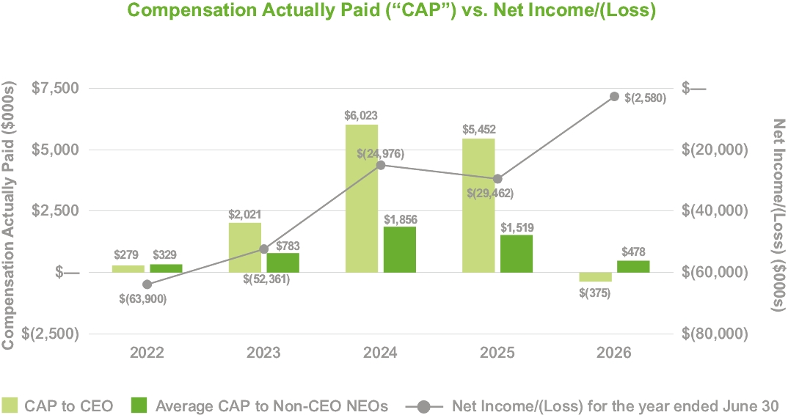

50

TABLE OF CONTENTS
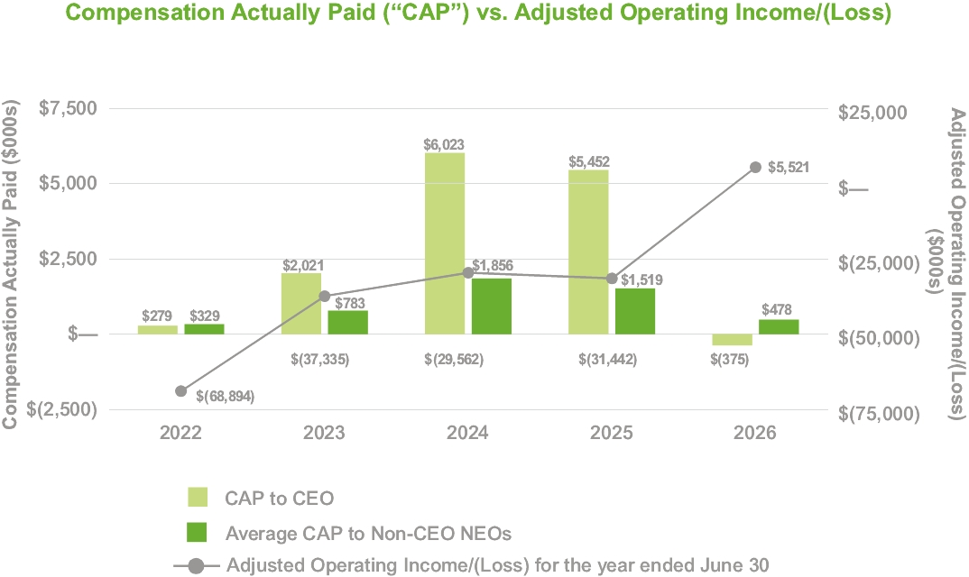

All information provided above under the “Pay Versus Performance” heading will not be deemed to be incorporated by reference in any filing by the Company under the Securities Act of 1933, as amended, whether made before or after the date hereof and irrespective of any general incorporation language in any such filing.
51

TABLE OF CONTENTS
PROPOSAL NUMBER 3:
Advisory Vote to Approve Named Executive Officer Compensation
As required by SEC rules, we are seeking an advisory vote from our stockholders to approve our Named Executive Officer compensation, as set forth below.
We are asking for stockholder approval of the compensation of our Named Executive Officers as disclosed in this proxy statement, which disclosures include the disclosures under the caption “Compensation Discussion and Analysis,” the compensation tables and the narrative discussion accompanying the compensation tables. This vote is not intended to address any specific item of compensation, but rather the overall compensation of our Named Executive Officers and the policies and practices described in this proxy statement. We are open to receiving feedback from stockholders on executive compensation and currently provide stockholders with the opportunity to cast an advisory vote to approve the compensation of our Named Executive Officers every year. We expect our next advisory vote to approve Named Executive Officer compensation will be held during our 2027 Annual Meeting of Stockholders.
As discussed under the heading “Compensation Discussion and Analysis,” our executive compensation and benefit programs are designed to attract, motivate and retain a talented management team and to appropriately reward individual contributions to the achievement of our strategic goals. The Board believes this approach establishes a solid alignment of our executives’ and stockholders’ interests.
Approval of this advisory vote requires the affirmative vote of holders of a majority of the issued and outstanding shares of common stock present in person or represented by proxy and entitled to vote on the matter. The Board unanimously recommends a vote “For” the approval of the compensation of our Named Executive Officers as disclosed in this proxy statement.
The Board welcomes our stockholders’ views on this subject and will carefully consider the outcome of this vote. However, as an advisory vote, the outcome is not binding on us or the Board.
52

TABLE OF CONTENTS
CERTAIN RELATIONSHIPS AND RELATED TRANSACTIONS
Transactions with Related Persons
David Miller, the son of non-executive director James H. Miller, is Vice President, General Counsel and Corporate Secretary of the Company. In fiscal 2026, his salary combined with short- and long-term incentives totaled less than $550,000. The Board has designated James H. Miller as a non-independent director.
Additionally, Peyton Payne, the son of our Chief Executive Officer, Shawn P. Payne, is employed by an operating subsidiary of the Company as an estimator. In fiscal 2026, his salary combined with short-term incentives totaled less than $150,000.
Review, Approval or Ratification of Transactions with Related Persons
Our Corporate Governance Guidelines, which are available on the Corporate Governance page in the Investor Relations section of our website, matrixservicecompany.com, provide that we shall conduct an appropriate review of all transactions with related persons (those transactions which are required to be disclosed pursuant to Item 404 of Regulation S-K) for potential conflict of interest situations on an ongoing basis, and all such transactions shall be approved by the Audit Committee or another independent body of the Board.
In the course of its review and approval or ratification of a transaction, the Audit Committee will consider:
• | the nature of the related person’s interest in the transaction;
• | the material terms of the transaction;
• | the significance of the transaction to the related person;
• | the significance of the transaction to us;
• | whether the transaction would impair the judgment of a director or executive officer to act in our best interest; and
• | any other matters the Audit Committee deems appropriate.
Our Corporate Governance Guidelines also provide that each director and executive officer is required to complete a Director and Officer Questionnaire on an annual basis, and to update such information when the questionnaire responses become incomplete or inaccurate. The Director and Officer Questionnaire requires disclosure of any transactions with the Company in which the director or executive officer, or any member of his or her immediate family, has a direct or indirect material interest.
53

TABLE OF CONTENTS
SECURITY OWNERSHIP OF CERTAIN BENEFICIAL OWNERS AND MANAGEMENT
The following table sets forth, as of August 31, 2026, unless otherwise indicated, certain information with respect to the shares of common stock beneficially owned by (i) each person known by the Company to own beneficially more than 5% of its outstanding shares of common stock, (ii) each director and director nominee of the Company, (iii) each executive officer of the Company named in the Summary Compensation Table herein and (iv) all directors, director nominees and executive officers of the Company as a group. Unless otherwise noted, each of the persons listed below has sole voting and investment power with respect to the shares listed.
 | Identity of Beneficial Owner |  |  | Shares  Beneficially  Owned |  |  | Calculated  Ownership %(1)
 | BlackRock, Inc.  50 Hudson Yards  New York, NY 10001 |  |  | 1,920,729(2) |  |  | 6.8%
 | James H. Miller |  |  | 84,092 |  |  | *
 | John D. Chandler |  |  | 78,053 |  |  | *
 | Martha Z. Carnes |  |  | 63,197 |  |  | *
 | Liane K. Hinrichs |  |  | 56,302 |  |  | *
 | Carlin G. Conner |  |  | 47,233 |  |  | *
 | Jose L. Bustamante |  |  | 33,638 |  |  | *
 | John R. Hewitt |  |  | 508,180 |  |  | 1.8%
 | Kevin S. Cavanah |  |  | 56,999 |  |  | *
 | Shawn P. Payne |  |  | 46,834 |  |  | *
 | Justin D. Sheets |  |  | 47,106 |  |  | *
 | Nancy E. Austin |  |  | 88,347 |  |  | *
 | All directors, director nominees and executive officers as a group (10 persons) |  |  | 520,796 |  |  | 1.9%
* | Indicates ownership of less than one percent of the outstanding shares of common stock.
(1) | Shares of common stock which were not outstanding but which could be acquired by a director or executive officer upon vesting of a restricted stock unit or upon exercise of an option within 60 days of August 31, 2026 are deemed outstanding for the purpose of computing the percentage of outstanding shares beneficially owned by such person. Such shares, however, are not deemed to be outstanding for the purpose of computing the percentage of outstanding shares beneficially owned by any other person.
(2) | Information is as of March 31, 2026 and is based on the Schedule 13G dated April 7, 2026 filed by BlackRock, Inc. (“BlackRock”). BlackRock is a parent holding company or control person in accordance with Rule 13d-1(b)(1)(ii)(G). BlackRock has sole voting power over 1,895,011 shares and sole dispositive power over all of the shares shown.
54

TABLE OF CONTENTS
Securities Authorized for Issuance under Equity Compensation Plans
The following table provides information concerning our common stock that may be issued upon the exercise of options, warrants and rights under our existing equity compensation plans as of June 30, 2026.
 | Plan Category |  |  | Number of securities  to be issued upon  exercise of outstanding  options, warrants  and rights(1) |  |  | Weighted-average  exercise price  of outstanding  options, warrants  and rights |  |  | Number of securities  remaining available  for future issuance  under equity  compensation plans
 | Equity compensation plans approved by stockholders |  |  | 1,778,179 |  |  | N/A |  |  | 3,115,864(2)
 | Equity compensation plans not approved by stockholders |  |  | — |  |  | N/A |  |  | —
 | Total |  |  | 1,778,179 |  |  | N/A |  |  | 3,115,864
(1) | Includes 612,788 RSUs and 1,165,391 performance units, which have no exercise price. The amount included assumes that target level performance is achieved under outstanding performance units for which performance has not yet been determined.
(2) | Represents the total number of shares available for issuance under the Matrix Service Company 2020 Stock and Incentive Compensation Plan. Of the 3,115,864 shares available for issuance, all may be awarded as stock options, stock appreciation rights, restricted stock, RSUs, performance shares or performance units.
PROPOSALS OF STOCKHOLDERS
A proposal of a stockholder intended to be presented at our 2027 Annual Meeting of Stockholders must be received at our principal executive offices no later than May 26, 2027, if the proposal is to be considered for inclusion pursuant to Rule 14a-8 promulgated under the Securities Exchange Act of 1934, as amended (“Rule 14a-8”), in our proxy statement and proxy card for such meeting.
In accordance with the Bylaws, any stockholder who intends to present a proposal at our 2027 Annual Meeting of Stockholders and has not sought inclusion of the proposal in our proxy statement and accompanying proxy pursuant to Rule 14a-8, must provide the Corporate Secretary of the Company with notice of such proposal in order for such proposal to be properly brought before the meeting, no later than the close of business on the 90th day nor earlier than the close of business on the 120th day prior to the first anniversary of the preceding year's annual meeting; provided, however, that in the event that the date of such annual meeting is more than 30 days before or more than 60 days after such anniversary date, notice by the stockholder must be delivered not earlier than the close of business on the 120th day prior to such annual meeting and not later than the close of business on the later of the 90th day prior to such annual meeting or if the first public announcement of the date of such annual meeting is less than 100 days prior to the date of such annual meeting, the close of business on the 10th day following the day on which public announcement of the date of such meeting is first made by us (the “Advance Notice Provisions”).
In addition to the Advance Notice Provisions, in 2023, the SEC adopted Rule 14a-19 (known as the universal proxy rules), which governs proxy contests for companies subject to the U.S. proxy rules. As a result, we are subject to the new universal proxy rules. Under the universal proxy rules, stockholders who seek to nominate a director for election to the Company’s board of directors must submit to the Company not later than August 5, 2027, nor earlier than July 6, 2027, (1) the name(s) of the nominee(s) it intends to solicit proxies for, and (2) a representation that the stockholder will solicit at least 67% of the Company's stockholders.
55

TABLE OF CONTENTS
OTHER MATTERS
Matters That May Come Before the Annual Meeting
The Board knows of no matters other than those described in this proxy statement which will be brought before the Annual Meeting for a vote of the stockholders. If, however, any other matter requiring a vote of stockholders arises, the persons named as proxies (or their substitutes) will vote thereon in accordance with their best judgment. The persons named as proxies will have discretionary authority to take action with respect to any additional matters that may come before the meeting.
Availability of Form 10-K
A copy of our Annual Report on Form 10-K may be found by visiting our website at matrixservicecompany.com.
Householding of Proxy Materials
We have adopted a process called “householding” for mailing proxy materials in order to reduce printing and mailing expenses. The SEC householding rules allow us to deliver a single Notice of Internet Availability to stockholders of record who share the same address. If you share an address with another stockholder and have received only one Notice of Internet Availability, but you would prefer to continue receiving a separate Notice of Internet Availability, you may request a separate copy of the Notice of Internet Availability at no cost to you by writing to our Corporate Secretary at 15333 JFK Blvd., Ste. 400, Houston, TX 77032, or by calling (281) 458-8781. Alternatively, if you are currently receiving multiple copies of the Notice of Internet Availability at the same address and wish to receive a single copy in the future, you may contact us by calling or writing to us at the telephone number or address given above.
If you are a beneficial owner, the bank, broker or other holder of record may deliver only one copy of the Notice of Internet Availability to stockholders who have the same address unless the bank, broker or other holder of record has received contrary instructions from one or more of the stockholders. If you wish to receive a separate copy of the Notice of Internet Availability, now or in the future, you may contact us at the address or telephone number above and we will promptly deliver a separate copy. Beneficial owners sharing an address who are currently receiving multiple copies of the Notice of Internet Availability and wish to receive a single copy in the future should contact their bank, broker or other holder of record to request that only a single copy be delivered to all stockholders at the shared address in the future.
Forward-Looking Statements
This Proxy Statement includes “forward-looking statements” within the meaning of Section 27A of the Securities Act of 1933, as amended, and Section 21E of the Securities Exchange Act of 1934, as amended. All statements, other than statements of historical facts, included in this Proxy Statement which address activities, events or developments, which we expect, believe or anticipate will or may occur in the future are forward-looking statements. The words “believes,” “intends,” “expects,” “anticipates,” “projects,” “estimates,” “predicts” and similar expressions are also intended to identify forward-looking statements. Although we believe that our expectations regarding future events are based on reasonable assumptions, we can give no assurance that such expectations or assumptions will be achieved. Important factors that could cause actual results to differ materially from those in the forward-looking statements are described under Part I, Item 1A, Risk Factors in our fiscal 2026 Annual Report on Form 10-K.
Consequently, all of the forward-looking statements made in this Proxy Statement are qualified by these cautionary statements and there can be no assurance that the actual results or developments anticipated by us will be realized or, even if substantially realized, that they will have the expected consequences or effects on our business operations. We assume no obligation to update publicly, except as required by law, any such forward-looking statements, whether as a result of new information, future events or otherwise.
56

TABLE OF CONTENTS
Important Notice Regarding the Availability of Proxy Materials for the Stockholders Meeting to be Held on November 3, 2026
Stockholders may view this proxy statement, the proxy card and our 2026 Annual Report to Stockholders over the Internet at www.proxyvote.com and by accessing our website at matrixservicecompany.com. Information on our website does not constitute a part of this proxy statement.
By Order of the Board,


David J. Miller
Vice President, General Counsel and Corporate Secretary
September 23, 2026
Houston, Texas
57

TABLE OF CONTENTS
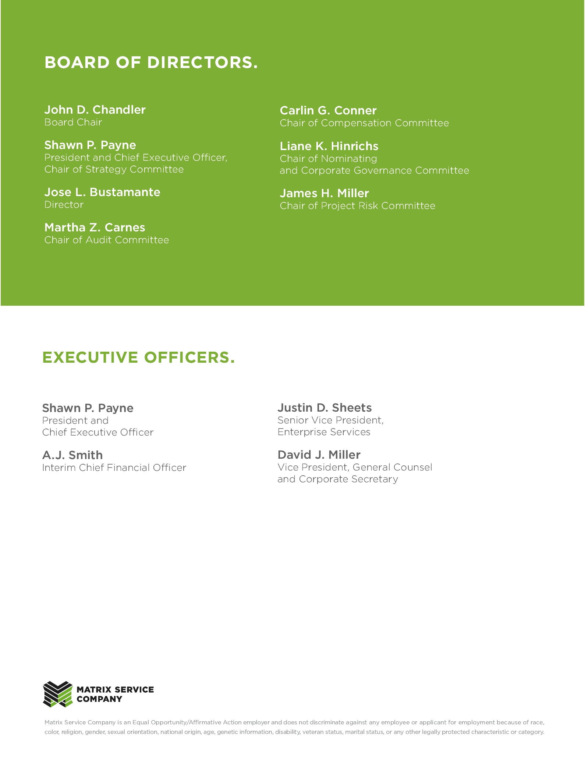

TABLE OF CONTENTS


TABLE OF CONTENTS
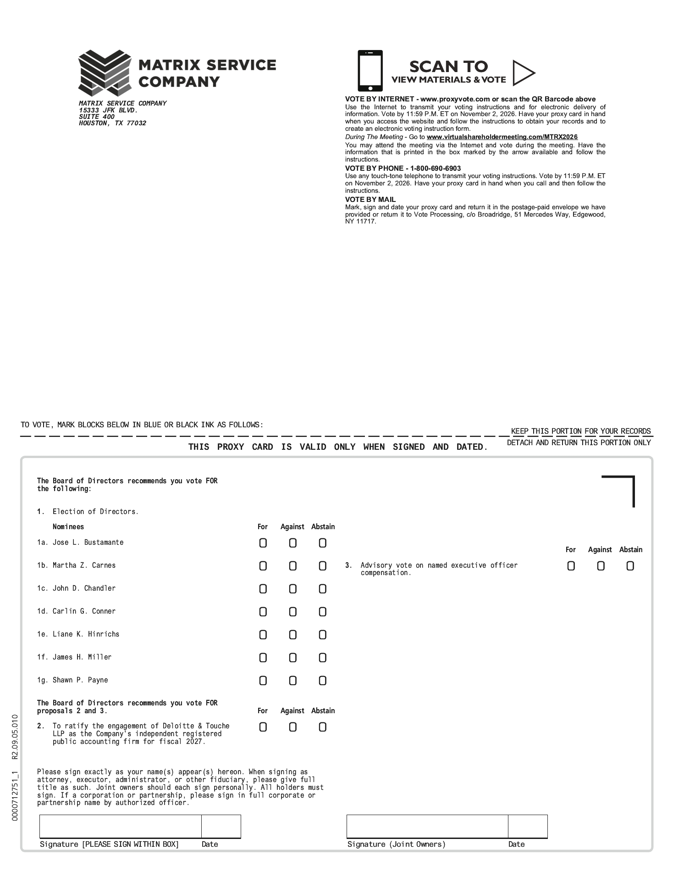

TABLE OF CONTENTS


